Evaluation Warning: The document was created with Spire.Doc for Python.

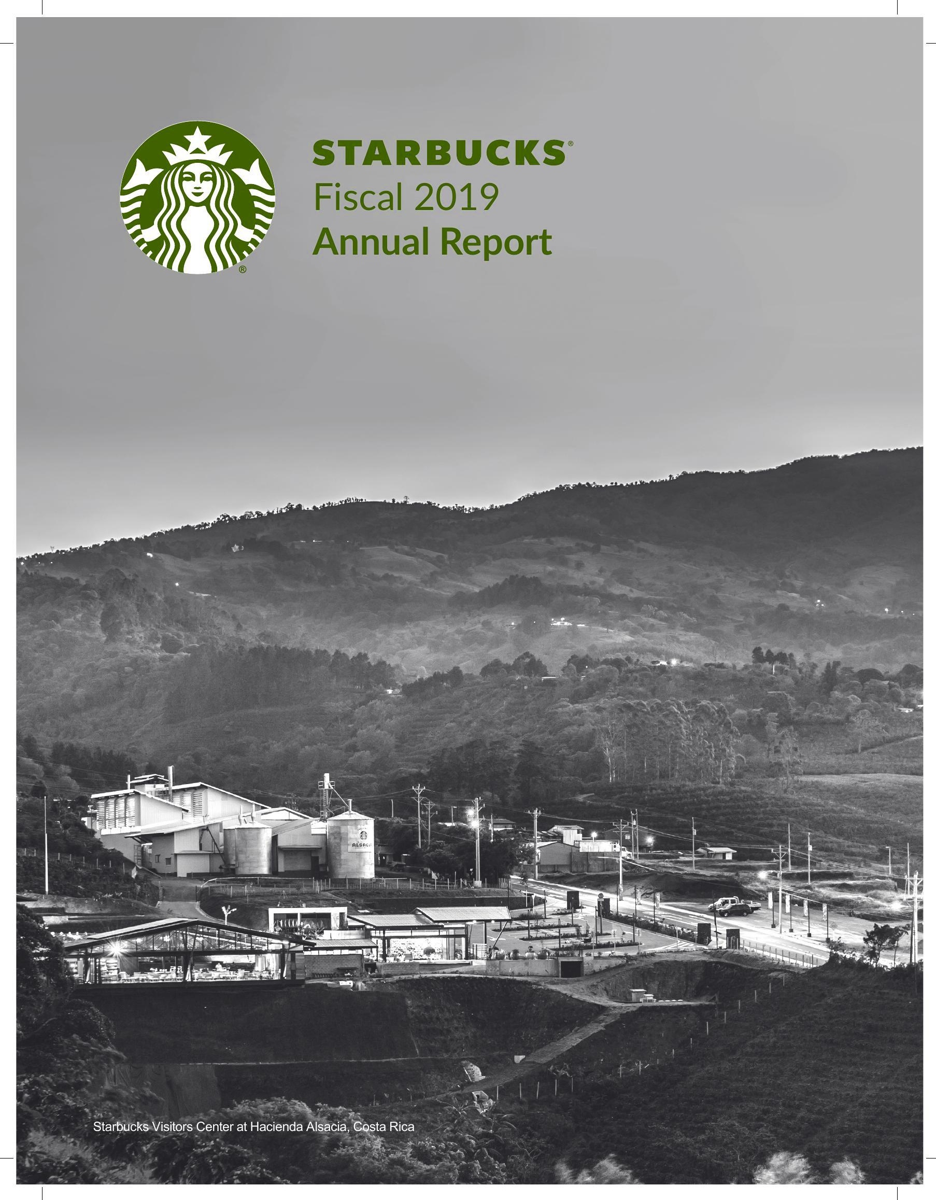

Pursuant to the requirements of Section 13 or 15(d) of the Securities Exchange Act of 1934, the registrant has duly caused this report to be signed on its behalf by the undersigned, thereunto duly authorized.

November 15, 2019

STARBUCKSCORPORATION

By:/s/Kevin R. Johnson

Kevin R. Johnson president and chief executive officer

# POWER OF ATTORNEY

Know all persons by these presents, that each person whose signature appears below constitutes and appoints Kevin R. Johnson, Patrick J. Grismer and Rachel A. Gonzalez, and each of them, as such person's true and lawful attorneys-in-fact and agents, with full power of substitution and resubstitution, for such person and in such person's name, place and stead, in any and all capacities, to sign any and all amendments to this report, and to file the same, with all exhibits thereto, and other documents in connection therewith, with the Securities and Exchange Commission, granting unto said attorneys-in-fact and agents, and each of them, full power and authority to do and perform each and every act and thing requisite and necessary to be done in connection therewith, as fully to all intents and purposes as such person might or could do in person, hereby ratifying and confirming all that said attorneys-in-fact and agents, or any of them or their or such person's substitute or substitutes, may lawfully do or cause to be done by virtue thereof.

Starbucks Corporation 2019 Form 10-K97

|  |  |  |
| --- | --- | --- |
| persons on behalf of the registrant and in the capacities indicated as of November 15, 2019. |  | Title |
| By: | Signature Is/ Kevin R. Johnson | president and chief executive officer, director (principal executive officer) |
|  | Kevin R. Johnson |  |
| By: | /s/ Patrick J.Grismer | executive vice president, chief financial office (principal financial officer) |
|  | Patrick J. Grismer | senior vice president,Corporate Financial Services |
| By: | Jill L.Walker | chief accounting officer (principal accounting offi |
|  | Jill L. Walker |  |
| By: | /s/Richard E. Allison, Jr. | director |
|  | Richard E. Allison, Jr. |  |
| By: | Is/ Rosalind G.Brewer | director |
|  | Rosalind G. Brewer |  |
| By: | /s/ Andrew Campion | director |
|  | Andrew Campion |  |
| By: | Isl Mary N. Dillon | director |
|  | Mary N. Dillon |  |
| By: | Is/ Mellody Hobson | director |
|  | Mellody Hobson |  |
| By: | 1s/ Jorgen Vig Knudstorp | director |
|  | Jorgen Vig Knudstorp |  |
| By: | /s/Isabel Ge Mahe | director |
|  | Isabel Ge Mahe |  |

98Starbucks Corporation 2019 Form 10-K

98Starbucks Corporation 2019 Form 10-K

|  |  |
| --- | --- |
| Signature |  |
|  | By: /s/ SatyaNadella Satya Nadella |
| By: |  |
|  | /s/Joshua Cooper Ramo Joshua Cooper Ramo |
| By: |  |
|  | /s/ Clara Shih |
|  | Clara Shih |
| By: | /s/Javier G.Teruel |
|  | Javier G.Teruel |
|  |  |
|  |  |
| By: Isl | Myron E. Ullman, III Myron E. Ullman, III |

Starbucks Corporation 2019 Form 10-K99

100 Starbucks Corporation 2019 Form 10-K

This Page Intentionally Left Blank

This Page Intentionally Left Blank

Starbucks Corporation 2019 Form 10-K 101

Starbucks Corporation 2019 Form 10-K 101

This Page Intentionally Left Blank

102 Starbucks Corporation 2019 Form 10-K

102 Starbucks Corporation 2019 Form 10-K

STARBUCKS

2019 Starbucks Corporation.

Employees

Starbucks employed approximately 346,000 people worldwide as of September 29, 2019. In the U.S., Starbucks employed approximately 218,000 people, with approximately 209,000 in company-operated stores and the remainder in support facilities, store development, roasting, manufacturing, warehousing and distribution operations. Approximately 128,000 employees were employed outside of the U.S., with approximately 124,000 in company-operated stores and the remainder in regional support operations. The number of Starbucks employees represented by unions is not significant. We believe our current relations with our employees are good. Information about our Executive Officers

|  |  |  |
| --- | --- | --- |
| Name | Age | Position |
| Kevin R.Johnson | 59 | president and chief executive officer |
| Rosalind G. Brewer | 57 | group president, Americas and chief operating officer |
| Cliff Burrows | 60 | group president, Siren Retail |
| John Culver | 59 | group president, International, Channel Development and Global Coffee & Tea |
| Rachel A.Gonzalez | 50 | executive vice president, general counsel and secretary |
| Patrick J. Grismer | 57 | executive vice president, chief financial officer |
| Lucy Lee Helm | 62 | executive vice president, chief partner officer |
| John Kelly | 53 | executive vice president, Global Public Affairs and Social Impact |

Kevin R. Johnson has served as president and chief executive officer since April 2017, and has been a Starbucks director since March 2009.Mr.Johnson served as president and chief operating officer from March 2015 to April2017.Mr. Johnson served as Chief Executive Officer of Juniper Networks, Inc., a leading provider of high-performance networking products and services, from September 2008 to December 2013.He also served on the Board of Directors of Juniper Networks from September 2008 through February 2014. Prior to joining Juniper Networks, Mr. Johnson served as President, Platforms and Services Division for Microsoft Corporation, a worldwide provider of software, services and solutions. Mr. Johnson was a member of Microsoft's Senior Leadership Team and held a number of senior executive positions over the course of his 16 years at Microsoft. Prior to joining Microsoft in 1992, Mr. Johnson worked in International Business Machine Corp.'s systems integration and consulting business. Rosalind G. Brewer has served as group president, Americas and chief operating officer since October 2017, and has been a director of Starbucks since March 2017.Ms.Brewer served as President and Chief Executive Officer of Sam's Club,a membership-only retail warehouse club and a division of Walmart Inc., from February 2012 to February 2017. Previously, Ms Brewer was Executive Vice President and President of Walmart's East Business Unit from February 2011 to January 2012: Executive Vice President and President of Walmart South from February 2010 to February 2011; Senior Vice President and Division President of the Southeast Operating Division from March 2007 to January 2010; and Regional General Manager, Georgia Operations, from 2006 to February 2007. Prior to joining Walmart, Ms. Brewer was President of Global Nonwovens Division for Kimberly-Clark Corporation, a global health and hygiene products company, from 2004 to 2006 and held various management positions at Kimberly-Clark Corporation from 1984 to 2006. Ms. Brewer formerly served on the Board of Directors for Lockheed Martin Corporation and Molson Coors Brewing Company. She currently serves on the Board of Directors of Amazon.com, Inc. and as the Chair of the Board of Trustees for Spelman College. Cliff Burrows joined Starbucks in April 2001 and has served as group president, Siren Retail, since September 2016, which includes the Starbucks Reserverm Roastery & Tasting Rooms, Starbucks Reserve brand and Princi operations. On April 1, 2019 Mr. Burrows took an extended unpaid leave, also known as a "coffee break"or sabbatical. From July 2015 to September 2016. he served as group president, U.S. and Americas. From February 2014 to June 2015, he served as group president, U.S.. Americas and Teavana. From May 2013 to February 2014, he served as group president, Americas and U.S., EMEA (Europe, Middle East and Africa) and Teavana. Mr. Burrows served as president, Starbucks Coffee Americas and U.S. from October 2011 to May 2013 and as president,Starbucks Coffee U.S.from March 2008 to October 2011.He served as president,EMEA from April 2006 to March 2008. He served as vice president and managing director, U.K. prior to April 2006. Prior to joining Starbucks, Mr. Burrows served in various management positions with Habitat Designs Limited, a furniture and housewares retailer. John Culver joined Starbucks in August 2002 and has served as group president, International, Channel Development and Global Coffee & Tea, since July 2018.From October 2017 to July 2018,Mr.Culver served as group president,International and Channels. From September 2016 to October 2017, he served as group president, Starbucks Global Retail. From May 2013 to September 2016, he served as group president, China, Asia Pacific, Channel Development and Emerging Brands. Mr. Culver

Starbucks Corporation

2019 Form 10-K

served as president, Starbucks Coffee China and Asia Pacific from October 2011 to May 2013. From December 2009 to October 2011,he served as president, Starbucks Coffee International. Mr. Culver served as executive vice president; president. Global Consumer Products.Foodservice and Seattle's Best Coffee from February 2009 to September 2009,and then as president, Global Consumer Products and Foodservice from October 2009 to November 2009. He previously served as senior vice president; president, Starbucks Coffee Asia Pacific from January 2007 to February 2009, and vice president; general manager, Foodservice from August 2002 to January 2007. Rachel A. Gonzalez joined Starbucks and has served as executive vice president, general counsel and secretary since joining Starbucks in April 2018.Prior to joining Starbucks,Ms.Gonzalez served as executive vice president and chief administrative officer of Sabre Corporation, a technology provider to the travel industry, from May 2017 to April 2018 and as Sabre's executive vice president and general counsel from September 2014 to May 2017. From March 2013 to September 2014, Ms. Gonzalez served as executive vice president, general counsel and corporate secretary of Dean Foods Company, a food and beverage company, and as its executive vice president, general counsel designate from November 2012 to March 2013. She served as chief counsel, corporate and securities of Dean Foods from 2008 to November 2012.From 2006 to 2008, Ms Gonzalez served as senior vice president and group counsel for Affiliated Computer Services, Inc., an information technology service provider. Prior to that, Ms. Gonzalez was a partner with the law firm of Morgan,Lewis & Bockius LLP,where she focused on corporate finance, mergers and acquisitions, SEC compliance and corporate governance. Ms. Gonzalez serves on the Board of Directors of Dana Incorporated. Patrick J. Grismer joined Starbucks in November 2018 as executive vice president, chief financial officer. From March 2016 to November 2018, Mr. Grismer served as Executive Vice President, Chief Financial Officer of Hyatt Hotels Corporation,a global hospitality company. From May 2012 to February 2016, Mr. Grismer served as Chief Financial Officer at Yum! Brands, Inc., a global restaurant company. He previously held a number of roles at Yum!, including Chief Planning and Control Officer and Chief Financial Officer for Yum! Restaurants International. Prior to that, Mr. Grismer served in various roles at The Walt Disney Company including Vice President, Business Planning and Development for The Disneyland Resort and Chief Financial Officer for the Disney Vacation Club. Mr. Grismer began his career with Price Waterhouse. Lucy Lee Helm joined Starbucks in September 1999, and has served as executive vice president, chief partner officer since August 2017.From May 2012 to August 2017, Ms. Helm served as executive vice president, general counsel and secretary. She served as senior vice president and deputy general counsel from October 2007 to April 2012 and served as interim general counsel and secretary from April 2012 to May 2012. Ms. Helm previously served as vice president, assistant general counsel from June 2002 to September 2007 and as director, corporate counsel from September 1999 to May 2002. During her tenure at Starbucks, Ms. Helm has led various teams of the Starbucks legal department, including the Litigation and Brand protection team, the Global Business (Commercial) team and the Litigation and Employment team. Prior to joining Starbucks, Ms. Helm Was a principal at the Seattle law firm of Riddell Williams P.S. from 1990 to 1999, where she was a trial lawyer specializing in commercial, insurance coverage and environmental litigation. John Kelly joined Starbucks in October 2013, and serves as executive vice president,Public Affairs and Social Impact.From 2013 to October 2019, Mr. Kelly served as senior vice president, Public Affairs and Social Impact. Prior to joining Starbucks, Mr.Kelly was vice president of Industry Affairs,in the Law and Corporate Affairs department of the Microsoft Corporation,a worldwide provider of software, services and solutions, from September 2007 to September 2013.From April 1998 to

# Global Social Impact

We are committed to being a deeply responsible company in the communities where we do business. Our focus is on ethically sourcing high-quality coffee and tea, reducing our environmental impacts and contributing positively to communities around the world. Starbucks Global Social Impact strategy and commitments are integral to our overall business strategy. As a result, we believe we deliver benefits to our stakeholders, including employees, business partners, customers, suppliers, shareholders, community members and others. For an overview of Starbucks Global Social Impact strategy and commitments, please visit www.starbucks.com/responsibility.

# Available Information

Starbucks 10-K reports, along with all other reports and amendments filed with or furnished to the Securities and Exchange Commission ("SEC"), are publicly available free of charge on the Investor Relations section of our website at investor.starbucks.com or at www.sec.gov as soon as reasonably practicable after these materials are filed with or furnished to the SEC. Our corporate governance policies, code of ethics and Board committee charters and policies are also posted on the Investor Relations section of Starbucks website. The information on our website is not part of this or any other report Starbucks files with, or furnishes to, the SEC.

2019 Form 10-K

Starbucks Corporation

Item 1A.Risk Factors

You should carefully consider the risks described below in addition to the other information set forth in this Annual Report on Form 10-K, including the Management's Discussion and Analysis of Financial Conditions and Results of Operations section and the consolidated financial statements and related notes. If any of the risks and uncertainties described in the cautionary factors described below actually occur or continue to occur, our business, financial condition and results of operations, and the trading price of our common stock could be materially and adversely affected. Moreover, the risks below are not the only risks we face and additional risks not currently known to us or that we presently deem immaterial may emerge or become material at any time and may negatively impact our business, reputation, financial condition, results of operations or the trading price of our common stock.

As a retailer that is dependent upon consumer discretionary spending, our results of operations are sensitive to changes in or uncertainty about macro-economic conditions. Our customers may have or in the future have less money for discretionary purchases and may stop or reduce their purchases of our products or switch to Starbucks or competitors' lower-priced products as a result of various factors, including job losses, inflation, higher taxes, reduced access to credit, changes in federal economic policy and recent international trade disputes. Decreases in customer traffic and/or average value per transaction without a corresponding decrease in costs would put downward pressure on margins and would negatively impact our financial results There is also a risk that if negative economic conditions or uncertainty persist for a long period of time or worsen, consumers may make long-lasting changes to their discretionary purchasing behavior, including less frequent discretionary purchases on a more permanent basis or there may be a general downturn in the restaurant industry.

We believe we have built an excellent reputation globally for the quality of our products, for delivery of a consistently positive consumer experience and for our global social impact programs. The Starbucks brand is recognized throughout the world, and we have received high ratings in global brand value studies. To be successful in the future,particularly outside of the U.S where the Starbucks brand and our other brands are less well-known, we believe we must preserve, grow and leverage the value of our brands across all sales channels. Brand value is based in part on consumer perceptions on a variety of subjective qualities.

of our brands across all sales channels. Brand value is based in part on consumer perceptions on a variety of subjective qualities. Business incidents, whether isolated or recurring and whether originating from us or our business partners, that erode consumer trust can significantly reduce brand value, potentially trigger boycotts of our stores or result in civil or criminal liability and can have a negative impact on our financial results. Such incidents include actual or perceived breaches of privacy or violations of domestic or international privacy laws, contaminated food, product recalls, store employees or other food handlers infected with communicable diseases or other potential incidents discussed in this risk factors section. The impact of such incidents may be exacerbated if they receive considerable publicity, including rapidly through social or digital media (including for malicious reasons) or result in litigation. Consumer demand for our products and our brand equity could diminish significantly if we, our employees,licensees or other business partners fail to preserve the quality of our products,act or are perceived to act in an unethical, illegal, racially-biased, unequal or socially irresponsible manner, including with respect to the sourcing, content or sale of our products, service and treatment of customers at Starbucks stores, or the use of customer data for general or direct marketing or other purposes. Additionally, if we fail to comply with laws and regulations, publicly take controversial positions or actions or fail to deliver a consistently positive consumer experience in each of our markets, including by failing to invest in the right balance of wages and benefits to attract and retain employees that represent the brand well, our brand value may be diminished.

Starbucks Corporation 2019 Form 10-K

Starbucks Corporation 2019 Form 10-K

Starbucks Corporation 2019 Form 10-K

could damage our brand and our financial results could suffer. Our global business strategy, including our plans for new stores, branded products and other initiatives, relies significantly on a variety of business partners, including licensee and joint venture relationships, third-party manufacturers, distributors and retailers, particularly for our entire global Channel Development business. Licensees, retailers and foodservice operators are often authorized to use our logos and provide branded food, beverage and other products directly to customers. We believe our customers expect the same quality of service regardless of whether they visit a licensed or company-operated store, so we provide training and support to, and monitor the operations of, certain of these licensees and other business partners. However, the product quality and service they deliver may still be diminished by any number of factors beyond our control. We also source our food, beverage and other products from a wide variety of domestic and international business partners and in certain cases such products are produced or sourced by our licensees directly.And although foodservice operators are authorized to use our logos and provide branded products as part of their foodservice business, we do not monitor the quality of non-Starbucks products served in those locations. Additionally, inconsistent uses of our brand and other of our intellectual property assets, as well as failure to protect our intellectual property, can erode consumer trust and our brand value and have a material negative impact on our financial results.

: Incidents involving food or beverage-borne illnesses, tampering, adulteration, contamination or mislabeling, whether or not accurate, as well as adverse public or medical opinions about the health effects of consuming our products, could harm our business.

Instances or reports, whether true or not, of unclean water supply or food-safety issues, such as food or beverage-borne illnesses, tampering, adulteration, contamination or mislabeling, either during growing, manufacturing, packaging, storing or preparation, have in the past severely injured the reputations of companies in the food and beverage processing, grocery and quick-service restaurant sectors. Any report linking us to such instances could severely hurt our sales and could possibly lead to product liability claims, litigation (including class actions) and/or temporary store closures. Clean water is critical to the preparation of coffee, tea and other beverages, as well as ice for our cold beverages, and our ability to ensure a clean water and ice supply to our stores can be limited, particularly in some international locations. We are also continuing to incorporate more products in our food and beverage lineup that require freezing or refrigeration, which increases the risk of food safety related incidents if correct temperatures are not maintained due to mechanical malfunction or human error. We also face risk by relying on third-party food suppliers to provide and transport ingredients and finished products to our Stores. We monitor the operations of certain of these business partners, but the product quality and service they deliver may be diminished by any number of factors beyond our control and it may be difficult to detect contamination or other defect in these products. Additionally, we are evolving our product lineup to include more local or smaller suppliers for some of our products who may not have as rigorous quality and safety systems and protocols as larger or more national suppliers. In addition, instances of food or beverage-safety issues, even those involving solely the restaurants or stores of competitors or of suppliers or distributors (regardless of whether we use or have used those suppliers or distributors), could, by resulting in negative publicity about us or the foodservice industry in general, adversely affect our sales on a regional or global basis. A decrease in customer traffic as a result of food-safety concerns or negative publicity, or as a result of a temporary closure of any of our stores, product recalls or food or beverage-safety claims or litigation, could materially harm our business and results of operations. - The unauthorized access, use, theft or destruction of customer or employee personal, financial or other data or of Starbucks proprietary or confidential information that is stored in our information systems or by third parties on our behalf could impact our reputation and brand and expose us to potential liability and loss of revenues. Many of our information technology systems (and those of our licensees and other third-party business partners, whether cloud. based or hosted in proprietary servers), including those used for our point-of-sale, web and mobile platforms, online and mobile payment systems, delivery services and rewards programs, and administrative functions, contain personal, financial or other information that is entrusted to us by our customers and employees. Many of our information technology systems also contain Starbucks proprietary and other confidential information related to our business, such as business plans, product development initiatives and designs. Similar to many other retail companies and because of the prominence of our brand, we are consistently subject to attempts to compromise our information technology systems. To the extent we or a third party were to experience a material breach of our or such third parties' information technology systems that result in the unauthorized access, theft, use, destruction or other compromises of customers' or employees' data or confidential information of the Company stored in such systems, including through cyber-attacks or other external or internal methods, it could result in a material loss of revenues from the potential adverse impact to our reputation and brand, our ability to retain or attract new customers and the potential disruption to our business and plans. Such security breaches also could result in a violation of applicable U.S. and international privacy and other laws, and subject us to private consumer, business partner, or securities litigation and governmental investigations and proceedings, any of which could result in our exposure to material civil or criminal liability. For example, 10 Starbucks Corporation 2019 Form 10-K

the European Union adopted a new regulation that became effective in May 2018, called the General Data Protection Regulation (GDPR'), which requires companies to meet new requirements regarding the handling of personal data, including its use, protection and transfer and the ability of persons whose data is stored to correct or delete such data about themselves. Failure to meet the GDPR requirements could result in penalties of up to 4% of annual worldwide revenue. The GDPR also confers a private right of action on certain individuals and associations. Additionally, the California Privacy Act of 2018 ("CCPA"), which was enacted in June 2018 and will come into effect on January 1, 2020, provides a new private right of action for data breaches and requires companies that process information on California residents to make new disclosures to consumers about their data collection,use and sharing practices and allow consumers to opt out of certain data sharing with third parties. Our reputation and brand and our ability to attract new customers could also be adversely impacted if we fail, or are perceived to have failed, to properly respond to security breaches of our or third party's information technology systems. Such failure to properly respond could also result in similar exposure to liability. Compliance with the GDPR, the CCPA and other current and future applicable international and U.S. privacy, cybersecurity and related laws can be costly and time-consuming. Significant capital investments and other expenditures could also be required to remedy cybersecurity problems and prevent future breaches, including costs associated with additional security technologies, personnel, experts and credit monitoring services for those whose data has been breached. These costs, which could be material, could adversely impact our results of operations in the period in which they are incurred and may not meaningfully limit the success of future attempts to breach our information technology systems. Media or other reports of existing or perceived security vulnerabilities in our systems or those of our third-party business partners or service providers can also adversely impact our brand and reputation and materially impact our business Additionally, the techniques and sophistication used to conduct cyber-attacks and breach information technology systems, as well as the sources and targets of these attacks, change frequently and are often not recognized until such attacks are launched or have been in place for a period of time. We continue to make significant investments in technology, third-party services and personnel to develop and implement systems and processes that are designed to anticipate cyber-attacks and to prevent or minimize breaches of our information technology systems or data loss, but these security measures cannot provide assurance that we will be successful in preventing such breaches or data loss.

We rely heavily on information technology systems across our operations for numerous purposes including for administrative functions, point-of-sale processing and payment in our stores and online, management of our supply chain, Starbucks Cards, online business, delivery services, mobile technology, including mobile payments and ordering apps, reloads and loyalty functionality and various other processes and transactions, and many of these systems are interdependent on one another for their functionality. Additionally, the success of several of our initiatives to drive growth, including our ability to increase digital relationships with our customers to drive incremental traffic and spend, is highly dependent on our technology systems. We also rely on third-party providers and platforms for some of these information technology systems and support. Additionally, our systems hardware, software and services provided by third-party service providers are not fully redundant within a market or across our markets. Although we have operational safeguards in place, they may not be effective in preventing the failure of these systems or platforms to operate effectively and be available. Such failures may be caused by various factors, including power outages, catastrophic events, physical theft, computer and network failures, inadequate or ineffective redundancy, problems with transitioning to upgraded or replacement systems or platforms, flaws in third-party software or services, errors or improper use by our employees or third party service providers, or a breach in the security of these systems or platforms, including through cyber-attacks such as those that result in the blockage of our or our third-party business partners' or service providers' systems and platforms and those discussed in more detail in this risk factors section. If our incident response, disaster recovery and business continuity plans do not resolve these issues in an effective manner they could result in an interruption in our operations and could cause material negative impacts to our product availability and sales, the efficiency of our operations and our financial results. In addition, remediation of any problems with our systems could result in significant, unplanned expenses.

# - We may not be successful in implementing important strategic initiatives or effectively managing growth, which may have

There is no assurance that we will be able to implement important strategic initiatives in accordance with our expectations or that they will generate expected returns, which may result in an adverse impact on our business and financial results. These strategic initiatives are designed to create growth, improve our results of operations and drive long-term shareholder value, and include: being an employer of choice and investing in employees to deliver a superior customer experience; - building our leadership position around coffee;

Starbucks Corporation 2019 Form 10-K11

Starbucks Corporation

2019 Form 10-K11

driving convenience, brand engagement and digital relationships through our mobile, loyalty, delivery and digital capabilities both domestically and internationally; - simplifying store administrative tasks to allow store partners to better engage with customers; increasing the scale of the Starbucks store footprint with disciplined global expansion and introducing flexible and unique store formats; moving to a more licensed store model in some markets and a more company-owned model in other markets; creating new occasions in stores across all dayparts with new product offerings, including our growing lunch food and beverage product lineup: - continuing the global growth of our Channel Development business through our supply, distribution and licensing agreements with Nestle and other Channel Development business partners; delivering continued growth in our cold beverage business, including our tea business through the Teavana brand in our Starbucks" retail stores and other channels and internationally; and reducing our operating costs, particularly general and administrative expenses. In addition to other factors listed in this risk factors section, factors that may adversely affect the successful implementation of these initiatives, which could have a material adverse impact on our business and financial results, include the following: imposition of additional taxes by jurisdictions, such as on certain types of beverages or based on number of employees; construction cost increases associated with new store openings and remodeling of existing stores; delays in store openings for reasons beyond our control or a lack of desirable real estate locations available for lease at reasonable rates, either of which could keep us from meeting annual store opening targets in the U.S. and internationally; - not successfully scaling our supply chain infrastructure as our product offerings increase and as we continue to expand, including our emphasis on a broad range of high-quality food offerings; and the deterioration in our credit ratings, which could limit the availability of additional financing and increase the cost of obtaining financing to fund our initiatives. Effectively managing growth can be challenging,particularly as we expand into new markets internationally where we must balance the need for flexibility and a degree of autonomy for local management against the need for consistency with our goals, philosophy and standards. If we are not successful in implementing our strategic initiatives, such as large acquisitions and integrations, we may be required to evaluate whether certain assets, including goodwill and other intangibles, have become impaired. In the event we record an impairment charge, it could have a material impact on our financial results.

Our continued success depends on our ability to retain and convert customers. Our financial results could be adversely affected by a shift in consumer spending away from outside-the-home food and beverages (such as the disruption caused by on-line commerce that results in reduced foot traffic to "brick & mortar" retail stores); lack of customer acceptance of new products (including due to price increases necessary to cover the costs of new products or higher input costs), brands (such as the global expansion of the Teavana brand in our Starbucks"retail stores and other channels) and platforms (such as features of our mobile technology, changes in our loyalty rewards programs and our delivery services initiatives); or customers reducing their demand for our current offerings as new products are introduced. In addition, some of our products contain caffeine, dairy products, sugar and other compounds and allergens, the health effects of which are the subject of public and regulatory scrutiny, including the suggestion of linkages to a variety of adverse health effects. Particularly in the U.S., there is increasing consumer awareness of health risks, including obesity, as well as increased consumer litigation based on alleged adverse health impacts of consumption of various food and beverage products. While we have a variety of beverage and food items, including items that are coffee-free and have reduced calories, an unfavorable report on the health effects of caffeine or other compounds present in our products, whether accurate or not, imposition of additional taxes on certain types of food and beverage components, or negative publicity or litigation arising from certain health risks could significantly reduce the demand for our beverages and food products and could materially harm our business and results of operations.

The growth of our business relies on the ability of our licensee partners to implement our growth platforms and product innovations as well as on the degree to which we are able to enter into, maintain, develop and negotiate appropriate terms and conditions of, and enforce, commercial and other agreements and the performance of our business partners under such agreements. Our international joint venture partners or licensees may face capital constraints or other factors that may limit the

speed at which they are able to expand and develop in a certain market. Our Channel Development business is heavily reliant on Nestle, which acquired the right to sell and distribute our packaged goods and foodservice products to retailers and operators, with few exceptions. If Nestle fails to perform its distribution and marketing commitments under our agreements and/or fails to support, protect and grow our brand in Channel Development, our Channel Development business could be adversely impacted for a period of time, present long-term challenges to our brand, limit our ability to grow our Channel Development business and have a material adverse impact on our business and financial results. Additionally, the growth of our Channel Development business is in part dependent on the level of discretionary support provided by our retail and licensed store businesses. There are generally a relatively small number of licensee partners operating in specific markets. If they are not able to access sufficient funds or financing, or are otherwise unable to successfully operate and grow their businesses it could have a material adverse effect on our results in the markets.

# - Changes in the availability of and the cost of labor could adversely affect our business.

Increases in labor costs, including wages and benefits, which, in a retail business such as ours, are two of our most significant costs, both domestically and internationally, including those increases triggered by regulatory actions regarding wages, scheduling and benefits; increased health care and workers' compensation insurance costs and increased wages and costs of other benefits necessary to attract and retain high quality employees with the right skill sets. Furthermore, the growth of our business can make it increasingly difficult to locate and hire sufficient numbers of key employees, to maintain an effective system of internal controls for a globally dispersed enterprise and to train employees worldwide to deliver a consistently high-quality product and customer experience which could materially harm our business and results of operations. - We face intense competition in each of our channels and markets, which could lead to reduced profitability.

The specialty coffee market is intensely competitive, including with respect to product quality, innovation, service, convenience, such as delivery service and mobile ordering, and price, and we face significant and increasing competition in all these areas in each of our channels and markets. Accordingly, we do not have leadership positions in all channels and markets. In the U.S., the ongoing focus by large competitors in the quick-service restaurant sector on selling high-quality specialty coffee beverages could lead to decreases in customer traffic to Starbucks" stores and/or average value per transaction adversely affecting our sales and results of operations. Similarly, continued competition from well-established competitors, or competition from large new entrants or well-funded smaller companies in our domestic and international markets could hinder growth and adversely affect our sales and results of operations in those markets. Many small competitors also continue to open coffee specialty stores in many of our markets across the world, which in the aggregate may also lead to significant decreases of customer traffic to our stores in those markets. Increased competition globally in packaged coffee and tea and single-serve and ready-to-drink coffee beverage markets, including from new and large entrants to this market, could adversely affect the profitability of the Channel Development segment. Furthermore, declines in general consumer demand for specialty coffee products for any reason, including due to consumer preference for other products or flattening demand for our products, could have a negative effect on our business.

# : We are highly dependent on the financial performance of our Americas operating segment.

Our financial performance is highly dependent on our Americas operating segment, as it comprised approximately 69% of consolidated total net revenues in fiscal 2019. If the Americas operating segment revenue trends slow or decline, especially in our U.S. market, our other segments may be unable to make up any significant shortfall and our business and financial results could be adversely affected. And because the Americas segment is relatively mature and produces the large majority of our operating cash flows, such a slowdown or decline could result in reduced cash flows for funding the expansion of our international businesses and other initiatives and for returning cash to shareholders.

Our future growth increasingly depends on the growth and sustained profitability of certain international markets. Some or all of our international market business units ("MBUs"), which we generally define by the countries in which they operate, may not be successful in their operations or in achieving expected growth,which ultimately requires achieving consistent, stable net revenues and earnings. The performance of these international operations may be adversely affected by economic downturns in one or more of the countries in which our large MBUs operate. A decline in performance of one or more of our significant international MBUs could have a material adverse impact on our consolidated results. The International segment is a significant profit center driving our global returns, along with our Americas segment. In particular, our China MBU contributes meaningfully to both consolidated and International net revenues and operating income. China is currently our fastest growing market and second largest market overall. With our acquisition of the East China business, the China market is 100% company-owned. Due to the significance of our China market for our profit and growth, we are exposed to risks in China, including the risks mentioned elsewhere and the following:

Starbucks Corporation

|  |  |  |  |  |  |
| --- | --- | --- | --- | --- | --- |
|  | the effects of current U.S.-China relations, including rounds of tariff increases and retaliations and increasing |  |  |  |  |
| restrictive regulations, potential boycotts and increasing anti-Americanism; |  |  |  |  |  |
|  | entry of new competitors to the specialty coffee market in China; |  |  |  |  |
|  | changes in economic conditions in China and potential negative effects to the growth of its middle class, wages, labo |  |  |  |  |
|  | inflation discretionary spending and real estate and supply chain costs; |  |  |  |  |
|  |  |  |  |  |  |
|  |  |  |  | ongoing government regulatory reform, including relating to food safety, tariffs and tax, bringing uncertainty and |  |
|  |  |  |  | inconsistent interpretations,which may be contrary to ours, as well as potential significant increases in compliance |  |
| costs; |  |  |  |  |  |
|  |  |  |  | food-safety related matters, including compliance with food-safety regulations and ability to ensure product quality |  |
| and safety; and |  |  |  |  |  |
|  |  |  |  |  |  |
|  |  | the ability to successfully integrate the East China business. |  |  |  |

Additionally, some factors that will be critical to the success of our international operations overall are different than those affecting our U.S. stores and licensees. Tastes naturally vary by region, and consumers in some MBUs may not embrace our products to the same extent as consumers in the U.S. or other international markets. Occupancy costs and store operating expenses can be higher internationally than in the U.S. due to higher rents for prime store locations or costs of compliance with country-specific regulatory requirements. Because many of our international operations are in an early phase of development. operating expenses as a percentage of related revenues are often higher compared to more developed operations. - We face risks as a global business that could adversely affect our financial performance. We operate in over 80 markets globally. Our international operations are also subject to additional inherent risks of conducting business abroad, such as: - foreign currency exchange rate fluctuations, or requirements to transact in specific currencies; changes or uncertainties in economic,legal, regulatory, social and political conditions in our markets,as well as negative effects on U.S. businesses due to increasing anti-American sentiment in certain markets; interpretation and application of laws and regulations, including tax, tariffs, labor, merchandise, anti-bribery and privacy laws and regulations; uncertainties and effects of the implementation of the United Kingdom's referendum to withdraw membership from the European Union (referred to as "Brexit"), including financial, legal, tax and trade implications; restrictive actions of foreign or U.S. governmental authorities affecting trade and foreign investment, especially during periods of heightened tension between the U.S. and such foreign governmental authorities, including protective measures such as export and customs duties and tariffs, government intervention favoring local competitors, and restrictions on the level of foreign ownership; import or other business licensing requirements; - the enforceability of intellectual property and contract rights; limitations on the repatriation of funds and foreign currency exchange restrictions due to current or new U.S. and international regulations; in developing economies, the growth rate in the portion of the population achieving sufficient levels of disposable income may not be as fast as we forecast; difficulty in staffing, developing and managing foreign operations and supply chain logistics, including ensuring the consistency of product quality and service, due to governmental actions affecting supply chain logistics, distance. language and cultural differences, as well as challenges in recruiting and retaining high quality employees in local markets; local laws that make it more expensive and complex to negotiate with, retain or terminate employees; and - delays in store openings for reasons beyond our control, competition with locally relevant competitors or a lack of desirable real estate locations available for lease at reasonable rates, any of which could keep us from meeting annual store opening targets and, in turn, negatively impact net revenues, operating income and earnings per share. Moreover, many of the foregoing risks are particularly acute in developing countries, which are important to our long-term growth prospects.

2019 Form 10-K

2019 Form 10-K

14 Starbucks Corporation

Increases in the cost of high-quality arabica coffee beans or other commodities or decreases in the availability of high. quality arabica coffee beans or other commodities could have an adverse impact on our business and financial results. The availability and prices of coffee beans and other commodities are subject to significant volatility. We purchase, roast and sell high-quality whole bean arabica coffee beans and related coffee products.The high-quality arabica coffee of the quality we seek tends to trade on a negotiated basis at a premium above the "C" price. This premium depends upon the supply and demand at the time of purchase and the amount of the premium can vary significantly. Increases in the "C" coffee commodity price increase the price of high-quality arabica coffee and also impact our ability to enter into fixed-price purchase commitments. We frequently enter into supply contracts whereby the quality, quantity, delivery period, and other negotiated terms are agreed upon, but the date, and therefore price, at which the base "C" coffee commodity price component will be fixed has not yet been established. The supply and price of coffee we purchase can also be affected by multiple factors in the producing countries, such as weather (including the potential effects of climate change), natural disasters, crop disease, general increase in farm inputs and costs of production, inventory levels, political and economic conditions, and the actions of certain organizations and associations that have historically attempted to influence prices of green coffee through agreements establishing export quotas or by restricting coffee supplies. Speculative trading in coffee commodities can also influence coffee prices. Because of the significance of coffee beans to our operations, combined with our ability to only partially mitigate future price risk through purchasing practices and hedging activities, increases in the cost of high-quality arabica coffee beans could have a material adverse impact on our profitability. In addition, if we are not able to purchase sufficient quantities of green coffee due to any of the above factors or to a worldwide or regional shortage, we may not be able to fulfill the demand for our coffee,which could have a material adverse impact on our profitability. We also purchase significant amounts of dairy products, particularly fluid milk, to support the needs of our company-operated retail stores. Additionally, and although less significant to our operations than coffee or dairy, other commodities, including but not limited to tea and those related to food and beverage inputs, such as cocoa, produce, baking ingredients, meats, eggs and

Our operating results have been in the past and will continue to be subject to a number of factors, many of which are largely outside our control. Any one or more of the factors listed below or described elsewhere in this risk factors section could have a material adverse impact our business, financial condition and/or results of operations:

severe weather or other natural or man-made disasters affecting a large market or several closely located markets that may temporarily but significantly affect our retail business in such markets; especially in our large markets, labor discord or disruption, geopolitical events, war, terrorism (including incidents targeting us), political instability, acts of public violence, boycotts, increasing anti-American sentiment in certain markets, social unrest, and health pandemics that lead to avoidance of public places or restrictions on public gatherings such as in our stores; and the discontinuation of the London Interbank Offered RateLIBORafter 2021 and the replacement with an alternative reference rate may adversely impact interest rates.

Any material interruption in our supply chain, such as material interruption of roasted coffee supply due to the casualty loss of any of our roasting plants, interruptions in service by our third party logistic service providers or common carriers that ship goods within our distribution channels, trade restrictions, such as increased tariffs or quotas, embargoes or customs restrictions, natural disasters or political disputes and military conflicts that cause a material disruption in our supply chain could have a negative material impact on our business and our profitability. Additionally, our food, beverage and other products are sourced from a wide variety of domestic and international business partners in our supply chain operations, and in certain cases are produced or sourced by our licensees directly. We rely on these suppliers to provide high quality products and to comply with applicable laws. Our ability to find qualified suppliers who meet our standards and supply products in a timely and efficient manner is a significant challenge as we increase our fresh and Starbucks Corporation 2019 Form 10-K15

2019 Form 10-K15

prepared food offerings, especially with respect to goods sourced from outside the U.S. and from countries or regions with diminished infrastructure, developing or failing economies or which are experiencing political instability or social unrest. For certain products, we may rely on one or very few suppliers. A supplier's failure to meet our standards, provide products in a timely and efficient manner, or comply with applicable laws is beyond our control. These issues could have a material negative impact on our business and profitability. -Failure to meet market expectations for our financial performance and fluctuations in the stock market as a whole will likely adversely affect the market price and volatility of our stock. Failure to meet market expectations going forward, particularly with respect to operating margins, earnings per share,

Failure to meet market expectations going forward, particularly with respect to operating margins, earnings per share, comparable store sales growth, operating cash flows, shareholder returns and net revenues, will likely result in a decline and/or increased volatility in the market price of our stock. In addition, price and volume fluctuations in the stock market as a whole may affect the market price of our stock in ways that may be unrelated to our financial performance.

- The loss of key personnel or difficulties recruiting and retaining qualified personnel could adversely impact our business and financial results.

Much of our future success depends on the continued availability and service of senior management personnel. The loss of any of our executive officers or other key senior management personnel could harm our business. Our success also depends substantially on the contributions and abilities of our retail store employees on whom we rely to give customers a superior in- store experience and elevate our brand. Accordingly, our performance depends on our ability to recruit and retain high quality management personnel and other employees to work in and manage our stores, both domestically and internationally. Our ability to attract and retain both corporate and retail personnel is also acutely impacted in certain international and domestic markets where the competition for a relatively small number of qualified employees is intense or in markets where large high- tech companies are able to offer more competitive salaries and benefits. Additionally, there is intense competition for qualified technology systems developers necessary to develop and implement new technologies for our growth initiatives, including increasing our digital relationships with customers. If we are unable to recruit, retain and motivate employees sufficiently to maintain our current business and support our projected growth, our business and financial performance may be adversely affected.

Our policies and procedures are designed to comply with all applicable laws, accounting and reporting requirements, tax rules and other regulations and requirements, including those imposed by the SEC, Nasdaq, and foreign countries, as well as applicable trade, labor, healthcare, food and beverage, sanitation, safety, environmental, labeling, anti-bribery and corruption and merchandise laws. Changes in applicable environmental regulations, including increased or additional regulations to limit carbon dioxide and other greenhouse gas emissions, to discourage the use of plastic or to limit or impose additional costs on commercial water use, may result in increased compliance costs, capital expenditures, incremental investments, and other financial obligations for us and our business partners, which could affect our profitability. In addition, our business is subject to complex and rapidly evolving U.S. and international laws and regulations regarding data privacy and data protection, and companies are under increased regulatory scrutiny relating to these matters. The Federal Trade Commission and many state attorneys general are also interpreting federal and state consumer protection laws to impose standards for the online collection, use, dissemination and security of data. The interpretation and application of existing laws and regulations regarding data privacy and data protection are in flux and authorities around the world are considering a number of additional legislative and regulatory proposals in this area. Current and future data privacy and data protection laws and regulations (including the GDPR and the CCPA, discussed in more detail in this risk factors section, and other applicable international and U.S. privacy laws), or new interpretations of existing laws and regulations, may limit our ability to collect and use data, require us to otherwise modify our data processing practices and policies or result in the possibility of fines, litigation or orders, which may have an adverse effect on our business and results of operations. The burdens imposed by these and other laws and regulations that may be enacted, or new interpretations of existing and future laws and regulations, may also require us to incur substantial costs in reaching compliance in a manner adverse to our business. In addition, the European Commission in July 2016 and the Swiss Government in January 2017 approved the EU-U.S. and the Swiss-U.S. Privacy Shield frameworks, respectively, which are designed to allow U.S. companies that self-certify to the U.S. Department of Commerce and publicly commit to comply with the Privacy Shield requirements to freely import personal data from the EU and Switzerland. However, these frameworks face a number of legal challenges and their validity remains subject to legal, regulatory and political developments in both Europe and the U.S. The EU-U.S. Privacy Shield framework approved by the European Commission which is relied upon for transfers of personal data outside the European Economic Area could be invalidated by the Court of Justice of the European Union. The potential invalidation of this mechanism could have a significant adverse impact on our ability to process and transfer personal data outside of the European Economic Area.

2019 Form 10-K

The complexity of the regulatory environment in which we operate and the related cost of compliance are both increasing due to additional or changing legal and regulatory requirements, our ongoing expansion into new markets and new channels, and the fact that foreign laws occasionally conflict with domestic laws. In addition to potential damage to our reputation and brand, failure by us or our business partners to comply with the various applicable laws and regulations, as well as changes in laws and regulations or the manner in which they are interpreted or applied, may result in litigation, civil and criminal liability, damages, fines and penalties, increased cost of regulatory compliance and restatements of our financial statements and have an adverse impact on our business and financial results Item 1B.Unresolved Staff Comments None. Item 2. Properties

The material properties used by Starbucks in connection with its roasting, manufacturing, warehousing, distribution and corporate administrative operations, serving all segments, are as follows:

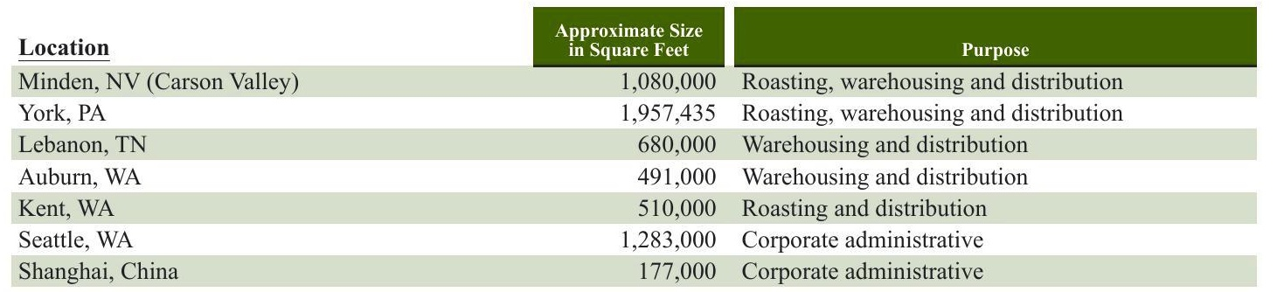

We own most of our roasting facilities and lease the majority of our warehousing and distribution locations. As of September 29, 2019, Starbucks had 15,834 company-operated stores, almost all of which are leased. We also lease space in various locations worldwide for regional, district and other administrative offices, training facilities and storage. In addition to the locations listed above, we hold inventory at various locations managed by third-party warehouses. Item 3. Legal Proceedings See Note 15, Commitments and Contingencies, to the consolidated financial statements included in Item 8 of Part II of this 10- K for information regarding certain legal proceedings in which we are involved Item 4. Mine Safety Disclosures Not applicable.

Starbucks Corporation 2019 Form 10-K17

Item 5. Market for the Registrant's Common Equity, Related Shareholder Matters and Issuer Purchases of Equity Securities SHAREHOLDER INFORMATION MARKETINFORMATION AND DIVIDEND POLICY Starbucks common stock is traded on NASDAQ, under the symbol "SBUX." As of November 8, 2019, we had approximately 18,000 shareholders of record. This does not include persons whose stock is in nominee or "street name" accounts through brokers. Future decisions to pay cash dividends continue to be at the discretion of the Board of Directors and will be dependent on our operating performance, financial condition, capital expenditure requirements and other factors that the Board of Directors considers relevant. ISSUER PURCHASES OFEQUITY SECURITIES The following table provides information regarding repurchases of our common stock during the quarter ended September 29, 2019:

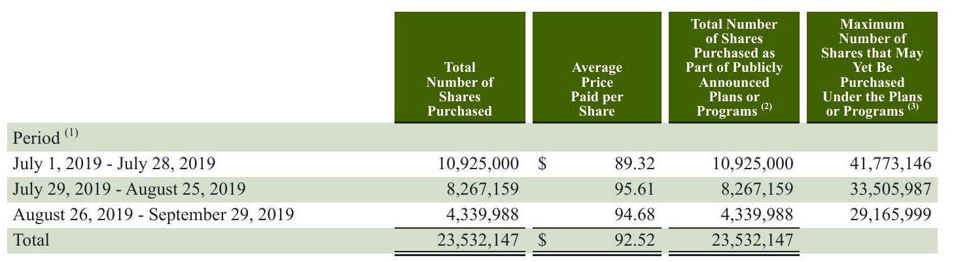

1 Monthly information is presented by reference to our fiscal months during the fourth quarter of fiscal 2019. (2) Share repurchases are conducted under our ongoing share repurchase program announced in September 2001, which has no expiration date. This column includes the total number of shares available for repurchase under the Company's ongoing share repurchase program. Shares under our ongoing share repurchase program may be repurchased in open market transactions, including pursuant to a trading plan adopted in accordance with Rule 10b5-1 of the Securities Exchange Act of 1934, or through privately negotiated transactions. The timing, manner, price and amount of repurchases will be determined at our discretion, and the share repurchase program may be suspended, terminated or modified at any time for any reason.

18Starbucks Corporation 2019 Form 10-K

18Starbucks Corporation 2019 Form 10-K

Performance Comparison Graph

The following graph depicts the total return to shareholders from September 28, 2014 through September 29, 2019, relative to the performance of the Standard & Poor's 500 Index, the NASDAQ Composite Index and the Standard & Poor's 500 Consumer Discretionary Sector, a peer group that includes Starbucks. All indices shown in the graph have been reset to a base of 100 as of September 28, 2014, and assume an investment of $100 on that date and the reinvestment of dividends paid since that date. The stock price performance shown in the graph is not necessarily indicative of future price performance

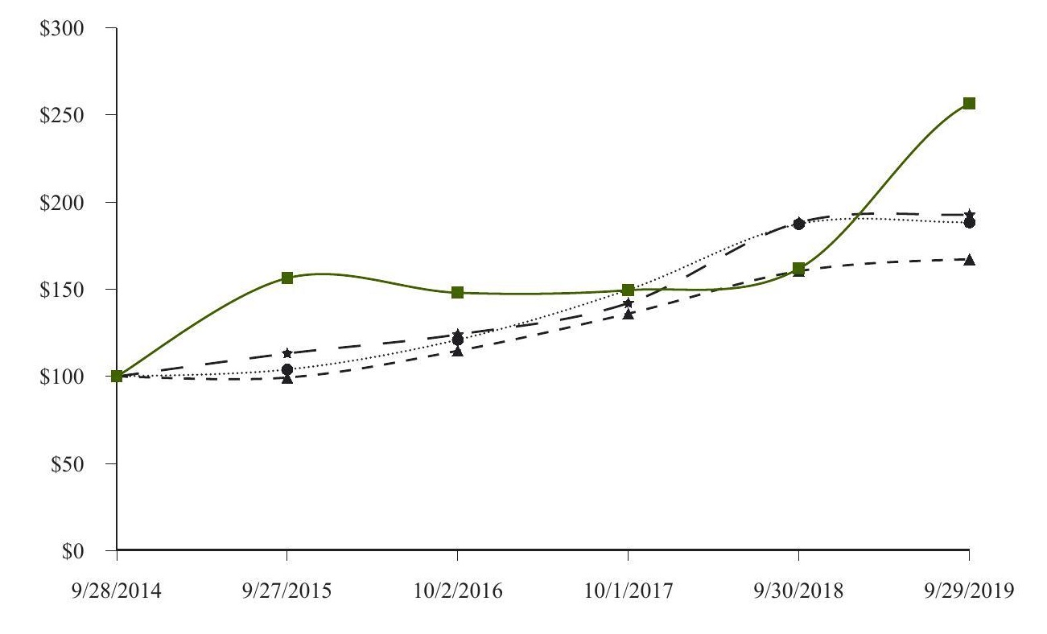

|  |  |  |  |  |  |  |  |  |  |  |  |  |
| --- | --- | --- | --- | --- | --- | --- | --- | --- | --- | --- | --- | --- |
|  | Sep 28,2014 | | Sep 27,2015 | | Oct 2,2016 | | Oct 1, 2017 | | Sep 30, 2018 | | Sep 29,2019 | |
| Starbucks Corporation | $ | 100.00 |  | 156.42 |  | 148.03$ |  | 149.49 | $ | 161.87 | $ | 256.48 |
| S&P 500 |  | 100.00 |  | 99.39 |  | 114.72 |  | 136.07 |  | 160.44 |  | 167.27 |
| NASDAQ Composite |  | 100.00 |  | 104.00 |  | 121.08 |  | 149.75 |  | 187.44 |  | 188.43 |
| S&P Consumer Discretionary |  | 100.00 |  | 113.18 |  | 124.09 |  | 142.10 |  | 188.34 |  | 192.78 |

Starbucks Corporation 2019 Form 10-K19

Item 6.Selected Financial Data The following selected financial data is derived from the consolidated financial statements. The data below should be read in conjunction withManagement's Discussion and Analysis of Financial Condition and Results of OperationsRisk Factors, and the consolidated financial statements and notes. Financial Information (in millions, except per share data):

|  |  |  |  |  |  |  |  |  |  |
| --- | --- | --- | --- | --- | --- | --- | --- | --- | --- |
| As of and for the Fiscal Year Ended (1) | Sept 29, 2019 (52 Wks) |  | 2018 (52 Wks) |  | Oct 1, 2017 (52 Wks) |  | 2016 (53 Wks) |  | 2015 52Wks) |
| Results of Operations |  |  |  |  |  |  |  |  |  |
| Net revenues: |  |  |  |  |  |  |  |  |  |
| Company-operated stores | $21,544.4 |  | $19,690.3 |  | $17,650.7 |  | $16,844.1 |  | $15,197.3 |
| Licensed stores |  | 2,875.0 | 2,652.2 |  | 2,355.0 |  | 2,154.2 |  | 1,861.9 |
| Other |  | 2,089.2 | 2,377.0 |  | 2,381.1 |  | 2,317.6 |  | 2,103.5 |
| Total net revenues |  | $ 26,508.6 | $2 24,719.5 |  | 22,386.8 |  | 21,315.9 |  | 19,162.7 |
| Operating income/(loss) | $ | 4,077.9 $ | 3,883.3 | $ | 4,134.7 | $ | 4,171.9 | $ | 3,601.0 |
| Net earnings including noncontrolling interests () |  | 3,594.6 | 4,518.0 |  | 2,884.9 |  | 2,818.9 |  | 2,759.3 |
| Net earnings/(loss) attributable to noncontrolling interests |  | (4.6) | (0.3) |  | 0.2 |  | 1.2 |  | 1.9 |
| Net earnings attributable to Starbucks (2) |  | 3,599.2 | 4,518.3 |  | 2,884.7 |  | 2,817.7 |  | 2,757.4 |
| EPS-diluted2 |  | 2.92 | 3.24 |  | 1.97 |  | 1.90 |  | 1.82 |
| Cash dividends declared per share |  | 1.49 | 1.32 |  | 1.05 |  | 0.85 |  | 0.68 |
| Net cash provided by operating activities 6) |  | 5,047.0 | 11,937.8 |  | 4,251.8 |  | 4,697.9 |  | 3,881.5 |
| Capital expenditures (additions to property, plant and equipment) |  | 1,806.6 | 1,976.4 |  | 1,519.4 |  | 1,440.3 |  | 1,303.7 |
| Balance Sheet |  |  |  |  |  |  |  |  |  |
| Total assets |  | $19,219.6 | $24,156.4$14,365.6 |  |  |  | $14,312.5$1 |  | 12,404.1 |
| Long-term debt (including current portion) |  | 11,167.0 | 9,440.1 |  | 3,932.6 |  | 3,585.2 |  | 2,335.3 |
| Shareholders' equity/(deficit) |  | (6,232.2) | 1,169.5 |  | 5,450.1 |  | 5,884.0 |  | 5,818.0 |

(1) Our fiscal year ends on the Sunday closest to September 30. The fiscal year ending on October 2, 2016 included 53 weeks, with the 53rd week falling in our fourth fiscal quarter. (2 Fiscal 2018 results include a gain not subject to income tax of $1.4 billion resulting from the acquisition of our East China joint venture. The impact of the gain to our diluted EPS was $0.99. (3) Net cash provided by operating activities for fiscal 2015 through fiscal 2017 has been adjusted for the adoption of new accounting guidance related to excess tax benefits as discussed in Note 1, Summary of Significant Accounting Policies.

20Starbucks Corporation 2019 Form 10-K

20Starbucks Corporation 2019 Form 10-K

Comparable Store Sales:

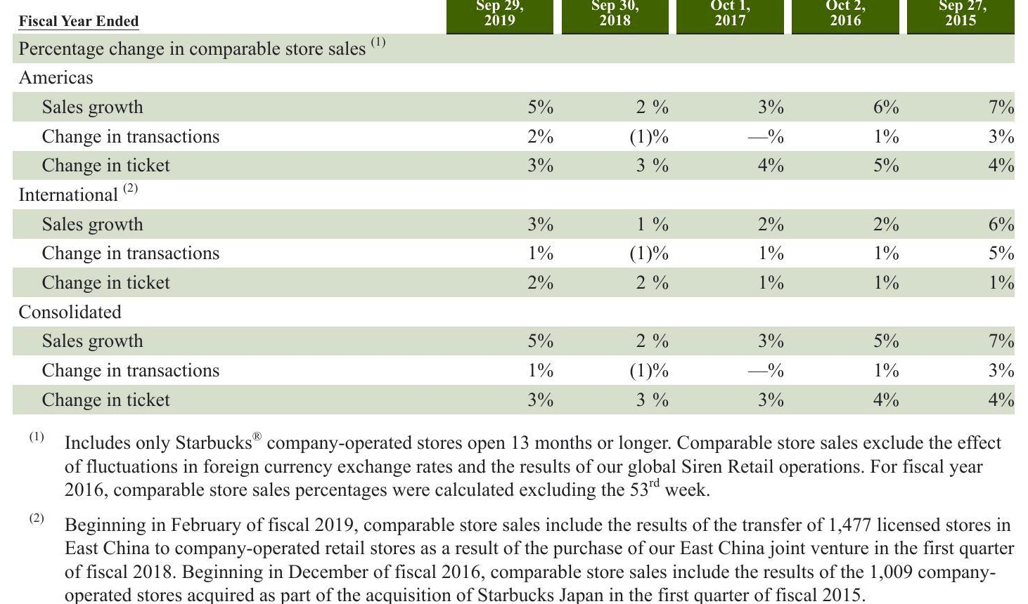

Starbucks Corporation 2019 Form 10-K21

Starbucks Corporation 2019 Form 10-K21

Starbucks Corporation 2019 Form 10-K21

Store Count Data:

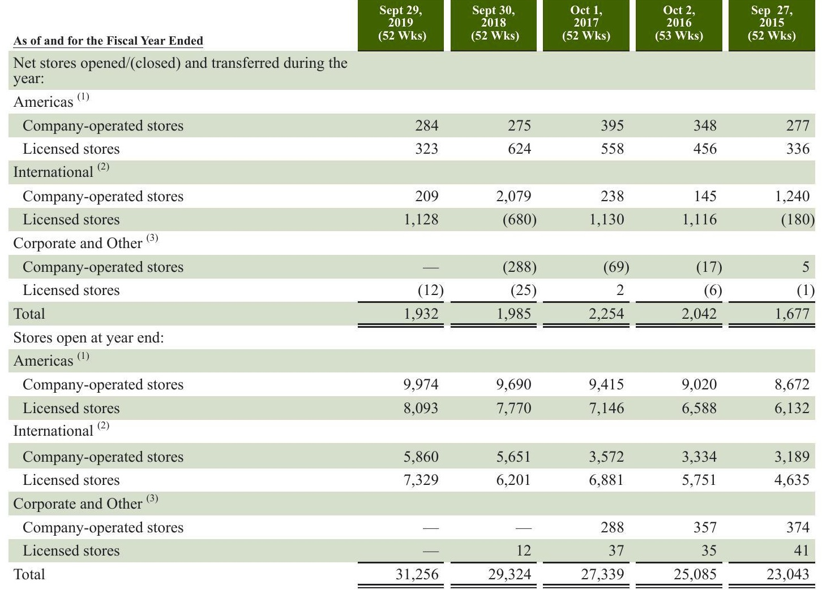

(1) Americas store data includes the transfer of 112 company-operated retail stores in Brazil to licensed stores as a result of the sale of our Brazil retail operations in the second quarter of fiscal 2018 and the closure of 132 Target Canada licensed stores in the second quarter of fiscal 2015. (2) International store data includes in fiscal 2019 the transfer of 82 company-operated stores in France and the Netherlands to licensed stores as a result of the sales of operations in the second quarter and the transfer of 377 company-operated stores in Thailand to licensed stores as a result of the sale of operations late in the third quarter. Additionally, store data includes the transfer of 1,477 licensed stores in East China to company-operated retail stores as a result of the purchase of our East China joint venture in the first quarter of fiscal 2018, the transfer of 133 Singapore stores from company- operated stores to licensed stores in fiscal 2017, the transfer of 144 Germany company-operated stores to licensed stores in fiscal 2016, and the transfer of 1,009 Japan stores from licensed stores to company-operated as a result of the acquisition of Starbucks Japan in fiscal 2015. (3) Corporate and Other store data includes the closure of 313 Teavana retail stores in fiscal 2018 and 12 Teavana retail stores in the first quarter of fiscal 2019.

22 Starbucks Corporation 2019 Form 10-K

2019 Form 10-K

Overview Starbucks results for fiscal 2019 reflect the impacts of continued streamlining efforts, initiated during the fourth quarter of fiscal 2017, to focus on accelerating growth in high-returning businesses and converting several market operations, including Thailand, France, and the Netherlands, to fully licensed models in fiscal 2019. Additionally, in fiscal 2019, we saw the full impact from the licensing of the majority of our CPG and Foodservice businesses to Nestle in the fourth quarter of fiscal 2018. In the fourth quarter of fiscal 2019, we realigned our operating segment reporting structure to better reflect the cumulative effect of our streamlining efforts. Specifically,our previous China/Asia Pacific ("CAP) segment and Europe, Middle East, and Africa ("EMEA") segment have been combined into one International segment. Results of Siren Retail, a non-reportable operating segment consisting of Starbucks ReserveTM Roastery & Tasting Rooms, certain stores under the Starbucks Reserve brand and Princi operations, which were previously included within Corporate and Other, are now reported within the Americas and International segments based on the geographical location of the operations. As a result, we have three reportable operating segments: Americas, International and Channel Development. Non-reportable operating segments and unallocated corporate expenses are reported within Corporate and Other. Further, to better support the review of our results, we have changed the classification of certain costs. The most significant change was the reclassification of company-owned store occupancy costs from cost of sales to store operating expenses. We also made certain other immaterial changes. Concurrent with the change in reportable segments and realignment of certain operating expenses noted above, we revised our prior period financial information to be consistent with the current period presentation. There was no impact on consolidated net revenues, total operating expenses, operating income, or net earnings per share as a result of these changes. In December 2017, the U.S. government enacted comprehensive tax legislation into law H.R. 1, commonly referred to as the Tax Cuts and Jobs Act (the "Tax Act), which significantly changed existing U.S. tax law and included numerous provisions that affect our business. Our U.S. corporate income tax rate for fiscal 2019 and future years is 21%, while a blended rate of 24.5% was applied in fiscal 2018.

# Financial Highlights

Total net revenues increased 7% to $26.5 billion in fiscal 2019 compared to $24.7 billion in fiscal 2018. Consolidated operating income increased to $4.1 billion in fiscal 2019 compared to operating income of $3.9 billion in fiscal 2018. Fiscal 2019 operating margin was 15.4% compared to 15.7% in fiscal 2018. Operating margin compression in fiscal 2019 was primarily driven by partner (employee) investments and growth in wages and benefits, licensing our CPG and Foodservice businesses to Nestle and other strategic investments. These decreases were partially offset by sales leverage, cost savings initiatives, lower restructuring and impairment costs and the impact of the adoption of new revenue recognition guidance on stored value card breakage. Earnings per share ("EPS) for fiscal 2019 decreased to $2.92, compared to EPS of $3.24 in fiscal 2018. The decrease Was primarily driven by lapping the prior year gains from the acquisition of our East China joint venture and the sale of our Tazo brand, partially offset by the gain from the sale of our Thailand retail operations during fiscal 2019. Capital expenditures were $1.8 billion in fiscal 2019 compared to $2.0 billion in fiscal 2018. We returned $12.0 billion to our shareholders in fiscal 2019 through share repurchases and dividends compared to $8.9 billion in fiscal 2018. Acquisitions and Divestitures See Note 2,Acquisitions, Divestitures and Strategic Alliance, to the consolidated financial statements included in Item 8 of Part II of this 10-K for information regarding acquisitions and divestitures.

Starbucks Corporation 2019 Form 10-K23

Starbucks Corporation 2019 Form 10-K23

RESULTSOF OPERATIONS-FISCAL2019COMPARED TO FISCAL2018 Consolidated results of operations (in millions):

|  |  |  |  |  |  |
| --- | --- | --- | --- | --- | --- |
| Fiscal Year Ended | Sep 29, 2019 | | Sep 30, 2018 | | % Change |
| Net revenues: |  |  |  |  |  |
| Company-operated stores | $ | 21,544.4$ |  | 19,690.3 | 9.4% |
| Licensed stores |  | 2,875.0 |  | 2,652.2 | 8.4 |
| Other |  | 2,089.2 |  | 2,377.0 | (12.1) |
| Total net revenues | $ | 26,508.6 | $ | 24,719.5 | 7.2% |

Total net revenues increased $1.8 billion, or 7%, over fiscal 2018, primarily driven by higher revenues from company-operated stores ($1.9 billion). The growth in company-operated store revenues was driven by incremental revenues from 947 net new Starbucks company-operated store openings over the past 12 months ($957 million) and a 5% increase in comparable store sales ($879 million), attributable to a 3% increase in average ticket and a 2% increase in comparable transactions. These increases were partially offset by unfavorable foreign currency translation ($189 million) and the conversion of our Thailand, France, and the Netherlands retail businesses to fully licensed markets during fiscal 2019 ($161 million). Licensed store revenue growth also contributed to the increase in total net revenues ($223 million), primarily due to higher product and equipment sales to and royalty revenues from our licensees ($228 million),largely due to the opening of 992 net new Starbucks licensed stores over the past 12 months, and the conversion of our Thailand, France, and the Netherlands retail businesses to fully licensed markets ($35 million), partially offset by unfavorable foreign currency translation ($41 million). Other revenues decreased $288 million, primarily driven by the licensing of our CPG and Foodservice businesses to Nestle. Partially offsetting this decrease was growth in product revenue, primarily premium single-serve products, in connection with the Global Coffee Alliance.

|  |  |  |  |  |  |  |
| --- | --- | --- | --- | --- | --- | --- |
| Fiscal Year Ended | Sep 29, 2019 | | Sep 30, 2018 | | Sep 30, 2018 | |
|  |  |  | | As a % of Total Net Revenues | |
| Cost of sales | $ | 8,526.9 $ | 7,930.7 | Sep 29, 2019 | | 32.1% |
| Store operating expenses |  | 10,493.6 | 9,472.2 | 32.2% 39.6 | | 38.3 |
| Other operating expenses |  | 371.0 | 554.9 | 1.4 | | 2.2 |
| Depreciation and amortization expenses |  | 1,377.3 | 1,247.0 | 5.2 | | 5.0 |
| General and administrative expenses |  | 1,824.1 | 1,708.2 | 6.9 | | 6.9 |
| Restructuring and impairments |  | 135.8 | 224.4 | 0.5 | | 0.9 |
| Total operating expenses |  | 22,728.7 | 21,137.4 | 85.7 | | 85.5 |
| Income from equity investees |  | 298.0 | 301.2 | 1.1 | | 1.2 |
| Operating income | $ | 4,077.9$ | 3,883.3 | 15.4% | | 15.7% |
| Store operating expenses as a % of related revenues |  |  |  | 48.7% | | 48.1% |

Store operating expenses as a percentage of total net revenues increased 130 basis points. Store operating expenses as a percentage of company-operated store revenues increased 60 basis points, primarily driven by investments in our store partners that are funded by savings from the Tax Act and growth in wages and benefits (approximately 120 basis points), largely in the Americas segment, partially offset by sales leverage driven by price increases and the impact of the adoption of new revenue recognition guidance on stored value card breakage.

24Starbucks Corporation 2019 Form 10-K

24Starbucks Corporation 2019 Form 10-K

Other operating expenses decreased $184 million, primarily due to cost savings related to licensing our CPG and Foodservice businesses to Nestle ($176 million) and lapping prior year costs associated with the establishment of the Global Coffee Alliance ($34 million), including business taxes associated with the up-front prepaid royalty from Nestle and headcount-related costs, primarily relating to employee bonus and retention costs. Depreciation and amortization expenses as a percentage of total net revenues increased 20 basis points, primarily due to the impact of our ownership change in East China (approximately 20 basis points). General and administrative expenses increased $116 million, primarily driven by higher performance-based compensation ($89 million) and the 2019 Starbucks Leadership Experience in Chicago, heavily concentrated in our fiscal fourth quarter ($52 million). Restructuring and impairment expenses decreased $89 million, primarily due to lower restructuring and impairment costs million), partially offset by higher exit costs associated with the closure of certain Starbucks" company-operated stores ($32 million) and severance costs ($25 million). Income from equity investees decreased $3 million, primarily due to the impact of our ownership changes in East China. This decrease was partially offset by improved comparable store sales from our joint venture in South Korea and higher income from our North American Coffee Partnership joint venture. The combination of these changes resulted in an overall decrease in operating margin of 30 basis points in fiscal 2019 when compared to fiscal 2018 Other Income and Expenses

Fiscal Year Ended

|  |  |  |  |  |  |
| --- | --- | --- | --- | --- | --- |
| Operating income |  | 4,077.9 $ |  | Net Revenues |  |
| Gain resulting from acquisition of joint | $ |  | 3,883.3 | 15.4% | 15.7% |
| venture Net gain resulting from divestiture of |  |  | 1,376.4 |  | 5.6 |
| certain operations Interest income and other, net |  | 622.8 | 499.2 | 2.3 | 2.0 |
| Interest expense |  | 96.5 | 191.4 | 0.4 | 0.8 |
| Earnings before income taxes |  | (331.0) | (170.3) | (1.2) | (0.7) |
|  |  | 4,466.2 871.6 | 5,780.0 1,262.0 | 16.8 | 23.4 |
| Income tax expense Net earnings including |  |  |  | 3.3 | 5.1 |
| noncontrolling interests Net earnings/(loss) attributable to |  | 3,594.6 | 4,518.0 | 13.6 | 18.3 |
| noncontrolling interests Net earnings attributable to |  | (4.6) | (0.3) |  |  |
| Starbucks Effective tax rate including | $ | 3,599.2 s | 4,518.3 | 13.6% | 18.3% |
| noncontrolling interests |  |  |  | 19.5 % | 21.8% |

Gain resulting from acquisition of joint venture in fiscal 2018 was due to remeasuring our preexisting 50% ownership interest in our East China joint venture to fair value upon acquisition. Net gain resulting from divestiture of certain operations was primarily due to the sale of our Thailand, France and the Netherlands retail operations in fiscal 2019. The gain in fiscal 2018 was primarily due to the sale of our Tazo brand and Taiwan joint venture, partially offset by the net loss from the sale of our Brazil retail operations in fiscal 2018. Interest income and other, net decreased $95 million, primarily due to the adoption of the new revenue recognition guidance on a prospective basis,which required estimated breakage on unredeemed store value cards to be recorded as revenue.We recorded store value card breakage in interest income and other, net in the prior year. Interest expense increased $161 million primarily due to additional interest incurred on long-term debt issued in November 2017, March 2018, August 2018 and May 2019.

2019 Form 10-K25

Starbucks Corporation

2019 Form 10-K25

The effective tax rate for fiscal 2019 was 19.5% compared to 21.8% for fiscal 2018. The decrease in the effective tax rate was primarily due to the lower corporate tax rate as a result of the Tax Act (approximately 350 basis points), lapping prior year's transition tax on our accumulated undistributed foreign earnings and remeasurement of our deferred tax liabilities (approximately 300 basis points), higher stock-based compensation excess tax benefit (approximately 140 basis points), the release of income tax reserves related to the settlement of a U.S. tax examination and the expiration of statute of limitations (approximately 130 basis points) and the tax impacts of the gain on the sale of our Thailand retail operations (approximately 130 basis points). These favorable impacts were partially offset by the lapping of prior year's gain on the purchase of our East China joint venture that was not subject to income tax (approximately 580 basis points) and the impact of changes in indefinite reinvestment assertions for certain foreign subsidiaries during the first quarter of fiscal 2019 (approximately 170 basis points). See Note 13, Income Taxes, for further discussion

26Starbucks Corporation2019 Form 10-K

26Starbucks Corporation2019 Form 10-K

# UNITED STATES SECURITIES AND EXCHANGE COMMISSION

Common Stock, $0.001 par value per share

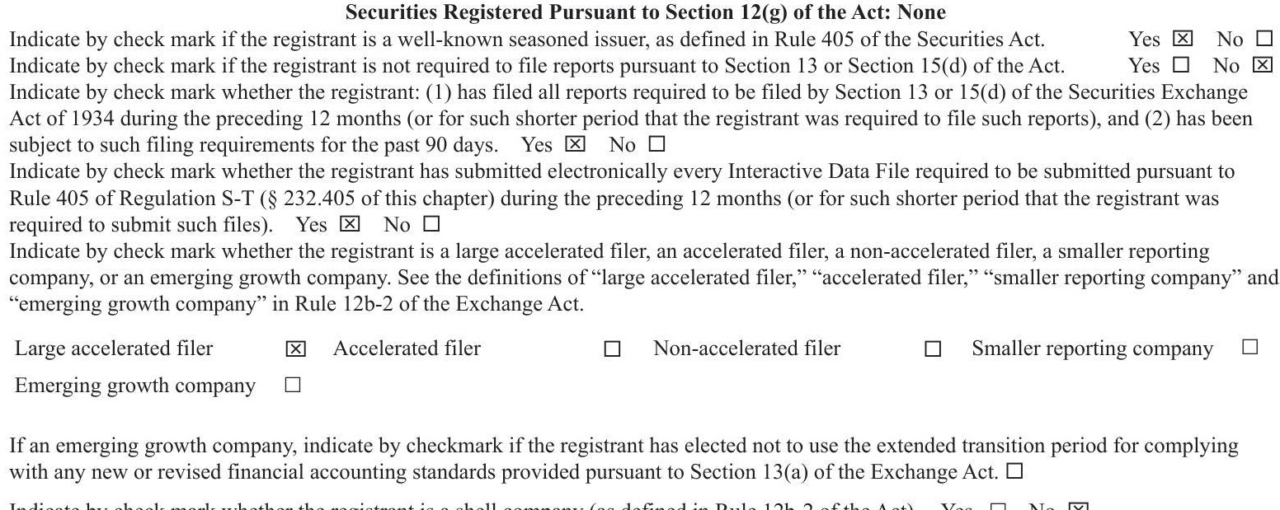

The aggregate market value of the voting stock held by non-affiliates of the registrant as of the last business day of the registrant's most recently completed second fiscal quarter, based upon the closing sale price of the registrant's common stock on March 31, 2019 as reported on the NASDAQ Global Select Market was $89.8 billion. As of November 8, 2019, there were 1,181.0 million shares of the registrant's Common Stock outstanding. DOCUMENTS INCORPORATED BY REFERENCE Portions of the definitive Proxy Statement for the registrant's Annual Meeting of Shareholders to be held on March 18, 2020 have been incorporated by reference into Part III of this Annual Report on Form 10-K

Segment Information Results of operations by segment (in millions): Americas

|  |  |  |  |  |  |
| --- | --- | --- | --- | --- | --- |
| Fiscal Year Ended | Sep 29, 2019 | Sep 30, 2018 |  |  | Sep 30, 2018 |
|  |  | Sep 29, 2019 | As a % of Americas Total Net Revenues | |
| Net revenues: |  |  | $ |  |  |
| Company-operated stores | $ | 16,288.2 | 14,921.5 | 89.2 % | 89.1% |
| Licensed stores |  | 1,958.0 | 1,814.0 | 10.7 | 10.8 |
| Other |  | 12.8 | 13.1 | 0.1 | 0.1 |
| Total net revenues |  | 18,259.0 | 16,748.6 | 100.0 | 100.0 |
| Cost of sales |  | 5,174.7 | 4,884.1 | 28.3 | 29.2 |
| Store operating expenses |  | 8,064.8 | 7,248.6 | 44.2 | 43.3 |
| Other operating expenses |  | 159.8 | 151.2 | 0.9 | 0.9 |
| Depreciation and amortization expenses |  | 696.1 | 641.0 | 3.8 | 3.8 |
| General and administrative expenses |  | 323.9 | 305.1 | 1.8 | 1.8 |
| Restructuring and impairments |  | 56.9 | 33.4 | 0.3 | 0.2 |
| Total operating expenses |  | 14,476.2 | 13,263.4 3,485.2 | 79.3 | 79.2 |
| Operating income | $ | 3,782.8 | $ | 20.7% | 20.8% |

Americas total net revenues for fiscal 2019 increased $1.5 billion, or 9%, primarily driven by a 5% increase in comparable store sales ($744 million) and 282 net new Starbucks company-operated stores, or a 3% increase, over the past 12 months ($580 million). Also contributing were higher product sales to and royalty revenues from our licensees ($144 million), primarily resulting from comparable store sales growth and the opening of 323 net new Starbucks@ licensed stores, or 4% increase, over the past 12 months and the impact of the adoption of revenue recognition guidance on stored value card breakage ($119 million.

Americas operating income for fiscal 2019 increased 9% to $3.8 billion, compared to $3.5 billion in fiscal 2018. Operating margin decreased 10 basis points to 20.7%, primarily driven by higher partner investments, largely funded by savings from the Tax Act, growth in wages and benefits (approximately 130 basis points) and to a much lesser extent, investments in labor hours heavily concentrated in our fiscal fourth quarter. Partially offsetting these were cost savings initiatives, primarily in cost of sales (approximately 90 basis points), the impact of the adoption of revenue recognition guidance on stored value card breakage (approximately 50 basis points) and sales leverage

Starbucks Corporation 2019 Form 10-K27

Starbucks Corporation 2019 Form 10-K27

Starbucks Corporation 2019 Form 10-K27

Sep 2g, Sep 29, Sep 30, As a % of International

|  |  |  |  |  |  |
| --- | --- | --- | --- | --- | --- |
| Net revenues: | | | | | |
|  | s | 5,256.2$ | 4,702.1 | Total Net Revenues | 84.7% |
| Company-operated stores |  |  |  | 84.9% |  |
| Licensed stores |  | 917.0 | 837.0 | 14.8 | 15.1 |
| Other |  | 17.5 | 12.1 | 0.3 | 0.2 |
| Total net revenues |  | 6,190.7 | 5,551.2 | 100.0 | 100.0 |
| Cost of sales |  | 1,894.9 | 1,709.4 | 30.6 | 30.8 |
| Store operating expenses |  | 2,428.5 | 2,182.3 | 39.2 | 39.3 |
| Other operating expenses |  | 116.4 | 98.9 | 1.9 | 1.8 |
| Depreciation and amortization expenses |  | 511.5 | 447.6 | 8.3 | 8.1 |
| General and administrative expenses |  | 317.9 | 302.5 | 5.1 | 5.4 |
| Restructuring and impairments |  | 59.2 | 55.1 | 1.0 | 1.0 |
| Total operating expenses |  | 5,328.4 | 4,795.8 | 86.1 | 86.4 |
| Income from equity investees |  | 102.4 | 117.4 | 1.7 | 2.1 |
| Operating income | $ | 964.7 $ | 872.8 | 15.6% | 15.7% |

Discussion of our International segment results below reflects the impact of fully consolidating our East China business from an equity method joint venture to a company-operated market since the acquisition date of December 31, 2017. Under the joint venture model, we recognized royalties and product sales within revenue and related product cost of sales as well as our proportionate share of East China's net earnings, which resulted in a higher margin business. Under the company-operated ownership model, East China's operating results are reflected in most income statement lines of this segment

International total net revenues for fiscal 2019 increased $640 million, or 12%, primarily driven by 665 net new Starbucks company-operated stores, or a 12% increase, over the past 12 months ($377 million), the ownership change in East China ($280 million) and a 3% increase in comparable store sales ($135 million).Also contributing were increased product sales to and royalty revenues from licensees ($84 million), primarily resulting from opening of 669 net new Starbuckslicensed stores, or an 11% increase, over the past 12 months and the impact of the adoption of revenue recognition guidance on stored value card breakage ($20 million).These increases were partially offset by unfavorable foreign currency translation ($183 million) and the conversion of our Thailand, France, and the Netherlands retail businesses to fully licensed markets ($126 million).

# Operating Margin

International operating income for fiscal 2019 increased 11% to $965 million, compared to $873 million in fiscal 2018 Operating margin decreased 10 basis points to 15.6%, primarily driven by strategic investments to support growth in China (approximately 80 basis points) and growth in wages and benefits (approximately 70 basis points), primarily offset by cost savings initiatives (approximately 80 basis points) and labor efficiencies (approximately 70 basis points).

28Starbucks Corporation2019 Form 10-K

28Starbucks Corporation2019 Form 10-K

パナソニックグループについて グループCEO&CFOメッセージ セグメント別戦略

人事戦略

サプライチェーンにおける人権の尊重 詳細はサズテナビリティデ タブック2024「責任ある調達活動の章（P105)をご覧ください。

当社グル- プは 当社製品の製造に用し る部品 材料を世界中約1 13,000社の購入先様から調達し ており、 購入先様と協働し て持続可能なサプ ンの構築を進め ています 当社ブル プは 人権や環境への配慮、 良好な労働環境、 公正な取引等、 社会的責任を果たされてい る購入先様と取引を行うよう努めています。

# 推進体制

サプライチェ `における人 権の尊重の取り組みに ついては、 Iパナソニックグル プ人権・労働方針のもと 各事業会社が責任ある調達活動の実践主体とし てPＤＣＡサイクルを回し てい ます。 ナ ツク オペレ - シミ ナル工クセレンス 株) ブロ バル調達本部は 購入先様に対するアセスメントの要請や監査など全社施策の立 案と各事業会社に おけ る推進を支援す る役割を担- てい ます。

# サプライチェーンのデュー・ディリジェンス

当社グルー プは、 国連の 「ビジネスと人権に関す る指導原則 をはじぬと た国際的な規範 原則を支持し「パ ナソニックグルー コンプライアンス行動基準および ノニックブル プ人権 労働方針へ への賛同を購 入先様に要請するとともに、 CSR調達に関する購入先様へ の要請事項をまとめた サブライチエ ソCSR推進ガイ ライ イン小(以下 CSRガ イドライン を交付して その順守を契約書等で購入先様に義務付けて います 既存の購入先様からは CSRガイ ライン順守の同意書提出を お願い ています また CSRガイドラ インの要求事項を 次以降の購入先様に対し ても伝達し その順守状況を確認するよう要請し ています。詳細は、 本ページの末尾にある TWEB 調達活動 購入先様 のお願 山をご覧ください。 そして 購入先様には 定期的にCSR自主 フセスメントの実施を要請し ています その結果 移民労働者の 労働環境等の課題が見 つかった 場合には 是正に向け た働きかけを行っ また 2022年度より 外部の専門家の知見を得ながら 国際機関の公表している リスク指標やインデックスを用い で購人先様の人権リス多を評価するう 優先的二村応すべき

購入先様を特定しています。 2023年度には、 のリスクアプロ チの手法により 白社または第 三者機関によ る購入先監査を合計 で141社(ら ち16社は第三者機関による監査)に対して実施 右表の例のように、 しました。 購入先監査におい て指摘した事項については購入先様に改善を依 頼し、改善状況について確認を行っています。

32 統合報告書2024

パナソニックHDの役割

企業データ

コーホレート・ガリキンス

人事戦略 環境 技術動略

Pxt Parasoric. Transformation? o取り組み ブランド戦略 コンプライア・ズの取リ組み

当社グループは、 紛争地域で武装勢力の資金源となるリスク および高リスク地域での人権侵害 採掘現場 における児童労働、 劣悪な労働環境、 環境破壊、 汚職等のリスクに関連す タンタル る錫 タングステン 金、 - バルト、 ン全体で責任ある鉱物調達を行つ マイ力等O鉱物エつしで でいます 責任ある鉱物 イニシアティフ Ｒお上皇の責任ある転物調達検討会に参画し RI 川の発行する業界標準の調査帳票 (CIMIRT .EMRT)を3,OOO社以 上の購入先様に依頼し その約93％から回収し ています。 当社サプライチェ `上で紛争や人権侵害に加担する鉱物が見つかった場合には、 不使用化に向けた取り組みをお願) するとともに 業界活動などを通じて製錬 精錬所に責任ある鉱物保証 ロセス (RMAP） への参加の働きかけを行つ ています。

# 社内教育と社外での啓発活動

調達部門の社員に対して サプライチェーンにおける人権 労働 安全衛生等 CSR調達の基本事項に関す る研修を定期的に実施しています。 昨年度は購入先監査を担う また 監査員を養成す るための研修を国内外で 合計11回実施し 合計 152名を購 先監査員とし で育式 ました。 ま亡 マレ シア 国連開発計画 (UNDP) と連携した人権デュー ・ディリジェンス研修を6回開催し 在マレ ーシアの購入先様約500社のうち特に取引 金額の多い購入先様207社、 228名に受講し ただきました。

# 通報・相談窓口

「グロ一パルホットラインEARS] を設置し 当社グル プの社員および購入先様が、 当社の違反行為に対して 匿名で通報できるようにし てし ます また サプライチェ ンにおい て人権対す る負の影響が発生し た場合 ほ 購入先様またはその従業員の方が利用 できる窓 1とし で ラットフォ JaCER. に参加し ています。 これらの通報窓口は 購入先様向けのポ タルサ イトおよび当社Webサイト 「購入先様へ のお願いにて購入先様へ への周知を行っています 通報窓口にて受領した購入先様における人権課題については、 第三者機関を通じて監査を実施し、購入先様 による是正の見届けを行いました。

|  |
| --- |
| 分野 事例 |
| 勤務時間・休み時間・残業時間の履歴が 労働 適切に管理されていなし |
| 女性に配慮したプライバシーを保てる休 人権 憩室が整備されていない |
| 安全衛生 - 有事の際の避難経路が不明確 |

|  |
| --- |
| https / / holdings. panasonici] ip/corporate! I about Iprocurement for - suppliers. htm! |
| WEBグローバルホツ トライン http. I Ipanasonic.ethicspoint . Com |
| WEB ビジネスと人権対話救済機構 JaCER) の苦情処理メカニズム httpsy/ Fiacer-bhr .orgyindex. htm! |

Corporate and Other

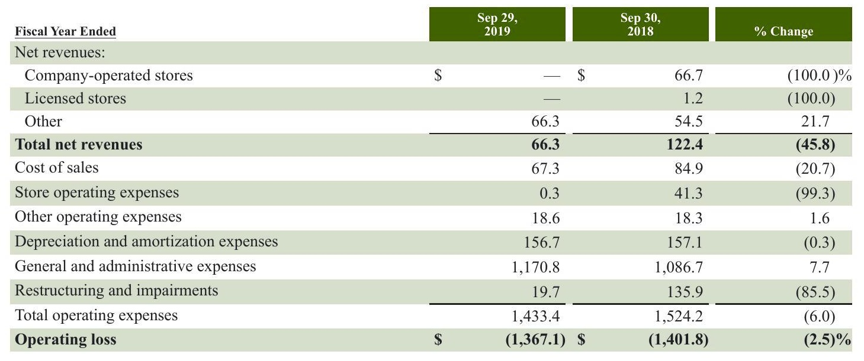

Corporate and Other primarily consists of our unallocated corporate expenses, as well as Evolution Fresh and the legacy operations of the Teavana retail business,which substantially ceased during fiscal 2018.Unallocated corporate expenses include corporate administrative functions that support the operating segments but are not specifically attributable to or managed by any segment and are not included in the reported financial results of the operating segments.

RESULTS OF OPERATIONS -- FISCAL 2018 COMPARED TO FISCAL 2017 Consolidated results of operations (in millions):

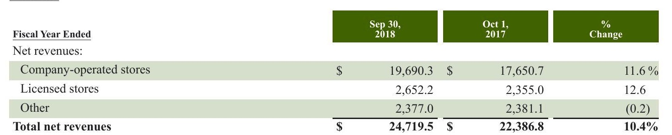

Total net revenues increased $2.3 billion, or 10%, over fiscal 2017, primarily driven by increased revenues from company- operated stores ($2.0 billion). The growth in company-operated store revenues was driven by incremental revenues from 816 net new Starbucks company-operated store openings over the past 12 months ($904 million), incremental revenues from the impact of our ownership change in East China ($903 million) and a 2% increase in comparable store sales ($345 million), attributable to a 3% increase in average ticket.

Licensed store revenue growth also contributed to the increase in total net revenues ($297 million),primarily due to increased product and equipment sales to and royalty revenues from our licensees ($298 million),largely due to the opening of 1,181 net new Starbucks@ licensed stores over the past 12 months and the conversions of both the Singapore and Taiwan markets to fully licensed in the fourth quarter of fiscal 2017 and the first quarter of fiscal 2018, respectively ($44 million). These increases were partially offset by the impact of our ownership change in East China at the end of the first quarter of fiscal 2018 ($53 million). Other revenues decreased $4 million, primarily driven by the absence of revenue due to the sale of our Tazo brand in the first quarter of fiscal 2018 ($56 million), the closure of our e-commerce business in the fourth quarter of fiscal 2017 ($51 million) and licensing our CPG and Foodservice businesses to Nestle late in the fourth quarter of fiscal 2018 ($50 million). Partially offsetting these decreases were increased sales of packaged coffee and premium single-serve products ($115 million).

2019 Form 10-K

30Starbucks Corporation

2019 Form 10-K

|  |  |  |  |  |  |
| --- | --- | --- | --- | --- | --- |
| Cost of sales | $ | 7,930.7$ | 7,065.8 | Net Revenues 32.1% |  |
| Store operating expenses |  | 9,472.2 | 8,486.4 | 38.3 | 31.6% 37.9 |
| Other operating expenses |  | 554.9 | 518.0 | 2.2 | 2.3 |
| Depreciation and amortization expenses |  | 1,247.0 | 1,011.4 | 5.0 | 4.5 |
| General and administrative expenses |  | 1,708.2 | 1,408.4 | 6.9 | 6.3 |
| Restructuring and impairments |  | 224.4 | 153.5 | 0.9 | 0.7 |
| Total operating expenses |  | 21,137.4 | 18,643.5 | 85.5 | 83.3 |
| Income from equity investees |  | 301.2 | 391.4 | 1.2 | 1.7 |
| Operating income | $ | 3,883.3 $ | 4,134.7 | 15.7% | 18.5% |
| Store operating expenses as a % of related revenues |  |  |  | 48.1% | 48.1% |

Cost of sales as a percentage of total net revenues increased 50 basis points, primarily due to food and beverage-related mix shifts (approximately 120 basis points), largely in the Americas segment, partially offset by the impact of our ownership change in East China (approximately 40 basis points). Store operating expenses, which include occupancy costs, as a percentage of total net revenues increased 40 basis points. Store operating expenses as a percentage of company-operated store revenues were flat, primarily driven by the impact of our ownership change in East China (approximately 40 basis points), partially offset by increased partner investments, largely in the Americas segment. Other operating expenses increased $37 million, primarily driven by business taxes associated with the up-front payment received from Nestle. Depreciation and amortization expenses as a percentage of total net revenues increased 50 basis points, primarily due to the impact of our ownership change in East China (approximately 60 basis points) General and administrative expenses increased $300 million, primarily due to higher salaries and benefits related to digital platforms, technology infrastructure and innovations and the 2018 U.S. stock award granted in the third quarter of fiscal 2018, which was funded by savings from the Tax Act and vests over one year. Restructuring and impairment expenses increased $71 million, primarily due to higher asset impairments associated with the decision to close certain company-operated stores in the U.S. and Canada ($23 million), higher goodwill impairment charges associated with our Switzerland company-operated retail reporting unit ($20 million) and International restructuring costs, including severance and asset impairments ($18 million). Income from equity investees decreased $90 million, primarily due to the impact of ownership changes in our East China and Taiwan joint ventures, partially offset by higher South Korea joint venture income. The combination of these changes resulted in an overall decrease in operating margin of 280 basis points in fiscal 2018 when compared to fiscal 2017.

Starbucks Corporation 2019 Form 10-K31

Starbucks Corporation 2019 Form 10-K31

Starbucks Corporation 2019 Form 10-K31

Other Income and Expenses

|  |  |  |  |  |  |  |  |
| --- | --- | --- | --- | --- | --- | --- | --- |
| Fiscal Year Ended | Sep 30, 2018 | | Oct 1, 2017 | | Sep 30, 2018 | Oct 1, 2017 | |
|  |  | |  | | As a % of Total Net Revenues. | |
| Operating income | $ | 3,883.3 $ | | 4,134.7 | | 15.7% 5.6 | |
| Gain resulting from acquisition of joint venture |  | 1,376.4 | |  | | 18.5% | |
| Net gain resulting from divestiture of certain operations |  | 499.2 | | 93.5 | | 2.0 0.4 | |
| Interest income and other, net |  | 191.4 | | 181.8 | | 0.8 0.8 | |
| Interest expense |  | (170.3) | | (92.5) | | (0.4) | |
| Earnings before income taxes |  | 5,780.0 | | 4,317.5 | |  | |
| Income tax expense Net earnings including | 1,262.0 | | 1,432.6 | | (0.7) 23.4 5.1 | | 19.3 6.4 |
| noncontrolling interests | 4,518.0 | | 2,884.9 | | 18.3 | | 12.9 |
| Net earnings attributable to noncontrolling interests |  | | 0.2 2,884.7 | | 18.3% 21.8% | | 12.9% |
| Net earnings attributable to Starbucks Effective tax rate including | $ | (0.3) 4,518.3 $ | |  | |  | |
| noncontrolling interests Gain resulting from acquisition of joint venture was due to remeasuring our preexisting 50% ownership interest in our East |  |  | |  | | 33.2% | |
| China joint venture to fair value upon acquisition. Net gain resulting from divestiture of certain operations primarily consisted of sales of our Tazo brand and Taiwan joint | | | | | | | |
| venture, partially offset by the net loss from the sale of our Brazil retail operations in fiscal 2018. The gain in fiscal 2017 was primarily due to the sale of our Singapore retail operations. Interest income and other, net increased $10 million, primarily due to recognizing higher income on unredeemed stored value | | | | | | | |
| card balances, partially offset by the lapping of prior year's gain on the sale of our investment in Square, Inc. warrants in the prior year period. | | | | | | | |
| Interest expense increased $78 million primarily related to additional interest incurred on long-term debt issued in November 2017, March 2018 and August 2018. | | | | | | | |
| The effective tax rate for fiscal 2018 was 21.8% compared to 33.2% for fiscal 2017. The decrease in the effective tax rate was primarily due to the gain on the purchase of our East China joint venture that was not subject to income tax (approximately 580 basis points) and the Tax Act (approximately 480 basis points). The impact from the Tax Act primarily included favorability from the lower corporate income tax rate applied to our fiscal 2018 results (approximately 760 basis points) and the remeasurement of our net deferred tax liabilities (approximately 130 basis points). This favorability was partially offset by the estimated transition tax on our accumulated undistributed foreign earnings (approximately 400 basis points). See Note 13, | | | | | | | |

32Starbucks Corporation 2019 Form 10-K

32Starbucks Corporation 2019 Form 10-K

Segment Information Results of operations by segment (in millions): Americas

|  |  |  |  |  |  |
| --- | --- | --- | --- | --- | --- |
| Fiscal Year Ended | Sep 30, 2018 | | Sep 30, 2018 | Oct 1, 2017 | |
|  | Oct1, 2017 |  |  | As a % of Americas Total Net Revenues | |
| Net revenues: | $ |  |  |  |  |
| Company-operated stores |  | 14,921.5$ | 14,005.8 | 89.1% | 89.6% |
| Licensed stores |  | 1,814.0 | 1,617.3 | 10.8 | 10.4 |
| Other |  | 13.1 | 6.3 | 0.1 |  |
| Total net revenues |  | 16,748.6 | 15,629.4 | 100.0 | 100.0 |
| Cost of sales |  | 4,884.1 | 4,371.0 | 29.2 | 28.0 |
| Store operating expenses |  | 7,248.6 | 6,673.1 | 43.3 | 42.7 |
| Other operating expenses |  | 151.2 | 131.6 | 0.9 | 0.8 |
| Depreciation and amortization expenses |  | 641.0 | 616.1 | 3.8 | 3.9 |
| General and administrative expenses |  | 305.1 | 256.3 | 1.8 | 1.6 |
| Restructuring and impairments |  | 33.4 | 4.1 | 0.2 |  |
| Total operating expenses |  | 13,263.4 | 12,052.2 | 79.2 | 77.1 |
| Operating income | $ | 3,485.2$ | 3,577.2 | 20.8% | 22.9% |

Americas total net revenues for fiscal 2018 increased $1.1 billion, or 7%, primarily driven by 383 net new Starbucks company-operated store openings,or a 4.1% increase,over the past 12 months ($604 million) and a 2% increase in comparable store sales ($319 million). Also contributing were higher product sales to and royalty revenues from our licensees ($173 million), primarily resulting from the opening of 512 net new Starbucks@ licensed stores, or a 7.2% increase, over the past 12 months. Operating Income

Americas operating income for fiscal 2018 decreased 3% to $3.5 billion, compared to $3.6 billion in fiscal 2017. Operating margin decreased 210 basis points to 20.8%, primarily due to food and beverage-related mix shifts (approximately 130 basis points), increased partner investments (approximately 120 basis points) which included incremental investments funded by the Tax Act, increased strategic investments (approximately 30 basis points), the impact of the May 29th anti-bias training (approximately 20 basis points) and higher restructuring costs, including asset impairments and severance (approximately 20 basis points), partially offset by sales leverage.

Starbucks Corporation 2019 Form 10-K33

Starbucks Corporation 2019 Form 10-K33

Starbucks Corporation 2019 Form 10-K33

Starbucks Corporation 2019 Form 10-K33

International

Sep 30, Sep 30,

|  |  |  |  |  |  |
| --- | --- | --- | --- | --- | --- |
| Net revenues: | | | | | |
| Company-operated stores | $ | 4,702.1$ |  |  |  |
| Licensed stores |  | 837.0 | 3,462.5 | 84.7% 15.1 | 82.4 % 17.5 |
| Other |  | 12.1 | 735.0 6.8 | 0.2 | 0.2 |
| Total net revenues |  | 5,551.2 | 4,204.3 | 100.0 | 100.0 |
| Cost of sales |  | 1,709.4 | 1,324.2 | 30.8 | 31.5 |
| Store operating expenses |  | 2,182.3 | 1,664.8 | 39.3 | 39.6 |
| Other operating expenses |  | 98.9 | 89.2 | 1.8 | 2.1 |
| Depreciation and amortization expenses |  | 447.6 | 233.2 | 8.1 | 5.5 |
| General and administrative expenses |  | 302.5 | 236.4 | 5.4 | 5.6 |
| Restructuring and impairments |  | 55.1 | 17.9 | 1.0 | 0.4 |
| Total operating expenses |  | 4,795.8 | 3,565.7 | 86.4 | 84.8 |
| Income from equity investees |  | 117.4 | 197.0 | 2.1 | 4.7 |
| Operating income | $ | 872.8 $ | 835.6 | 15.7% | 19.9% |

Discussion of our International segment results below reflects the impact of fully consolidating our East China business from an equity method joint venture to a company-operated market since the acquisition date of December 31, 2017. Under the joint venture model, we recognized royalties and product sales within revenue and related product cost of sales as well as our proportionate share of East China's net earnings, which resulted in a higher margin business. Under a company-operated ownership model, East China's operating results are reflected in most line items on the statements of earnings. Revenues

International total net revenues for fiscal 2018 increased $1.3 billion, or 32%, primarily driven by the impact of our ownership change in East China ($850 million), 433 net new Starbucks company-operated store openings, or a 12.1% increase, over the past 12 months ($298 million), and favorable foreign currency translation ($121 million).Also contributing were higher product sales to and royalty revenues from our licensees ($100 million), primarily resulting from the opening of 669 net new Starbucks licensed stores, or a 13.6% increase, over the past 12 months and the conversion of our Taiwan joint venture to fully licensed operations at the end of the first quarter of fiscal 2018 ($25 million).

International operating income for fiscal 2018 increased 4% to $872.8 million, compared to $835.6 million in fiscal 2017. Operating margin decreased 420 basis points to 15.7%, primarily due to the impact of our ownership change in East China (approximately 350 basis points). Also contributing were higher goodwill impairment charges associated with our Switzerland retail reporting unit (approximately 40 basis points) and restructuring costs, including severance and asset impairments (approximately 40 basis points).

34Starbucks Corporation2019 Form 10-K

34Starbucks Corporation2019 Form 10-K

|  |  |  |  |  |  |
| --- | --- | --- | --- | --- | --- |
| Fiscal Year Ended | Sep 30, 2018 | | Oct 1, 2017 | Sep 30, 2018 | Oct 1, 2017 |
|  |  |  |  | As a % of Channel Development Total Net Revenues | |
| Total net revenues | $ | 2,297.3$ | 2,256.6 |  |  |
| Cost of sales |  | 1,252.3 | 1,209.3 | 54.5 | 53.6 |
| Other operating expenses |  | 286.5 | 260.4 | 12.5 | 11.5 |
| Depreciation and amortization expenses |  | 1.3 | 3.0 | 0.1 | 0.1 |
| General and administrative expenses |  | 13.9 | 11.3 | 0.6 | 0.5 |
| Total operating expenses |  | 1,554.0 | 1,484.0 | 67.6 | 65.8 |
| Income from equity investees |  | 183.8 | 194.4 | 8.0 | 8.6 |
| Operating income | $ | 927.1 s | 967.0 | 40.4% | 42.9% |

Discussion of our Channel Development segment results reflects the impact of the licensing of our CPG and Foodservice businesses to Nestle and the sale of the Tazo brand. Late in the fourth quarter of fiscal 2018, we licensed our CPG (Starbucks-, Starbucks Reserve-, Teavana-, Seattle's Best Coffee-, Starbucks VIA- and Torrefazione Italia-branded packaged coffee and tea and Foodservice businesses to Nestle and formed the Global Coffee Alliance. Eleven months of fiscal 2018 results reflect our CPG and Foodservice businesses as company-owned and one month as licensed operations. Our collaborative business relationships for our global ready-to-drink products and the associated revenues remain unchanged due to the Global Coffee Alliance.

Channel Development net revenues for fiscal 2018 increased $41 million, or 2%, over fiscal 2017.Revenue growth was driven by an increase in sales of our packaged coffee and premium single-serve products ($115 million), lapping a prior year revenue deduction adjustment ($13 million) and favorable foreign currency translation ($10 million). These increases were partially offset by the absence of revenue from the sale of our Tazo brand in the first quarter of fiscal 2018 ($56 million) and licensing our CPG and Foodservice businesses to Nestle late in the fourth quarter of fiscal 2018 ($50 million). Operating Margin Channel Development operating income for fiscal 2018 decreased 4% to $927.1 million, compared to $967.0 million in fiscal 2017. Operating margin decreased 250 basis points to 40.4%, primarily driven by business taxes associated with the up-front payment received from Nestle (approximately 120 basis points), Global Coffee Alliance headcount-related costs, including employee bonus and retention costs (approximately 80 basis points), and the impact of our ownership changes, including licensing our CPG and Foodservice businesses to Nestle and the sale of our Tazo brand.

Starbucks Corporation 2019 Form 10-K35

Starbucks Corporation 2019 Form 10-K35

Starbucks Corporation 2019 Form 10-K35

Corporate and Other

%

|  |  |  |  |  |
| --- | --- | --- | --- | --- |
| Net revenues: |  | 66.7 $ | 182.4 | (63.4)% |
| Company-operated stores | $ |  |  |  |
| Licensed stores |  | 1.2 | 2.7 | (55.6) |
| Other |  | 54.5 | 111.4 | (51.1) |
| Total net revenues |  | 122.4 | 296.5 | (58.7) |
| Cost of sales |  | 84.9 | 161.3 | (47.4) |
| Store operating expenses |  | 41.3 | 148.5 | (72.2) |
| Other operating expenses |  | 18.3 | 36.8 | (50.3) |
| Depreciation and amortization expenses |  | 157.1 | 159.1 | (1.3) |
| General and administrative expenses |  | 1,086.7 | 904.4 | 20.2 |
| Restructuring and impairments |  | 135.9 | 131.5 | 3.3 |
| Total operating expenses |  | 1,524.2 | 1,541.6 | (1.1) |
| Operating loss | $ | (1,401.8) $ | (1,245.1) | 12.6 % |

Corporate and Other primarily consists of our unallocated corporate expenses, as well as Evolution Fresh and the legacy operations of the Teavana retail business, which substantially ceased during fiscal 2018. Unallocated corporate expenses include corporate administrative functions that support the operating segments but are not specifically attributable to or managed by any segment and are not included in the reported financial results of the operating segments.

FINANCIALCONDITION,LIQUIDITY AND CAPITALRESOURCES

Cash and Investment Overview

Our cash and investments were $3.0 billion and $9.2 billion as of September 29,2019 and September 30, 2018, respectively, with the decrease driven by the usage of the up-front prepaid royalty associated with the Global Coffee Alliance primarily for share repurchases. We actively manage our cash and investments in order to internally fund operating needs, make scheduled interest and principal payments on our borrowings, make acquisitions, and return cash to shareholders through common stock cash dividend payments and share repurchases. Our investment portfolio primarily includes highly liquid available-for-sale securities, including government treasury securities (domestic and foreign) and corporate debt securities. As of September 29, 2019, approximately $1.7 billion of cash was held in foreign subsidiaries. Borrowing capacity

Our $2.0 billion unsecured 5-year revolving credit facility (the 2018 credit facility) and our $1.0 billion unsecured 364- Day credit facility (the 364-day credit facility) are available for working capital, capital expenditures and other corporate purposes, including acquisitions and share repurchases.

The 2018 credit facility, of which $150 million may be used for issuances of letters of credit, is currently set to mature on October 25, 2022. We have the option, subject to negotiation and agreement with the related banks, to increase the maximum commitment amount by an additional $500 million. Borrowings under the credit facility will bear interest at a variable rate based on LIBOR, and, for U.S. dollar-denominated loans under certain circumstances, a Base Rate (as defined in the credit facility) in each case plus an applicable margin. The applicable margin is based on the better of (i) the Company's long-term credit ratings assigned by Moody's and Standard & Poor's rating agencies and (ii) the Company's fixed charge coverage ratio, pursuant to a pricing grid set forth in the five-year credit agreement. The current applicable margin is 0.910% for Eurocurrency Rate Loans and 0.000% (nil) for Base Rate Loans. The 364-day credit facility, of which no amount may be used for issuances of letters of credit, was set to mature on October 23, 2019.In the first quarter of fiscal 2020,the maturity has been extended to October 21,2020.We have the option, subject to negotiation and agreement with the related banks, to increase the maximum commitment amount by an additional $500 million Borrowings under the credit facility will bear interest at a variable rate based on LIBOR, and, for U.S. dollar-denominated loans under certain circumstances, a Base Rate (as defined in the credit facility), in each case plus an applicable margin. The applicable margin is 0.920% for Eurocurrency Rate Loans and 0.000% (nil) for Base Rate Loans. Both credit facilities contain provisions requiring us to maintain compliance with certain covenants, including a minimum fixed charge coverage ratio, which measures our ability to cover financing expenses. As of September 29, 2019, we were in

2019 Form 10-K

STARBUCKS CORPORATION Form 10-K For the Fiscal Year Ended September 29, 2019 TABLE OF CONTENTS

PARTI Item 1 Business Item 1A Risk Factors Item 1B Unresolved Staff Comments Item 2 Properties Item 3 Legal Proceedings Item 4 Mine Safety Disclosures PARTII Item 5 Market for the Registrant's Common Equity, Related Shareholder Matters and Issuer Purchases of Equity Securities Item 6 Selected Financial Data Item 7 Management's Discussion and Analysis of Financial Condition and Results of Operations Item 7A Quantitative and Qualitative Disclosures About Market Risk Item 8 Financial Statements and Supplementary Data Index for Notes to Consolidated Financial Statements Report of Independent Registered Public Accounting Firm Item 9 Changes in and Disagreements with Accountants on Accounting and Financial Disclosure Item 9A Controls and Procedures Item 9B Other Information

PARTIII Item 10 Directors, Executive Officers and Corporate Governance Item 11 Executive Compensation Item 12 Security Ownership of Certain Beneficial Owners and Management and Related Shareholder Matters Item 13 Certain Relationships and Related Transactions, and Director Independence Item 14 Principal Accounting Fees and Services PARTIV

Item 15 Exhibits, Financial Statement Schedules SIGNATURES

compliance with all applicable credit facility covenants. No amounts were outstanding under our credit facility as of September 29, 2019. Under our commercial paper program, we may issue unsecured commercial paper notes up to a maximum aggregate amount outstanding at any time of $3.0 billion, with individual maturities that may vary but not exceed 397 days from the date of issue. Amounts outstanding under the commercial paper program are required to be backstopped by available commitments under our credit facilities discussed above. The proceeds from borrowings under our commercial paper program may be used for working capital needs, capital expenditures and other corporate purposes, including, but not limited to, business expansion, payment of cash dividends on our common stock and share repurchases. As of September 29, 2019, we had no borrowings under our commercial paper program. In May 2019, we issued long-term debt in an underwritten registered public offering, which consisted of $1.0 billion of 10-year 3.550% Senior Notes (the 2029 notes) due August 2029 and $1.0 billion of 30-year 4.450% Senior Notes (the2049 notes) due August 2049. Interest on the 2029 notes and the 2049 notes is payable semi-annually on February 15 and August 15, commencing on August 15, 2019. In August 2018, we issued long-term debt in an underwritten registered public offering, which consisted of $1.25 billion of 7- year 3.800% Senior Notes (the "2025 notes) due August 2025, $750 million of 10-year 4.000% Senior Notes (the 2028 notes") due November 2028 and $1 billion of 30-year 4.500% Senior Notes (the 2048 notes) due November 2048. Interest on the 2025 notes is payable semi-annually on February 15 and August 15, commencing on February 15, 2019. Interest on the 2028 and 2048 notes is payable semi-annually on May 15 and November 15, commencing on November 15, 2018. In February 2018,we issued long-term debt in an underwritten registered public offering,which consisted of $1.0 billion of 5 year 3.100% Senior Notes (the "2023 notes") due March 2023 and $600 million of 10-year 3.500% Senior Notes (the "2028 notes") due March 2028. Interest on the 2023 and 2028 notes is payable semi-annually on March 1 and September 1, commencing on September 1,2018. In November 2017, we issued long-term debt in an underwritten registered public offering, which consisted of $500 million of 3-year 2.200% Senior Notes (the2020 notes) due November 2020 and $500 million of 30-year 3.750% Senior Notes (the "2047 notes) due December 2047. Interest on the 2020 notes is payable semi-annually on May 22 and November 22, commencing on May 22, 2018 and interest on the 2047 notes is payable semi-annually on June 1 and December 1, commencing on June 1, 2018. We will use the net proceeds from the offering of the 2049 notes to enhance our sustainability programs. We will use the net proceeds from these remaining offerings for general corporate purposes, including the repurchases of our common stock under our ongoing share repurchase program, business expansion and payment of dividends. See Note 9, Debt, to the consolidated financial statements included in Item 8 of Part II of this 10-K for details of the components of our long-term debt. The indentures under which all of our Senior Notes were issued require us to maintain compliance with certain covenants, including limits on future liens and sale and leaseback transactions on certain material properties. As of September 29, 2019, we were in compliance with all applicable covenants.

Use of Cash

We expect to use our available cash and investments, including, but not limited to, additional potential future borrowings under the credit facilities, commercial paper program and the issuance of debt, to invest in our core businesses, including capital expenditures,new product innovations,related marketing support and partner and digital investments,return cash to shareholders through common stock cash dividend payments and share repurchases, as well as other new business opportunities related to our core and other developing businesses. Further, we may use our available cash resources to make proportionate capital contributions to our investees. We may also seek strategic acquisitions to leverage existing capabilities and further build our business in support of our growth agenda. Acquisitions may include increasing our ownership interests in our investees. Any decisions to increase such ownership interests will be driven by valuation and fit with our ownership strategy. We believe that future cash flows generated from operations and existing cash and investments both domestically and internationally combined with our ability to leverage our balance sheet through the issuance of debt will be sufficient to finance capital requirements for our core businesses as well as any shareholder distributions for the foreseeable future. Significant new joint ventures, acquisitions and/or other new business opportunities may require additional outside funding. We have borrowed funds and continue to believe we have the ability to do so at reasonable interest rates; however, additional borrowings would result in increased interest expense in the future. In this regard, we may incur additional debt, within targeted levels, as part of our plans to fund our capital programs, including cash returns to shareholders through dividends and share repurchases. We regularly review our cash positions and our determination of indefinite reinvestment of foreign earnings. In the event we determine that all or a portion of such foreign earnings are no longer indefinitely reinvested, we may be subject to additional Starbucks Corporation2019 Form 10-K37

foreign withholding taxes and U.S. state income taxes, which could be material. We have revised our indefinite reinvestment assertions for prior years' cumulative earnings from certain foreign subsidiaries. This change did not have a material impact to our financial results. We have not, nor do we anticipate the need for, repatriated funds to the U.S. to satisfy domestic liquidity needs. See Note 13, Income Taxes, for further discussion. During each of the first two quarters of fiscal 2018, we declared a cash dividend to shareholders of $0.30 per share. In the last two quarters of fiscal 2018 and each of the first three quarters of fiscal 2019,we declared a cash dividend of $0.36 per share Dividends are paid in the quarter following the declaration date. Cash returned to shareholders through dividends in fiscal 2019 and 2018 totaled $1.8 billion and $1.7 billion,respectively. In the fourth quarter of fiscal 2019,we declared a cash dividend of $0.41 per share to be paid on November 29, 2019 with an expected payout of approximately $486 million. We entered into accelerated share repurchase agreements ("ASR agreements") with third-party financial institutions totaling $5.0 billion, effective October 1, 2018. We made a $5.0 billion up-front payment to the financial institutions and received an initial delivery of 72.0 million shares of our common stock. In March 2019, we received an additional 4.9 million shares upon the completion of the program based on a volume-weighted average share price (less discount) of $65.03. Additionally, we entered into ASR agreements with third-party financial institutions totaling $2.0 billion, effective March 22. 2019. We made a $2.0 billion up-front payment to the financial institutions and received an initial delivery of 22.2 million shares of our common stock. In June 2019, we received an additional 3.9 million shares upon the completion of the program based on a volume-weighted average share price (less discount of $76.50. Outside of the ASR agreements noted above, during fiscal 2019 and 2018, we repurchased 36.6 million and 131.5 million shares of common stock,respectively, or $3.1 billion and $7.2 billion, respectively,on the open market.For fiscal 2019,in connection with the ASR agreements and other open market transactions, we repurchased 139.6 million shares of common Sstock at a total cost of $10.1 billion. In the first quarter 2019, we announced that our Board of Directors approved an increase of 120 million shares to our ongoing share repurchase program. As of September 29, 2019, 29.2 million shares remained available for repurchase under current authorizations. Other than normal operating expenses, cash requirements for fiscal 2020 are expected to consist primarily of capital expenditures for investments in our new and existing stores and our supply chain and corporate facilities. Total capital expenditures for fiscal 2020 are expected to be approximately $1.8 billion. Cash Flows Cash provided by operating activities was $5.0 billion for fiscal 2019, compared to $11.9 billion for fiscal 2018.The change was primarily driven by lapping the prior year receipt of the up-front payment from Nestle in the fourth quarter of fiscal 2018. Cash used by investing activities totaled $1.0 billion for fiscal 2019, compared to $2.4 billion for fiscal 2018. The change was primarily driven by lapping the prior year payment to acquire the 50% ownership interest in our East China joint venture and higher proceeds from the divestiture of certain operations. Cash used by financing activities for fiscal 2019 totaled $10.1 billion, compared to $3.2 billion for fiscal 2018. The change was primarily due to lower proceeds from issuance of long-term debt and higher repurchases of our common stock under accelerated share repurchase agreements in fiscal 2019.

38Starbucks Corporation 2019 Form 10-K

38Starbucks Corporation 2019 Form 10-K

Contractual Obligations

The following table summarizes our contractual obligations and borrowings as of September 29, 2019, and the timing and effect that such commitments are expected to have on our liquidity and capital requirements in future periods (in millions):

|  |  |  |  |  |  |  |  |
| --- | --- | --- | --- | --- | --- | --- | --- |
|  | Payments Due by Period | | | | | | |
| Contractual Obligations | Total | Less than 1 Year | | 1-3 Years | | 3-5 Years | |
| Operating lease obligations () | $ | 10,230.9$ | 1,432.9$ |  | 2,589.6$ | 2,120.7*$ | More than 5Years 4,087.7 |
| Financing lease obligations |  | 67.9 | 5.2 | 10.2 |  | 9.9 | 42.6 |
| Debt obligations |  |  |  |  |  |  |  |
| Principal payments |  | 11,238.3 |  | 1,750.0 |  | 2,538.3 | 6,950.0 |
| Interest payments |  | 5,109.7 | 372.6 | 705.1 |  | 602.3 | 3,429.7 |
| Purchase obligations () |  | 1,135.4 | 665.3 | 411.1 |  | 59.0 |  |
| Other obligations () |  | 454.6 | 109.4 | 63.2 |  | 85.3 | 196.7 |
| Total | $ | 28,236.8 $ | 2,585.4 $ | 5,529.2 | $ | 5,415.5 $ | 14,706.7 |

(1 We have excluded long-term gross unrecognized tax benefits for uncertain tax positions, including interest and penalties of $140.1 million from the amounts presented as the timing of these obligations is uncertain. (2) Amounts include direct lease obligations, excluding any taxes, insurance and other related expenses. (3) Purchase obligations include agreements to purchase goods or services that are enforceable and legally binding on Starbucks and that specify all significant terms. Green coffee purchase commitments comprise 93% of total purchase obligations. (4 Other obligations include other long-term liabilities primarily consisting of the Tax Act transition tax, asset retirement obligations, Valor Siren Ventures I L.P. (VSV) investment and hedging instruments. Starbucks currently expects to fund these commitments primarily with operating cash flows generated in the normal course of business. Off-Balance Sheet Arrangements Off-balance sheet arrangements relate to operating lease and purchase commitments detailed in the footnotes to the

Commodity price risk represents Starbucks primary market risk, generated by our purchases of green coffee and dairy products, among other items. We purchase, roast and sell high-quality arabica coffee and related products and risk arises from the price volatility of green coffee. In addition to coffee, we also purchase significant amounts of dairy products to support the needs of our company-operated stores. The price and availability of these commodities directly impacts our results of operations, and we expect commodity prices, particularly coffee, to impact future results of operations. For additional details see Product Supply in Item 1, as well as Risk Factors in Item 1A of this 10-K.

# FINANCIAL RISK MANAGEMENT

Market risk is defined as the risk of losses due to changes in commodity prices, foreign currency exchange rates, equity security prices and interest rates. We manage our exposure to various market-based risks according to a market price risk management policy. Under this policy, market-based risks are quantified and evaluated for potential mitigation strategies, such as entering into hedging transactions. The market price risk management policy governs how hedging instruments may be used to mitigate risk. Risk limits are set annually and prohibit speculative trading activity. We also monitor and limit the amount of associated counterparty credit risk, which we consider to be low. Excluding interest rate swaps, hedging instruments generally do not have maturities in excess of three years. Refer to Note 1, Summary of Significant Accounting Policies, and Note 3, Derivative Financial Instruments,to the consolidated financial statements included in Item 8 of Part II of this 10-K for further discussion of our hedging instruments. The sensitivity analyses disclosed below provide only a limited, point-in-time view of the market risk of the financial instruments discussed. The actual impact of the respective underlying rates and price changes on the financial instruments may differ significantly from those shown in the sensitivity analyses.

Starbucks Corporation 2019 Form 10-K39

Starbucks Corporation

2019 Form 10-K39

Commodity Price Risk

We purchase commodity inputs, primarily coffee, dairy products, diesel, cocoa, sugar and other commodities, that are used in our operations and are subject to price fluctuations that impact our financial results. We use a combination of pricing features embedded within supply contracts, such as fixed-price and price-to-be-fixed contracts for coffee purchases, and financial derivatives to manage our commodity price risk exposure. The following table summarizes the potential impact as of September 29, 2019 to Starbucks future net earnings and other comprehensive income (OCI) from changes in commodity prices.The information provided below relates only to the hedging instruments and does not represent the corresponding changes in the underlying hedged items (in millions):

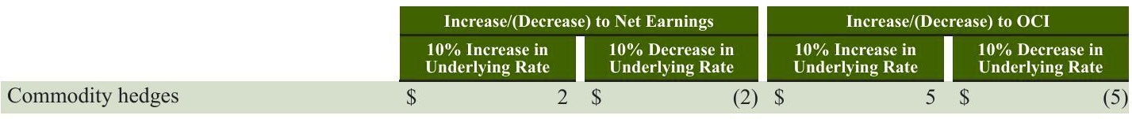

Foreign Currency Exchange Risk

The majority of our revenue, expense and capital purchasing activities are transacted in U.S. dollars. However, because a portion of our operations consists of activities outside of the U.S., we have transactions in other currencies, primarily the Chinese renminbi, Japanese yen, Canadian dollar, British pound, South Korean won and euro. To reduce cash flow volatility from foreign currency fluctuations, we enter into derivative instruments to hedge portions of cash flows of anticipated intercompany royalty payments, inventory purchases, intercompany borrowing and lending activities and certain other transactions in currencies other than the functional currency of the entity that enters into the arrangements, as well as the translation risk of certain balance sheet items. See Note 3,Derivative Financial Instruments, to the consolidated financial statements included in Item 8 of Part II of this 10-K for further discussion. The following table summarizes the potential impact as of September 29, 2019 to Starbucks future net earnings and other comprehensive income from changes in the fair value of these derivative financial instruments due to a change in the value of the U.S. dollar as compared to foreign exchange rates. The information provided below relates only to the hedging instruments and does not represent the corresponding changes in the underlying hedged items (in millions):

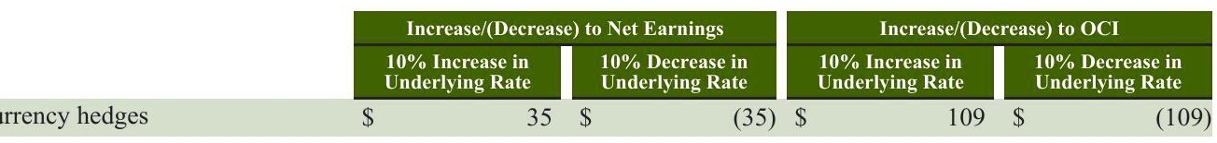

Equity Security Price Risk

We have minimal exposure to price fluctuations on equity mutual funds and equity exchange-traded funds within our marketable equity securities portfolio. Marketable equity securities are recorded at fair value and approximates a portion of our liability under our Management Deferred Compensation Plan ("MDCP'). Gains and losses from the portfolio and the change in our MDCP liability are recorded in our consolidated statements of earnings. We performed a sensitivity analysis based on a 10% change in the underlying equity prices of our investments as of September 29,2019 and determined that such a change would not have a significant impact on the fair value of these instruments.

40Starbucks Corporation 2019 Form 10-K

40Starbucks Corporation 2019 Form 10-K

# Interest Rate Risk

Long-term Debt

We utilize short-term and long-term financing and may use interest rate hedges to manage our overall interest expense related to our existing fixed-rate debt, as well as to hedge the variability in cash flows due to changes in benchmark interest rates related to anticipated debt issuances. See Note 3, Derivative Financial Instruments and Note 9, Debt, to the consolidated financial statements included in Item 8 of Part II of this 10-K for further discussion of our interest rate hedge agreements and details of the components of our long-term debt, respectively, as of September 29, 2019. The following table summarizes the impact of a change in interest rates as of September 29, 2019 on the fair value of Starbucks debt (in millions):

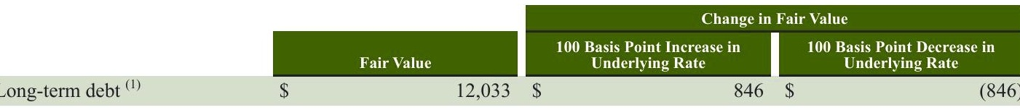

Derivative Financial Instruments, for additional information on our interest rate swap designated as a fair value hedge.

Our available-for-sale securities comprise a diversified portfolio consisting mainly of investment-grade debt securities. The primary objective of these investments is to preserve capital and liquidity. Available-for-sale securities are recorded on the consolidated balance sheets at fair value with unrealized gains and losses reported as a component of accumulated other comprehensive income. We do not hedge the interest rate exposure on our investments. We performed a sensitivity analysis based on a 100 basis point change in the underlying interest rate of our available-for-sale securities as of September 29,2019 and determined that such a change would not have a significant impact on the fair value of these instruments

# APPLICATION OF CRITICALACCOUNTING POLICIES

Critical accounting policies are those that management believes are both most important to the portrayal of our financial condition and results and require the most difficult, subjective or complex judgments, often as a result of the need to make estimates about the effect of matters that are inherently uncertain. Judgments and uncertainties affecting the application of those policies may result in materially different amounts being reported under different conditions or using different assumptions. Our significant accounting policies are discussed in Note 1, Summary of Significant Accounting Policies, to the consolidated financial statements included in Item 8 of Part II of this 10-K. We believe that of our significant accounting policies, the following policies involve a higher degree of judgment and/or complexity. We consider financial reporting and disclosure practices and accounting policies quarterly to ensure that they provide accurate and transparent information relative to the current economic and business environment. During the past five fiscal years, we have not made any material changes to the accounting methodologies used to assess the areas discussed below, unless noted otherwise.

# Property, Plant and Equipment and Other Finite-Lived Assets

that the carrying values of such assets may not be recoverable. When evaluating for impairment, we first compare the carrying value of the asset to the asset's estimated future undiscounted cash flows. If the estimated undiscounted future cash flows are less than the carrying value of the asset, we determine if we have an impairment loss by comparing the carrying value of the asset to the asset's estimated fair value and recognize an impairment charge when the asset's carrying value exceeds its estimated fair value. The adjusted carrying amount of the asset becomes its new cost basis and is depreciated over the asset's remaining useful life. Long-lived assets are grouped with other assets and liabilities at the lowest level for which identifiable cash flows are largely independent of the cash flows of other assets and liabilities. For company-operated store assets, the impairment test is performed at the individual store asset group level. The fair value of a store's assets is estimated using a discounted cash flow model. For other long-lived assets, fair value is determined using an approach that is appropriate based on the relevant facts and circumstances, which may include discounted cash flows, comparable transactions, or comparable company analyses. Our impairment calculations contain uncertainties because they require management to make assumptions and to apply judgment to estimate future cash flows and asset fair values. Key assumptions used in estimating future cash flows and asset fair values include projected revenue growth and operating expenses, as well as forecasting asset useful lives and selecting an Starbucks Corporation 2019 Form 10-K41

appropriate discount rate. For company-operated stores, estimates of revenue growth and operating expenses are based on internal projections and consider the store's historical performance, the local market economics and the business environment impacting the store's performance. The discount rate is selected based on what we believe a buyer would assume when determining a purchase price for the store. These estimates are subjective and our ability to realize future cash flows and asset fair values is affected by factors such as ongoing maintenance and improvement of the assets, changes in economic conditions, and changes in operating performance. During fiscal 2019, there were no significant changes in any of our estimates or assumptions that had a material impact on the outcome of our impairment calculations. However, as we periodically reassess estimated future cash flows and asset fair values, changes in our estimates and assumptions may cause us to realize material impairment charges in the future.

# Goodwill and Indefinite-Lived Intangible Assets

We evaluate goodwill and indefinite-lived intangible assets for impairment annually during our third fiscal quarter, or more frequently if an event occurs or circumstances change that would indicate that impairment may exist. When evaluating these assets for impairment, we may first perform a qualitative assessment to determine whether it is more likely than not that a. reporting unit is impaired. If we do not perform a qualitative assessment, or if we determine that it is not more likely than not that the fair value of the reporting unit exceeds its carrying amount, we calculate the estimated fair value of the reporting unit using discounted cash flows or a combination of discounted cash flow and market approaches. When assessing goodwill for impairment, our decision to perform a qualitative impairment assessment for an individual reporting unit in a given year is influenced by a number of factors, inclusive of the size of the reporting unit's goodwill, the significance of the excess of the reporting unit's estimated fair value over carrying value at the last quantitative assessment date, the amount of time in between quantitative fair value assessments and the date of acquisition. If we perform a quantitative assessment of an individual reporting unit's goodwill, our impairment calculations contain uncertainties because they require management to make assumptions and to apply judgment when estimating future cash flows and asset fair values, including projected revenue growth and operating expenses related to existing businesses, product innovation and new store concepts, as well as utilizing valuation multiples of similar publicly traded companies and selecting an appropriate discount rate. Estimates of revenue growth and operating expenses are based on internal projections considering the reporting unit's past performance and forecasted growth, strategic initiatives, local market economics and the local business environment impacting the reporting unit's performance. The discount rate is selected based on the estimated cost of capital for a market participant to operate the reporting unit in the region. These estimates, as well as the selection of comparable companies and valuation multiples used in the market approaches are highly subjective, and our ability to realize the future cash flows used in our fair value calculations is affected by factors such as the success of strategic initiatives, changes in economic conditions, changes in our operating performance and changes in our business strategies, including retail initiatives and international expansion When assessing indefinite-lived intangible assets for impairment, where we perform a qualitative assessment, we evaluate if changes in events or circumstances have occurred that indicate that impairment may exist. If we do not perform a qualitative impairment assessment or if changes in events and circumstances indicate that a quantitative assessment should be performed, management is required to calculate the fair value of the intangible asset group. The fair value calculation includes estimates of revenue growth,which are based on past performance and internal projections for the intangible asset group's forecasted growth, and royalty rates, which are adjusted for our particular facts and circumstances. The discount rate is selected based on the estimated cost of capital that reflects the risk profile of the related business. These estimates are highly subjective, and our ability to achieve the forecasted cash flows used in our fair value calculations is affected by factors such as the success of strategic initiatives, changes in economic conditions, changes in our operating performance and changes in our business strategies, including retail initiatives and international expansion. The goodwill impairment charges are discussed in Note 8, Other Intangible Assets and Goodwill, to the consolidated financial Statements included in Item 8 of Part II of this 10-K.

# Income Taxes

We recognize deferred tax assets and liabilities based on the differences between the financial statement carrying amounts and the respective tax bases of our assets and liabilities. Deferred tax assets and liabilities are measured using current enacted tax rates expected to apply to taxable income in the years in which we expect the temporary differences to reverse. We routinely evaluate the likelihood of realizing the benefit of our deferred tax assets and may record a valuation allowance if, based on all available evidence, we determine that some portion of the tax benefit will not be realized. In evaluating our ability to recover our deferred tax assets within the jurisdiction from which they arise, we consider all available positive and negative evidence, including scheduled reversals of deferred tax liabilities, projected future taxable income, tax-planning strategies, and results of operations. In projecting future taxable income, we consider historical results and incorporate assumptions about the amount of future state, federal and foreign pretax operating income adjusted for items that do not have tax consequences. Our assumptions regarding future taxable income are consistent with the plans and estimates

we use to manage our underlying businesses. In evaluating the objective evidence that historical results provide, we consider three years of cumulative operating income/(loss). In addition, our income tax returns are periodically audited by domestic and foreign tax authorities. These audits include review of our tax filing positions, including the timing and amount of deductions taken and the allocation of income between tax jurisdictions. We evaluate our exposures associated with our various tax filing positions and recognize a tax benefit only if it is more likely than not that the tax position will be sustained upon examination by the relevant taxing authorities, including resolutions of any related appeals or litigation processes, based on the technical merits of our position. For uncertain tax positions that do not meet this threshold,we record a related liability.We adjust our unrecognized tax benefit liability and income tax expense in the period in which the uncertain tax position is effectively settled, the statute of limitations expires for the relevant taxing authority to examine the tax position or when new information becomes available. As discussed in Note 13, Income Taxes, to the consolidated financial statements included in Item 8 of Part II of this 10-K, there is a reasonable possibility that our unrecognized tax benefit liability will be adjusted within 12 months due to the expiration of a statute of limitations and/or resolution of examinations with taxing authorities. We have generated income in certain foreign jurisdictions that may be subject to additional foreign withholding taxes and U.S. state income taxes. We have revised our indefinite reinvestment assertions for prior years' cumulative earnings from certain foreign subsidiaries. We regularly review our plans for reinvestment or repatriation of unremitted foreign earnings. While we do not expect to repatriate cash to the U.S. to satisfy domestic liquidity needs, if these amounts were distributed to the U.S., in the form of dividends or otherwise, we may be subject to additional foreign withholding taxes and U.S. state income taxes. which could be material. Our income tax expense, deferred tax assets and liabilities and liabilities for unrecognized tax benefits reflect management's best assessment of estimated current and future taxes to be paid. Deferred tax asset valuation allowances and our liabilities for unrecognized tax benefits require significant management judgment regarding applicable statutes and their related interpretation, the status of various income tax audits and our particular facts and circumstances. Although we believe that the judgments and estimates discussed herein are reasonable, actual results could differ, and we may be exposed to losses or gains that could be material. To the extent we prevail in matters for which a liability has been established or are required to pay amounts in excess of our established liability, our effective income tax rate in a given financial statement period could be materially affected. Refer to Note 13, Income Taxes, to the consolidated financial statements included in Item 8 of Part II of this 10-K, for additional discussion surrounding the changes as a result of the Tax Act. RECENT ACCOUNTING PRONOUNCEMENTS See Note 1, Summary of Significant Accounting Policies, to the consolidated financial statements included in Item 8 of Part II of this 10-K for a detailed description of recent accounting pronouncements. Item 7A. Quantitative and Qualitative Disclosures About Market Risk The information required by this item is incorporated by reference to the section entitled "Management's Discussion and Analysis of Financial Condition and Results of Operations -Commodity Prices,Availability and General Risk Conditions and "Management's Discussion and Analysis of Financial Condition and Results of Operations - Financial Risk Management" in Item 7 of this Report.

Starbucks Corporation 2019 Form 10-K43

Starbucks Corporation 2019 Form 10-K43

Starbucks Corporation 2019 Form 10-K43

Starbucks Corporation 2019 Form 10-K43

Item 8. Financial Statements and Supplementary Data

STARBUCKS CORPORATION CONSOLIDATED STATEMENTS OF EARNINGS (in millions, except per share data)

|  |  |  |  |  |  |  |
| --- | --- | --- | --- | --- | --- | --- |
| Fiscal Year Ended | Sep 29, 2019 | | Sep 30, 2018 | | Oct 1, 2017 | |
| Net revenues: |  |  |  |  |  |  |
| Company-operated stores | $ | 21,544.4$ |  | 19,690.3$ |  | 17,650.7 |
| Licensed stores |  | 2,875.0 |  | 2,652.2 |  | 2,355.0 |
| Other |  | 2,089.2 |  | 2,377.0 |  | 2,381.1 |
| Total net revenues |  | 26,508.6 |  | 24,719.5 |  | 22,386.8 |
| Cost of sales |  | 8,526.9 |  | 7,930.7 |  | 7,065.8 |
| Store operating expenses |  | 10,493.6 |  | 9,472.2 |  | 8,486.4 |
| Other operating expenses |  | 371.0 |  | 554.9 |  | 518.0 |
| Depreciation and amortization expenses |  | 1,377.3 |  | 1,247.0 |  | 1,011.4 |
| General and administrative expenses |  | 1,824.1 |  | 1,708.2 |  | 1,408.4 |
| Restructuring and impairments |  | 135.8 |  | 224.4 |  | 153.5 |
| Total operating expenses |  | 22,728.7 |  | 21,137.4 |  | 18,643.5 |
| Income from equity investees |  | 298.0 |  | 301.2 |  | 391.4 |
| Operating income |  | 4,077.9 |  | 3,883.3 |  | 4,134.7 |
| Gain resulting from acquisition of joint venture |  |  |  | 1,376.4 |  |  |
| Net gain resulting from divestiture of certain operations |  | 622.8 |  | 499.2 |  | 93.5 |
| Interest income and other, net |  | 96.5 |  | 191.4 |  | 181.8 |
| Interest expense |  | (331.0) |  | (170.3) |  | (92.5) |
| Earnings before income taxes |  | 4,466.2 |  | 5,780.0 |  | 4,317.5 |
| Income tax expense |  | 871.6 |  | 1,262.0 |  | 1,432.6 |
| Net earnings including noncontrolling interests |  | 3,594.6 |  | 4,518.0 |  | 2,884.9 |
| Net earnings/(loss) attributable to noncontrolling interests |  | (4.6) |  | (0.3) |  | 0.2 |
| Net earnings attributable to Starbucks | $ | 3,599.2 | $ | 4,518.3 | $ | 2,884.7 |
| Earnings per share --basic | $ | 2.95 | $ | 3.27 | $ | 1.99 |
| Earnings per share --diluted | $ | 2.92 | $ | 3.24 | $ | 1.97 |
| Weighted average shares outstanding: |  |  |  |  |  |  |
| Basic |  | 1,221.2 |  | 1,382.7 |  | 1,449.5 |
| Diluted |  | 1,233.2 |  | 1,394.6 |  | 1,461.5 |

44Starbucks Corporation 2019 Form 10-K

44Starbucks Corporation 2019 Form 10-K

See Notes to Consolidated Financial Statements.

STARBUCKS CORPORATION CONSOLIDATED STATEMENTS OF COMPREHENSIVE INCOME (in millions)

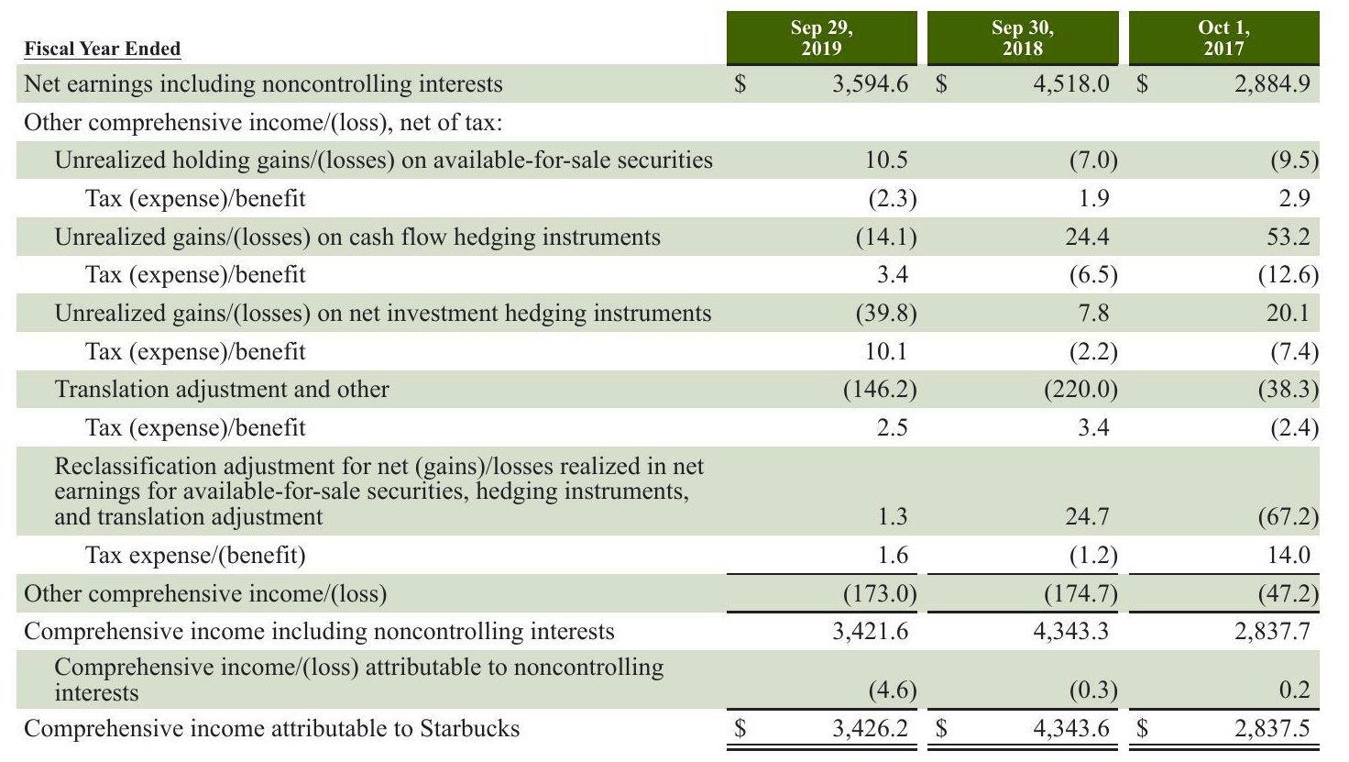

See Notes to Consolidated Financial Statements.

Starbucks Corporation 2019 Form 10-K45

STARBUCKS CORPORATION CONSOLIDATED BALANCE SHEETS (in millions, except per share data)

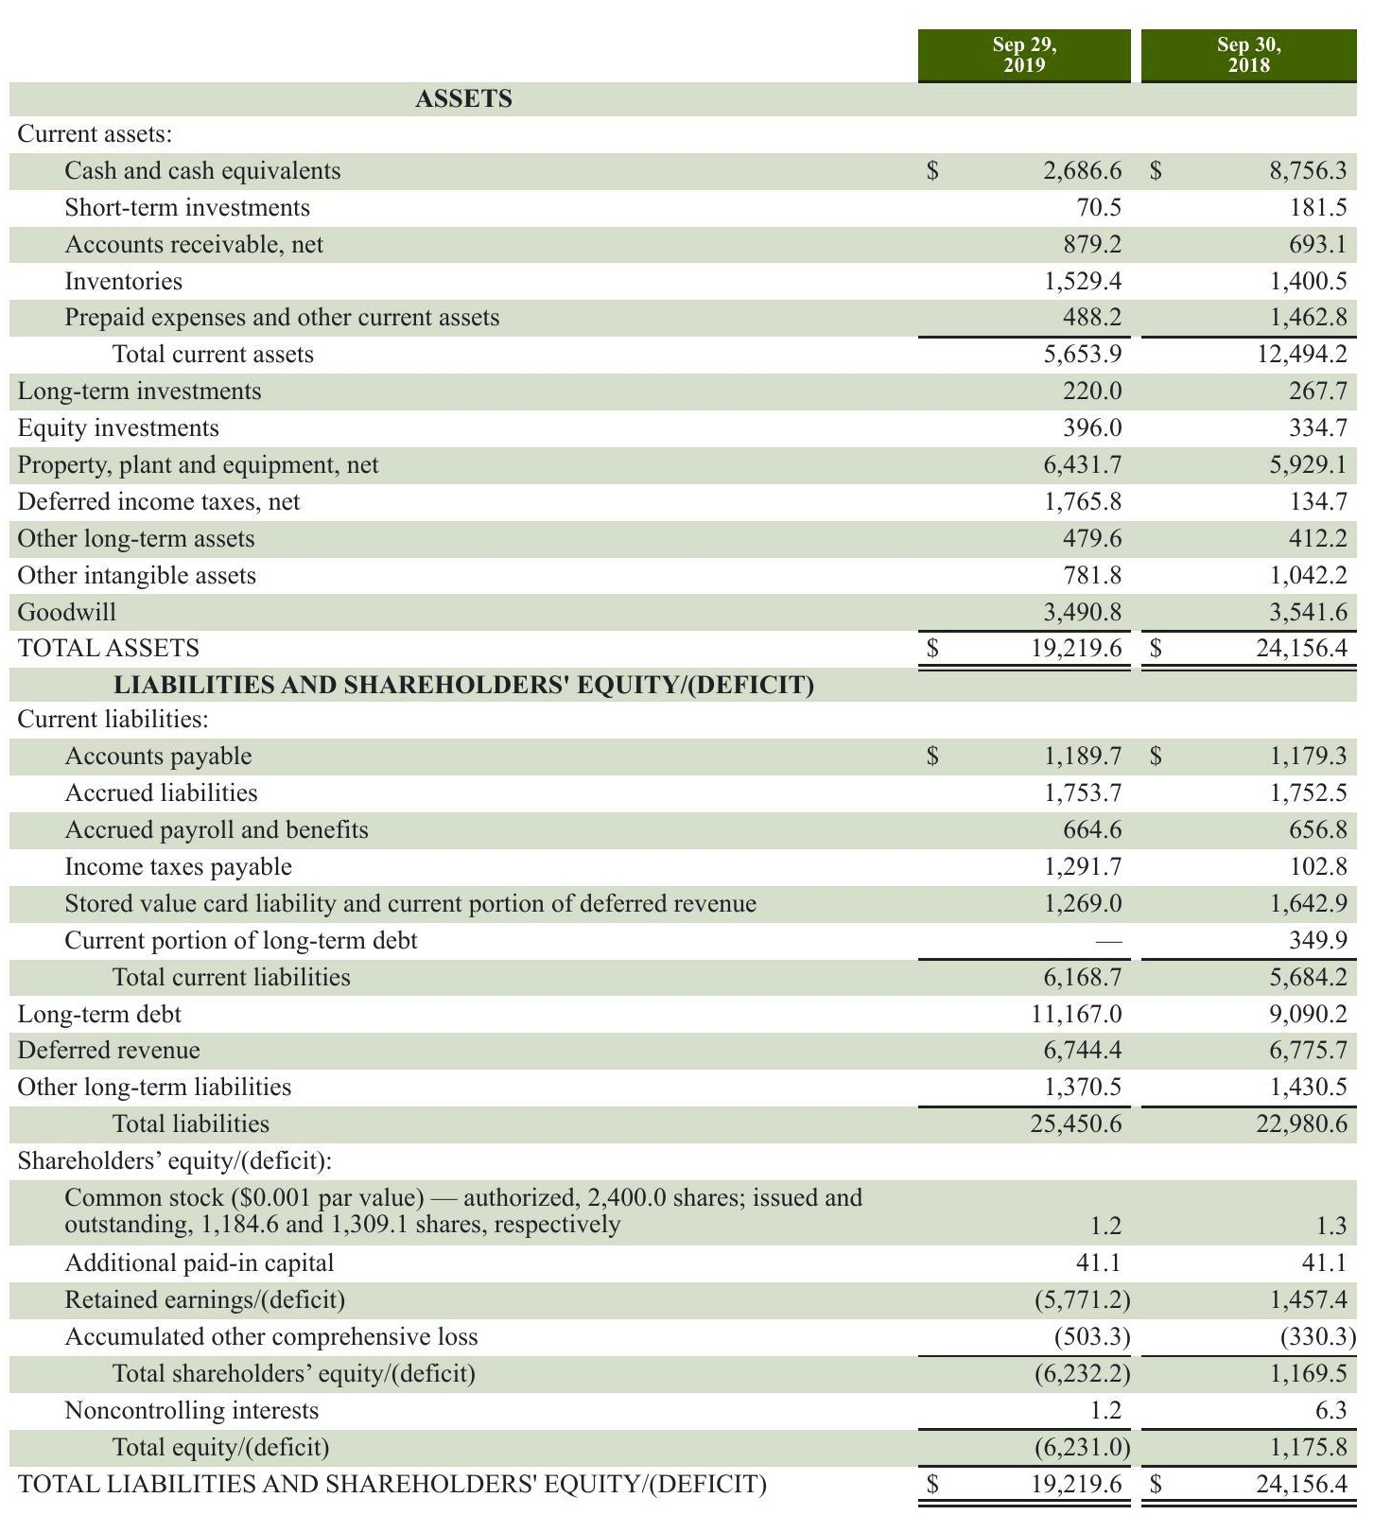

46 Starbucks Corporation

2019 Form 10-K

See Notes to Consolidated Financial Statements.

# CAUTIONARY NOTE REGARDING FORWARD-LOOKING STATEMENTS

This Annual Report on Form 10-K includes "forward-looking statements within the meaning of the Private Securities Litigation Reform Act of 1995.Forward-looking statements can be identified by the fact that they do not relate strictly to historical or current facts.They often include words such asbelieves"expects"anticipates"estimates,"intends "plans," "seeks" or words of similar meaning, or future or conditional verbs, such as "will, "should," "could,""may, "aims," "intends," or "projects." A forward-looking statement is neither a prediction nor a guarantee of future events or circumstances, and those future events or circumstances may not occur. You should not place undue reliance on forward-looking statements, which speak only as of the date of this Annual Report on Form 10-K.These forward-looking statements are all based on currently available operating, financial and competitive information and are subject to various risks and uncertainties. Our actual future results and trends may differ materially depending on a variety of factors, including, but not limited to, the risks and uncertainties discussed under Risk Factors" and Management's Discussion and Analysis of Financial Condition and Results of Operations." Given these risks and uncertainties, you should not rely on forward-looking statements as a prediction of actual results. Any or all of the forward-looking statements contained in this Annual Report on Form 10-K and any other public statement made by us, including by our management, may turn out to be incorrect. We are including this cautionary note to make applicable and take advantage of the safe harbor provisions of the Private Securities Litigation Reform Act of 1995 for forward-looking statements. We expressly disclaim any obligation to update or revise any forward-looking statements, whether as a result of new information, future events or otherwise

Starbucks Corporation g2019 Form 10-K

Starbucks Corporation g2019 Form 10-K

Starbucks Corporation g2019 Form 10-K

STARBUCKS CORPORATION CONSOLIDATED STATEMENTS OF CASH FLOWS (in millions)

|  |  |  |  |  |
| --- | --- | --- | --- | --- |
| Fiscal Year Ended | Sep 29, 2019 |  | Sep 30, 2018 | Oct 1, 2017 |
| OPERATING ACTIVITIES: |  |  |  |  |
| Net earnings including noncontrolling interests | s | 3,594.6 $ | 4,518.0$ | 2,884.9 |
| Adjustments to reconcile net earnings to net cash provided by |  |  |  |  |
| operating activities: | 1,449.3 |  | 1,305.9 | 1,067.1 |
| Depreciation and amortization |  |  |  |  |
| Deferred income taxes, net | (1,495.4) |  | 714.9 | 95.1 |
| Income earned from equity method investees | (250.6 216.8 |  | (242.8) | (310.2) |
| Distributions received from equity method investees |  |  | 226.8 | 186.6 |
| Gain resulting from acquisition of joint venture |  |  | (1,376.4) |  |
| Net gain resulting from divestiture of certain retail operations | (622.8) 308.0 |  | (499.2) | (93.5) 176.0 |
| Stock-based compensation Goodwill impairments | 10.5 |  | 250.3 37.6 | 87.2 |
| Other | 187.9 |  | 89.0 | 68.9 |
|  |  |  |  |  |
| Cash provided by changes in operating assets and liabilities: | (197.7) |  |  | (96.8) |
| Accounts receivable Inventories | (173.0) |  | 131.0 |  |
| Prepaid expenses and other current assets | 922.0 |  | (41.2) | 14.0 (20.0) |
|  | 1,237.1 |  | (839.5) | (91.9) |
| Income taxes payable |  |  | 146.0 391.6 | 46.4 |
| Accounts payable Deferred revenue | 31.9 (30.5) |  | 7,109.4 | 130.8 |
| Other operating assets and liabilities | (141.1) |  | 16.4 | 107.2 |
| Net cash provided by operating activities | 5,047.0 |  | 11,937.8 | 4,251.8 |
| INVESTING ACTIVITIES: |  |  |  |  |
| Purchases of investments | (190.4 |  | (191.9) | (674.4) |
| Sales of investments | 298.3 |  | 459.0 | 1,054.5 |
| Maturities and calls of investments | 59.8 |  | 45.3 | 149.6 |
| Acquisitions, net of cash acquired |  |  | (1,311.3) |  |
| Additions to property,plant and equipment | (1,806.6) |  | (1,976.4) | (1,519.4) |
| Net proceeds from the divestiture of certain operations | 684.3 |  | 608.2 | 85.4 |
| Other | (56.2) |  | 5.6 | 54.3 |
| Net cash used by investing activities | (1,010.8 |  | (2,361.5) | (850.0) |
| FINANCING ACTIVITIES: |  |  |  |  |
| Proceeds from issuance of long-term debt | 1,996.0 |  | 5,584.1 | 750.2 |
| Repayments of long-term debt | (350.0) |  |  | (400.0) |
| Proceeds from issuance of common stock | 409.8 |  | 153.9 | 150.8 |
| Cash dividends paid | (1,761.3) |  | (1,743.4) | (1,450.4) |
| Repurchase of common stock | (10,222.3) |  | (7,133.5) | (2,042.5) |
| Minimum tax withholdings on share-based awards | (111.6) |  | (62.7) | (82.8) |
| Other | (17.5) |  | (41.2) | (4.4) |
| Net cash used by financing activities | (10,056.9) |  | (3,242.8) | (3,079.1) |
| Effect of exchange rate changes on cash and cash equivalents | (49.0) |  | (39.5) | 10.8 |
| Net increase/(decrease) in cash and cash equivalents | (6,069.7) |  | 6,294.0 | 333.5 |
| CASH AND CASH EQUIVALENTS: |  |  |  |  |
| Beginning of period | 8,756.3 |  | 2,462.3 | 2,128.8 |
| End of period | s | 2.686.6 | 8.756.3$ | 2.462.3 |
| SUPPLEMENTAL DISCLOSURE OF CASH FLOW |  |  |  |  |
| Cash paid during the period for: |  |  |  |  |
| Interest, net of capitalized interest | $ | 299.5$ | 137.1$ | 96.6 |
| Income taxes, net of refunds | $ | 470.1 $ | 1,176.9 | 1,389.1 |

Starbucks Corporation 2019 Form 10-K47

Starbucks Corporation

2019 Form 10-K47

パナソニックグループについて グループCEO&CFOメッセージ ビケスント別昭

対談 取締役会議長 社外取締役

限られた時間の中で十分な成果を上げることは難しいかもしれません。 わせ方をすると、 短期的には既存事業で成果を積み上げながら 3つの投資領域には少し余裕を持たせて中 長期的に取り組ませることをホールディングスとして後押ししていきたいです。 現状は さまざまな期待を背負わせ過ぎており 短期視点で事業成長と利益創出を過度に求めて いるように感じています

# 決断の背景には執行側の強い覚悟あり

一オートモーティブ事業の株式譲渡について 取締役会ではどのような観点で 議論し、経営判断されましたか。

津賀 事業会社を譲渡するという大きな決断でしたが、 取締役会では意見が割れること なく、 決議となりました。 現在の自動車業界は大きな変革期にあり その変化に対応する には大規模な授資が必要ですが、 当社グルー プがその投資を実行するには限界がありま した。 この点は私も楠見さん もグル プCs0の隅田さん もオ トモ ティブ事業の経験 者であり 十分に理解 ていました また 自動車業界に精通す る社外役員もおり 取締 役会とし てある程度の将来性を掴め でいたのが大きし と感じ ています。

澤田 取締役会に上程された際は、 本当にやるのか 「思い切ったなという感覚でした。 パナソミックの冠や社員の ションがどう なるのかなど さまざまなことが頭を 巡りましたが、 決議に賛成し ました。 その理由は明快です。 津賀さんのお話の通り、 オー トモーティブ事業の経験者である津賀さん 楠見さん 隅田さんがすべてを理解した上で この案件を取締役会に 上程し ているからです もし オートモーティブ事業の経験が乏し い人が上程していたら 社外取締役とし てさまざまな意見をしていたと思います。 事業ポー トフォリオマネジメントは手段であり 今回のベストオ 一ナーを探す選択が本当に最良で あるのか 夢藤はありましたが、 執行側の強し 覚悟を感じて賛成しました

Panasonic Holdings 51 流合報告書2024

企業データ

パナソニックHDの役割

対談：取締授会議長 社引取緬役

# 次期中期計画の策定が肝要

# 取締役会の実効性をより

津賀 社外取締役 社外監査役の方には 多数の事業を有するパナソニッワグル 一プの ことをだいぶ理解いただけるようになりました。 この点は取締役会の実効性向上に つながつ ていると感じています 今後 実効性をより 一曽阿さ甘 ていくには 取締役会で次期中 期計画を干分に議論することが必要と考えています 皆が腹落ちした納得性のある中期 計画を取締役会で議論し 策定していきたいです

澤田 ステークホルダ からのパナソニックグループヘの期待は大きいので グループ がその期待の方向に進むことを、 取締役会とし ていかにして導くかが重要と 考えています 次期中期計画は表面的なものや机上の空論ではなく 実現性が件 宣言した以上は達成できることをステ クホルダ の皆様に見せていきたいです。 また 取締役会では単 の議論 ではなく さまざまな観点からの議論が必要であり、 取締役会メ ンバ の構成や人選 議案の設定、 議論のファシリテ トも重要です。 そのよ うなことを 実現し てはじめて ステ クホルダ の期待に応える取締役会になったと言えます。

Note 1 Summary of Significant Accounting Policies Note 2 Acquisitions, Divestitures and Strategic Alliance Note 3 Derivative Financial Instruments Note 4 Fair Value Measurements Note 5 Inventories Note 6 Equity and Cost Investments Note 7 Supplemental Balance Sheet Information Note 8 Other Intangible Assets and Goodwill Note 9 Debt Note 10 Leases Note 11 Equity Note 12 Employee Stock and Benefit Plans Note 13 Income Taxes Note 14 Earnings per Share Note 15 Commitments and Contingencies Note 16 Segment Reporting Note 17 Selected Quarterly Financial Information (unaudited)

STARBUCKS CORPORATION INDEX FOR NOTES TO CONSOLIDATED FINANCIAL STATEMENTS

Starbucks Corporation 2019 Form 10-K49

Note 1: Summary of Significant Accounting Policies Description of Business

STARBUCKS CORPORATION

NOTES TO CONSOLIDATED FINANCIAL STATEMENTS Fiscal Years ended September 29, 2019, September 30, 2018 and October 1, 2017

We purchase and roast high-quality coffees that we sell, along with handcrafted coffee and tea beverages and a variety of fresh and prepared food items,through our company-operated stores.We also sell a variety of coffee and tea products and license our trademarks through other channels such as licensed stores, grocery and foodservice. The grocery and foodservice business is primarily through our Global Coffee Alliance with Nestle established in August 2018. In this 10-K, Starbucks Corporation (together with its subsidiaries) is referred to as "Starbucks,"" the "Company," "we," us" or "our." Certain prior period information on the consolidated balance sheets and the consolidated statements of cash flows has been reclassified to conform to the current year presentation Segment information is prepared on the same basis that our management reviews financial information for operational decision-making purposes. In the fourth quarter of fiscal 2019, we realigned our operating segment reporting structure to better reflect the cumulative effect of our streamlining efforts.Specifically,our previous China/Asia Pacific ("CAP segment and Europe, Middle East, and Africa ("EMEA") segment have been combined into one International segment. Results of Siren Retail, a non-reportable operating segment consisting of Starbucks ReserveTM Roastery & Tasting Rooms, certain stores under the Starbucks Reserve brand and Princi operations, which were previously included within Corporate and Other, are now reported within the Americas and International segments based on the geographical location of the operations. Further, to better support the review of our results, we have changed the classification of certain costs. The most significant change was the reclassification of our company-owned store occupancy costs from cost of sales to store operating expenses of $2.2 billion and $2.0 billion for fiscal 2018 and 2017, respectively. Total store occupancy costs in fiscal 2019 were $2.4 billion. We also made certain other immaterial changes. There was no impact to consolidated net revenues, consolidated operating income, or net earnings per share as a result of these changes and prior period financial information has been revised to be consistent with the current period presentation.

Additional details on the nature of our business and our reportable operating segments are included in Note 16, Segment Reporting. We have three reportable operating segments: 1) Americas, which is inclusive of the U.S., Canada, and Latin America; 2) International,which is inclusive of China/Asia Pacific,Europe, Middle East, and Africa; and 3) Channel Development. Non- reportable operating segments such as Evolution Fresh and unallocated corporate expenses are reported within Corporate and Other.

Our consolidated financial statements reflect the financial position and operating results of Starbucks, including wholly-owned subsidiaries and investees that we control. Intercompany transactions and balances have been eliminated. Fiscal Year End Our fiscal year ends on the Sunday closest to September 30. Fiscal 2019, 2018, and 2017 included 52 weeks. Estimates and Assumptions

Preparing financial statements in conformity with accounting principles generally accepted in the United States of America ("GAAP") requires management to make estimates and assumptions that affect the reported amounts of assets, liabilities, revenues and expenses. Examples include, but are not limited to, estimates for inventory reserves, asset and goodwill impairments, assumptions underlying self-insurance reserves, income from unredeemed stored value cards, stock-based compensation forfeiture rates, future asset retirement obligations and the potential outcome of future tax consequences of events that have been recognized in the financial statements. Actual results and outcomes may differ from these estimates and assumptions.

# Cash and Cash Equivalents

We consider all highly liquid instruments with maturities of three months or less at the time of purchase, as well as credit card receivables for sales to customers in our company-operated stores that generally settle within two to five business days, to be cash equivalents. We maintain cash and cash equivalent balances with financial institutions that exceed federally-insured limits We have not experienced any losses related to these balances, and we believe credit risk to be minimal.

Our cash management system provides for the funding of all major bank disbursement accounts on a daily basis as checks are presented for payment. Under this system, outstanding checks are in excess of the cash balances at certain banks, which creates book overdrafts. Book overdrafts are presented as a current liability in accrued liabilities on our consolidated balance sheets. Investments

# Available-for-sale Debt Securities

Our short-term and long-term investments consist primarily of investment-grade debt securities, all of which are classified as available-for-sale. Available-for-sale debt securities are recorded at fair value, and unrealized holding gains and losses are recorded, net of tax, as a component of accumulated other comprehensive income. Available-for-sale securities with remaining maturities of less than one year and those identified by management at the time of purchase to be used to fund operations within one year are classified as short-term. All other available-for-sale securities are classified as long-term. We evaluate our available-for-sale securities for other-than-temporary impairment on a quarterly basis. Unrealized losses are charged against net earnings when a decline in fair value is determined to be other than temporary. We review several factors to determine whether a loss is other than temporary, such as the length and extent of the fair value decline, the financial condition and near-term prospects of the issuer and whether we have the intent to sell or will more likely than not be required to sell before the securities' anticipated recovery,which may be at maturity. Realized gains and losses are accounted for using the specifi identification method. Purchases and sales are recorded on a trade date basis.

# Marketable Equity Securities

We also have a marketable equity securities portfolio, which is comprised of marketable equity mutual funds and equity exchange-traded funds. Marketable equity securities are recorded at fair value and approximates a portion of our liability under our Management Deferred Compensation Plan ("MDCP). Gains or losses from the portfolio and the change in our MDCP liability are recorded in our consolidated statements of earnings. Equity Investments

Equity investments are accounted under the equity method if we are able to exercise significant influence,but not control, over an investee. Our share of the earnings or losses as reported by the investees are classified as income from equity investees on our consolidated statements of earnings. The investments are evaluated for impairment annually and when facts and circumstances indicate that the carrying value may not be recoverable. If a decline in fair value is determined to be other-than- temporary, an impairment charge is recorded in interest income and other, net on our consolidated statements of earnings. We account for equity investments for which we do not have significant influence and without readily determinable fair values at cost with adjustments for observable changes in price or impairments as permitted by the measurement alternative. Investments for which the measurement alternative has been elected are assessed for impairment quarterly, or if a triggering event indicates impairment may be present. Any adjustments as a result of price changes or impairments are recorded in interest income and other, net on our consolidated statements of earnings.

Fair value is the price we would receive to sell an asset or pay to transfer a liability (exit price) in an orderly transaction between market participants. For assets and liabilities recorded or disclosed at fair value on a recurring basis, we determine fair value based on the following: Level I: The carrying value of cash and cash equivalents approximates fair value because of the short-term nature of these instruments. For equity and U.S. government treasury securities and commodity futures contracts, we use quoted prices in active markets for identical assets to determine fair value. Level 2: When quoted prices in active markets for identical assets are not available, we determine the fair value of our available-for-sale securities and our over-the-counter forward contracts, collars and swaps based upon factors such as the quoted market price of similar assets or a discounted cash flow model using readily observable market data,which may include interest rate curves and forward and spot prices for currencies and commodities, depending on the nature of the investment. The fair value of our long-term debt is estimated based on the quoted market prices for the same or similar issues or on the current rates offered to us for debt of the same remaining maturities. Level 3: We determine the fair value of our auction rate securities using an internally-developed valuation model, using inputs that include interest rate curves, credit and liquidity spreads and effective maturity. Assets and liabilities recognized or disclosed at fair value on a nonrecurring basis may include items such as property, plant and equipment, goodwill and other intangible assets, equity and other investments and other assets. We determine the fair value of these items using Level 3 inputs, as described in the related sections below.

Starbucks Corporation 2019 Form 10-K51

# Derivative Instruments

We manage our exposure to various risks within our consolidated financial statements according to a market price risk management policy. Under this policy,we may engage in transactions involving various derivative instruments to hedge interest rates, commodity prices and foreign currency-denominated revenue streams, inventory purchases, assets and liabilities and investments in certain foreign operations. In order to manage our exposure to these risks, we use various types of derivative instruments including forward contracts, commodity futures contracts, collars and swaps. Forward contracts and commodity futures contracts are agreements to buy or sell a quantity of a currency or commodity at a predetermined future date and at a predetermined rate or price.A collar is a strategy that uses a combination of a purchased call option and a sold put option with equal premiums to hedge a portion of anticipated cash flows, or to limit possible gains or losses on an underlying asset or liability to a specific range. A swap agreement is a contract between two parties to exchange cash flows based on specified underlying notional amounts, assets and/or indices. We do not enter into derivative instruments for speculative purposes. We record all derivatives on our consolidated balance sheets at fair value and typically do not offset derivative assets and liabilities. Excluding interest rate swaps and foreign currency debt, we generally do not enter into derivative instruments with maturities longer than three years. However, we are allowed to net settle transactions with respective counterparties for certain derivative contracts, inclusive of interest rate swaps and foreign currency forwards, with a single, net amount payable by one party to the other. We also enter into collateral security arrangements that provide for collateral to be received or posted when the net fair value of certain financial instruments fluctuates from contractually established thresholds. Cash collateral under collateral security arrangements were immaterial as of September 29, 2019 and September 30, 2018. The potential effects of netting arrangements with our derivative contracts, excluding the effects of collateral, would not have had a material impact on our consolidated balance sheets. By using these derivative instruments, we expose ourselves to potential credit risk. Credit risk is the failure of the counterparty to perform under the terms of the derivative contract. We minimize this credit risk by entering into transactions with carefully selected, credit-worthy counterparties and distribute contracts among several financial institutions to reduce the concentration of credit risk.

For derivative instruments that are designated and qualify as a cash flow hedge, the derivative's gain or loss is reported as a component of other comprehensive income (OCI" and recorded in accumulated other comprehensive income ("AOCI") on our consolidated balance sheets. The gain or loss is subsequently reclassified into net earnings when the hedged exposure affects net earnings, in the same line item as the underlying hedged item on our consolidated statements of earnings. Cash flow hedges related to anticipated transactions are designated and documented at the inception of each hedge. Cash flows from hedging transactions are classified in the same categories as the cash flows from the respective hedged items. For de- designated cash flow hedges in which the transactions are no longer likely to occur, the related accumulated derivative gains or losses are recognized in interest income and other, net or interest expense on our consolidated statements of earnings based on the nature of the underlying transaction. Net Investment Hedges For derivative instruments that are designated and qualify as a net investment hedge, the derivative's, or qualifying non- derivative instrument's, gain or loss is reported as a component of OCI and recorded in AOCI. The gain or loss will be subsequently reclassified into net earnings when the hedged net investment is either sold or substantially liquidated.

52Starbucks Corporation 2019 Form 10-K

52Starbucks Corporation 2019 Form 10-K

Fair Value Hedges For derivative instruments that are designated and qualify as a fair value hedge, the changes in fair value of the derivative instrument and the offsetting changes in fair value of the underlying hedged item due to changes in the hedged risk are recorded in interest income and other, net or interest expense on our consolidated statements of earnings. Derivatives Not Designated As Hedging Instruments We also enter into certain foreign currency forward contracts, commodity futures contracts, collars and swaps that are not designated as hedging instruments for accounting purposes. The changes in the fair values of these contracts are immediately recognized in interest income and other, net on our consolidated statements of earnings. Normal Purchase Normal Sale We enter into fixed-price and price-to-be-fixed green coffee purchase commitments, which are described further in Note 5, Inventories. For both fixed-price and price-to-be-fixed purchase commitments, we expect to take delivery of green coffee and to utilize the coffee in a reasonable period of time in the ordinary course of business. Since these types of purchase commitments qualify for the normal purchase normal sale exemption, they are not recorded as derivative instruments on our consolidated balance sheets. Refer to Note 3, Derivative Financial Instruments, and Note 5, Inventories, for further discussion of our derivative instruments and green coffee purchase commitments. Receivables, net of Allowance for Doubtful Accounts

Our receivables are mainly comprised of receivables for product and equipment sales to and royalties from our licensees, as well as receivables from our Global Coffee Alliance and other Channel Development customers. Our allowance for doubtful accounts is calculated based on historical experience, customer credit risk and application of the specific identification method. As of September 29, 2019 and September 30, 2018, our allowance for doubtful accounts was $6.7 million and $8.0 million, respectively

Inventories are stated at the lower of cost (primarily moving average cost) or net realizable value. We record inventory reserves for obsolete and slow-moving inventory and for estimated shrinkage between physical inventory counts. Inventory reserves are based on inventory obsolescence trends, historical experience and application of the specific identification method. As of September 29, 2019 and September 30, 2018, inventory reserves were $33.7 million and $41.5 million, respectively.

# Property, Plant and Equipment

Property, plant and equipment, which includes assets under capital leases, are carried at cost less accumulated depreciation. Cost includes all direct costs necessary to acquire and prepare assets for use, including internal labor and overhead in some cases. Depreciation is computed using the straight-line method over estimated useful lives of the assets, generally ranging from 2 to 15 years for equipment and 30 to 40 years for buildings. Leasehold improvements are amortized over the shorter of their estimated useful lives or the related lease life, generally 10 years. For leases with renewal periods at our option, we generally use the original lease term, excluding renewal option periods, to determine estimated useful lives. If failure to exercise a renewal option imposes an economic penalty to us, we may determine at the inception of the lease that renewal is reasonably assured and include the renewal option period in the determination of the appropriate estimated useful lives. The portion of depreciation expense related to production and distribution facilities is included in cost of sales on our consolidated statements of earnings. The costs of repairs and maintenance are expensed when incurred, while expenditures for refurbishments and improvements that significantly add to the productive capacity or extend the useful life of an asset are capitalized. When assets are disposed of, whether through retirement or sale, the net gain or loss is recognized in net earnings. Long-lived assets to be disposed of are reported at the lower of their carrying amount or fair value less estimated costs to sell. We evaluate property, plant and equipment for impairment when facts and circumstances indicate that the carrying values of such assets may not be recoverable. When evaluating for impairment, we first compare the carrying value of the asset to the asset's estimated future undiscounted cash flows. If the estimated undiscounted future cash flows are less than the carrying value of the asset, we determine if we have an impairment loss by comparing the carrying value of the asset to the asset's estimated fair value and recognize an impairment charge when the asset's carrying value exceeds its estimated fair value. The fair value of the asset is estimated using a discounted cash flow model based on forecasted future revenues and operating costs, using internal projections. Property, plant and equipment assets are grouped at the lowest level for which identifiable cash flows are largely independent of the cash flows of other assets and liabilities. For company-operated store assets, the impairment test is performed at the individual store asset group level.

Starbucks Corporation 2019 Form 10-K53

Starbucks Corporation 2019 Form 10-K53

Starbucks Corporation 2019 Form 10-K53

We recognized net disposition charges of $64.6 million, $32.8 million, and $46.9 million in fiscal 2019, 2018, and 2017, respectively. Additionally, we recognized net impairment charges of $43.4 million, $42.8 million, and $56.1 million in fiscal 2019, 2018, and 2017, respectively. Of the total net impairment charges, $7.1 million and $37.0 million in fiscal 2019 and 2018, respectively, were restructuring related and recorded in restructuring and impairment expenses. Unless it is restructuring related, the nature of the underlying asset that is impaired or disposed of will determine the operating expense line on which the related impact is recorded on our consolidated statements of earnings.

We evaluate goodwill for impairment annually during our third fiscal quarter, or more frequently if an event occurs or circumstances change, such as material deterioration in performance or a significant number of store closures, that would indicate that impairment may exist. When evaluating goodwill for impairment, we may first perform a qualitative assessment to determine whether it is more likely than not that a reporting unit is impaired. If we do not perform a qualitative assessment, or if we determine that it is not more likely than not that the fair value of the reporting unit exceeds its carrying amount, we calculate the estimated fair value of the reporting unit. Fair value is typically calculated using a discounted cash flow model. For certain reporting units, where deemed appropriate, we may also utilize a market approach for estimating fair value. If the carrying amount of the reporting unit exceeds the estimated fair value, an impairment charge is recorded to reduce the carrying value to the estimated fair value. As part of our ongoing operations, we may close certain stores within a reporting unit containing goodwill due to underperformance of the store or inability to renew our lease, among other reasons. We may abandon certain assets associated with a closed store, including leasehold improvements and other non-transferable assets. When a portion of a reporting unit that constitutes a business is to be disposed of, goodwill associated with the business is included in the carrying amount of the business in determining any loss on disposal. Our evaluation of whether the portion of a reporting unit being disposed of constitutes a business occurs on the date of abandonment. Although an operating store meets the accounting definition of a business prior to abandonment, it does not constitute a business on the closure date because the remaining assets on that date do not constitute an integrated set of activities (substantive processes) and assets that are capable of being managed for the purpose of providing a return to investors. As a result, when closing individual stores, we do not include goodwill in the calculation of any loss on disposal of the related assets. We recorded goodwill impairment of $10.5 million, $37.6 million and $87.2 million during fiscal 2019, 2018, and 2017, respectively. See Note 8, Other Intangible Assets and Goodwill, for further information.

Other intangible assets include finite-lived intangible assets, which mainly consist of acquired and reacquired rights, trade secrets, licensing agreements, contract-based patents and copyrights. These assets are amortized over their estimated useful lives and are tested for impairment using a similar methodology to our property, plant and equipment, as described above. Indefinite-lived intangibles, which consist primarily of trade names and trademarks, are tested for impairment annually during the third fiscal quarter, or more frequently if an event occurs or circumstances change that would indicate that impairment may exist. When evaluating other intangible assets for impairment, we may first perform a qualitative assessment to determine whether it is more likely than not that an intangible asset group is impaired. If we do not perform the qualitative assessment, or if we determine that it is not more likely than not that the fair value of the intangible asset group exceeds its carrying amount, we calculate the estimated fair value of the intangible asset group. Fair value is the price a willing buyer would pay for the intangible asset group and is typically calculated using an income approach, such as a relief-from-royalty model. If the carrying amount of the intangible asset group exceeds the estimated fair value, an impairment charge is recorded to reduce the carrying value to the estimated fair value. In addition, we continuously monitor and may revise our intangible asset useful lives if and when facts and circumstances change.

# Insurance Reserves

We use a combination of insurance and self-insurance mechanisms, including a wholly-owned captive insurance entity and participation in a reinsurance treaty, to provide for the potential liabilities for certain risks, including workers' compensation, healthcare benefits, general liability, property insurance and director and officers' liability insurance. Liabilities associated with the risks that are retained by us are not discounted and are estimated, in part, by considering historical claims experience, demographics, exposure and severity factors and other actuarial assumptions. Revenue Recognition Consolidated revenues are presented net of intercompany eliminations for wholly-owned subsidiaries and investees controlled by us and for product sales to and royalty and other fees from licensees accounted for under the equity method. Additionally,

consolidated revenues are recognized net of any disco and sales incentives,including coupon redemptions and rebates. Company-operated Store Revenues Company-operated store revenues are recognized when payment is tendered at the point of sale as the performance obligation has been satisfied. Company-operated store revenues are reported excluding sales, use or other transaction taxes that are collected from customers and remitted to taxing authorities. Licensed Store Revenues Licensed store revenues consist of product and equipment sales, royalties and other fees paid by licensees using the Starbucks brand. Sales of coffee, tea, food and related products are generally recognized upon shipment to licensees, depending on

# Stored Value Cards

Stored value cards can be activated through various channels, including at our company-operated and most licensed store locations, online at Starbucks.com or via mobile devices held by our customers, and at certain other third-party websites and locations, such as grocery stores, although they cannot be reloaded at these third-party websites or locations. Amounts loaded onto stored value cards are initially recorded as deferred revenue and recognized as revenue upon redemption. Historically, the majority of stored value cards are redeemed within one year. In many of our company-owned markets, including the U.S., our stored value cards do not have an expiration date nor do we charge service fees that cause a decrement to customer balances. Based on historical redemption rates, a portion of stored value cards is not expected to be redeemed and will be recognized as breakage over time in proportion to stored value card redemptions. The redemption rates are based on historical redemption patterns for each market, including the timing and business channel in which the card was activated, and remittance to government agencies under unclaimed property laws, if applicable. Breakage is recognized as company-operated stores and licensed stores revenue within the consolidated statement of earnings beginning in fiscal 2019 in accordance with the new revenue recognition guidance as discussed in the recently adopted accounting pronouncements section of this note.For the year ended September 29,2019,we recognized breakage revenue of $125.1 million in company-operated store revenues and $15.7 million in licensed store revenues. Prior to the adoption of the new revenue recognition guidance, breakage was recorded using the remote method and recorded in interest income and other, net. In fiscal 2018 and 2017, we recognized breakage income of $155.9 million, and $104.6 million, respectively. There were no material impacts to our consolidated financial statements for the fiscal year ended September 29, 2019 including the change in income statement presentation.

# Loyalty Program

Customers in the U.S., Canada, and certain other countries who register their Starbucks Card are automatically enrolled in the StarbucksRewards program, which is primarily a spend-based loyalty program. They earn loyalty points ("Stars") with each purchase at participating Starbucks* stores and when making purchases with the Starbucks-branded credit and debit cards. After accumulating a certain number of Stars, the customer earns a reward that can be redeemed for free product that, regardless of where the related Stars were earned within that country, will be honored at company-operated stores and certain participating licensed store locations in that same country. We defer revenue associated with the estimated selling price of Stars earned by Starbucks Rewards members towards free product as each Star is earned and a corresponding liability is established in deferred revenue. This deferral is based on the estimated value of the product for which the reward is expected to be redeemed, net of estimated unredeemed Stars. Stars generally expire after six months. When a customer redeems an earned reward, we recognize revenue for the redeemed product and reduce the related deferred revenue. The new revenue recognition guidance does not impact the timing or total revenue recognized related to the loyalty program.

Starbucks Corporation 2019 Form 10-K55

2019 Form 10-K55

Starbucks Corporation

Other Revenues

Other revenues primarily include royalty revenues, sales of packaged coffee, tea and a variety of ready-to-drink beverages and single-serve coffee and tea products to customers outside of our company-operated and licensed stores. Sales of these products are generally recognized upon shipment to customers, depending on contract terms. Beginning in late fiscal 2018, other revenues also include product sales to and licensing revenue from Nestle related to our Global Coffee Alliance. Product sales to Nestle are generally recognized when the product is shipped whereas royalty revenues are recognized based on a percentage of reported sales. The timing and amount of revenue recognized related to other revenues were not impacted by the adoption of new revenue recognition guidance. Deferred Revenues

In the fourth quarter of fiscal 2018, we licensed the rights to sell and market our products in authorized channels through the Global Coffee Alliance, and received an up-front prepaid royalty from Nestle. The up-front payment of approximately $7 billion was recorded as deferred revenue as we have continuing performance obligations to support the Global Coffee Alliance, including providing Nestle access to certain intellectual properties and products for future resale. The up-front payment will be recognized as other revenue on a straight-line basis over the estimated economic life of the arrangement of 40 years for the ongoing access to the licenses within the contractual territories. Our obligations to maintain the Starbucks brand and other intellectual properties are generally constant throughout the term of the arrangement. Therefore, a ratable recognition pattern is reflective of how we satisfy our performance obligations. At September 29, 2019, the current and long-term deferred revenue related to the Nestle up-front payment was $175.9 million and $6.7 billion, respectively. During the fiscal year ended September 29, 2019, the Company recognized $175.2 million related to amortization of the up-front royalty payment. Additionally, deferred revenues include our unredeemed stored value card liability and unredeemed Stars associated with our loyalty program. Changes in our deferred revenue balance related to our stored value cards and loyalty program (in millions):

Total Stored value cards and loyalty program at September 30, 2018 1,328.6 (358.0) Revenue recognition adoption impact Stored value cards and loyalty program at October 1, 2018 970.6 Revenue deferred - card activations, card reloads and Stars earned 10,983.6 Revenue recognized - card and Stars redemptions and breakage (10,819.7) Other (l1) (20.8) Stored value cards and loyalty program at September 29, 2019 (2) $ 1,113.7

Stored value cards and loyalty program at September 29, 2019 (2) $ 1,113.7 1 "Other" primarily consists of changes in the stored value cards and loyalty program balance resulting from the sale of certain retail businesses and foreign currency translation. (2) Approximately $1.0 billion of this amount is current. Disaggregation of Revenues Revenues disaggregated by segment, product type and geographic area are disclosed in Note 16, Segment Reporting. Advertising We expense most advertising costs as they are incurred, except for certain production costs that are expensed the first time the advertising takes place. Advertising expenses totaled $245.7 million, $260.3 million and $282.6 million in fiscal 2019, 2018, and 2017, respectively. Store Preopening Expenses Costs incurred in connection with the start-up and promotion of new company-operated store openings are expensed as incurred. Leases Operating Leases We lease retail stores, roasting, distribution and warehouse facilities and office space for corporate administrative purposes under operating leases. Most lease agreements contain tenant improvement allowances, rent holidays, lease premiums, rent escalation clauses and/or contingent rent provisions. We recognize amortization of lease incentives, premiums and minimum 2019 Form 10-K

Item 1. Business

PARTI

Starbucks is the premier roaster, marketer and retailer of specialty coffee in the world, operating in 81 markets. Formed in 1985, Starbucks Corporation's common stock trades on the NASDAQ Global Select Market (NASDAQ) under the symbol "SBUX." We purchase and roast high-quality coffees that we sell, along with handcrafted coffee, tea and other beverages and a variety of high-quality food items through company-operated stores. We also sell a variety of coffee and tea products and license our trademarks through other channels such as licensed stores, as well as grocery and foodservice through our Global Coffee Alliance with Nestle S. A. ("Nestle"). In addition to our flagship Starbucks Coffee brand, we sell goods and services under the following brands: Teavana, Seattle's Best Coffee, Evolution Fresh, Ethos, Starbucks Reserve and Princi. Our objective is to maintain Starbucks standing as one of the most recognized and respected brands in the world. To achieve this, we are continuing the disciplined expansion of our global store base, adding stores in both existing, developed markets such as the U.S., and in newer, higher growth markets such as China, as well as optimizing the mix of company-operated and licensed stores around the world. In addition, by leveraging the experience gained through our traditional store model, we continue to offer consumers new coffee and other products in a variety of forms, across new categories, diverse channels and alternative store formats. We also believe our Starbucks Global Social Impact strategy, commitments related to ethically sourcing high-quality coffee, contributing positively to the communities we do business in and being an employer of choice are contributors to our objective. In this Annual Report on Form 10-K(10-KorReport for the fiscal year ended September29,2019(fiscal 2019 Starbucks Corporation (together with its subsidiaries) is referred to as "Starbucks," the "Company," ""we," "us" or "our.' Segment Financial Information

# Segment Financial Information

Segment information is prepared on the same basis that our management reviews financial information for operational decision- making purposes. In the fourth quarter of fiscal 2019, we realigned Starbucks operating segment reporting structure to better reflect the cumulative effect of our streamlining efforts. Specifically, our previous China/Asia Pacific ("CAp") segment and Europe, Middle East, and Africa ("EMEA") segment have been combined into one International segment. Concurrently, results of Siren Retail, a non-reportable operating segment consisting of Starbucks ReserveTM Roastery & Tasting Rooms, certain stores under the Starbucks Reserve brand and Princi operations, which were previously included within Corporate and Other, are now reported within the Americas and International segments based on the geographical location of the operations We have three reportable operating segments: 1) Americas, which is inclusive of the U.S., Canada, and Latin America; 2) International,which is inclusive of China, Japan,Asia Pacific,Europe, Middle East, and Africa; and 3) Channel Development Non-reportable operating segments such as Evolution Fresh and unallocated corporate expenses are reported within Corporate and Other. Revenues from our reportable operating segments as a percentage of total net revenues for fiscal 2019 were as follows: Americas (69%), International (23%) and Channel Development (8%). Our Americas and International segments include both company-operated and licensed stores. Our Americas segment is our most mature business and has achieved significant scale. Certain markets within our International operations are either in various stages of development or undergoing transformations of their business models. Therefore, they may require a more extensive support organization, relative to their current levels of revenue and operating income, than our Americas operations. Our Channel Development segment includes roasted whole bean and ground coffees, Seattle's Best Coffee*, Starbucks- and Teavana-branded single-serve products, a variety of ready-to-drink beverages, such as Frappuccino, Starbucks Doubleshot company-operated and licensed stores. Historically our consumer packaged goods ("CPG") have been sold directly to grocery, Warehouse club and specialty retail stores and through institutional foodservice companies. With the establishment of the Global Coffee Alliance with Nestle, a large portion of our Channel Development business transitioned to a licensed model in the fourth quarter of fiscal 2018. Our collaborative relationships with PepsiCo, Inc., Anheuser-Busch InBev, Tingyi Holding Corp., Arla Foods and others for our global ready-to-drink beverage businesses in this segment are excluded from the Global Coffee Alliance.

Starbucks Corporation 2019 Form 10-K

Starbucks Corporation 2019 Form 10-K

rent expenses on a straight-line basis beginning on the date of initial possession, which is generally when we enter the space and begin to make improvements in preparation for intended use. For tenant improvement allowances and rent holidays, we record a deferred rent liability within accrued liabilities, or other long-term liabilities, on our consolidated balance sheets and amortize the deferred rent over the terms of the leases as reductions to rent expense in store operating expenses on our consolidated statements of earnings. For premiums paid up-front to enter a lease agreement, we record a prepaid rent asset in prepaid expenses and other current assets and other long-term assets on our consolidated balance sheets and amortize the premium over the terms of the leases as additional rent expense in store operating expenses on our consolidated statements of earnings. For scheduled rent escalation clauses during the lease terms or for rental payments commencing at a date other than the date of initial possession, we record minimum rent expense on a straight-line basis over the terms of the leases in store operating expenses on our consolidated statements of earnings, with the adjustments to cash rent accrued as deferred rent in our consolidated balance sheets. Certain leases provide for contingent rent, which is determined as a percentage of gross sales in excess of specified levels. We record a contingent rent liability in accrued occupancy costs within accrued liabilities on our consolidated balance sheets and the corresponding rent expense when we determine that achieving the specified levels during the fiscal year is probable. When ceasing operations of company-operated stores under operating leases, in cases where the lease contract specifies a termination fee due to the landlord, we record such expense at the time written notice is given to the landlord. In cases where terms, including termination fees, are yet to be negotiated with the landlord, we will record the expense upon signing of an agreement with the landlord. In cases where the landlord does not allow us to prematurely exit the lease, we recognize a lease abandonment accrual equal to the present value of the remaining lease payments to the landlord and other rent related payments such as common area maintenance, taxes and insurance, less any projected sublease income at the cease-use date.

# Lease Financing Arrangements

We are sometimes involved in the construction of leased buildings, primarily stores. When we qualify as the deemed owner of these buildings due to significant involvement during the construction period under build-to-suit lease accounting requirements and do not qualify for sales recognition under sales-leaseback accounting guidance, we record the cost of the related buildings in property, plant and equipment, net. The offsetting lease financing obligations are recorded in other long-term liabilities, with the current portion recorded in accrued occupancy costs within accrued liabilities on our consolidated balance sheets. These assets and obligations are amortized in depreciation and amortization and interest expense, respectively, on our consolidated statements of earnings based on the terms of the related lease agreements.

# Asset Retirement Obligations

We recognize a liability for the fair value of required asset retirement obligations ("ARO) when such obligations are incurred. Our AROs are primarily associated with leasehold improvements,which, at the end of a lease, we are contractually obligated to remove in order to comply with the lease agreement. At the inception of a lease with such conditions, we record an ARO liability and a corresponding capital asset in an amount equal to the estimated fair value of the obligation. We estimate the liability using a number of assumptions, including store closing costs, cost inflation rates and discount rates, and accrete the liability to its projected future value over time. The capitalized asset is depreciated using the same depreciation convention as leasehold improvement assets. Upon satisfaction of the ARO conditions, any difference between the recorded ARO liability and the actual retirement costs incurred is recognized as a gain or loss in store operating expense on our consolidated statements of earnings. As of September 29, 2019 and September 30, 2018, our net ARO assets included in property, plant and equipment were $23.5 million and $19.1 million, respectively, and our net ARO liabilities included in other long-term liabilities were $95.5 million and $82.4 million, respectively.

# Stock-based Compensation

We maintain several equity incentive plans under which we may grant non-qualified stock options, incentive stock options, restricted stock, restricted stock units ("RSUs") or stock appreciation rights to employees, non-employee directors and consultants. We also have an employee stock purchase plan ("ESPP'). RSUs issued by us are equivalent to nonvested shares under the applicable accounting guidance. We record stock-based compensation expense based on the fair value of stock awards at the grant date and recognize the expense over the related service period following a graded vesting expense schedule. Expense for performance-based RSUs is recognized when it is probable the performance goal will be achieved. Performance goals are determined by the Board of Directors and may include measures such as earnings per share, operating income and return on invested capital. The fair value of each stock option granted is estimated on the grant date using the Black-Scholes- Merton option valuation model. The assumptions used to calculate the fair value of options granted are evaluated and revised, as necessary, to reflect market conditions and our historical experience. The fair value of RSUs is based on the closing price of Starbucks common stock on the award date, less the present value of expected dividends not received during the vesting period.

2019 Form 10-K57

2019 Form 10-K57

If applicable, our total shareholder return relative to our peer group is incorporated into the underlying assumptions used to calculate grant date fair value. Compensation expense is recognized over the requisite service period for each separately vesting portion of the award, and only for those awards expected to vest, with forfeitures estimated at the date of grant based on our historical experience and future expectations.

Our international operations generally use their local currency as their functional currency. Assets and liabilities are translated at exchange rates in effect at the balance sheet date. Income and expense accounts are translated at the average monthly exchange rates during the year. Resulting translation adjustments are reported as a component of OCI and recorded in AOCI on our consolidated balance sheets.

# Income Taxes

We compute income taxes using the asset and liability method, under which deferred income taxes are recognized based on the differences between the financial statement carrying amounts and the respective tax bases of our assets and liabilities. Deferred tax assets and liabilities are measured using current enacted tax rates expected to apply to taxable income in the years in which we expect the temporary differences to reverse. The effect of a change in tax rates on deferred taxes is recognized in income in the period that includes the enactment date. We routinely evaluate the likelihood of realizing the benefit of our deferred tax assets and may record a valuation allowance if, based on all available evidence, we determine that some portion of the tax benefit will not be realized. In evaluating our ability to recover our deferred tax assets within the jurisdictions from which they arise, we consider all available positive and negative evidence, including scheduled reversals of deferred tax liabilities, projected future taxable income, tax-planning strategies, and results of recent operations. If we determine that we would be able to realize our deferred tax assets in the future in excess of their net recorded amount, we would make an adjustment to the deferred tax asset valuation allowance, which would reduce the provision for income taxes. In addition, our income tax returns are periodically audited by domestic and foreign tax authorities. These audits include review of our tax filing positions, including the timing and amount of deductions taken and the allocation of income between tax jurisdictions. We evaluate our exposures associated with our various tax filing positions and recognize a tax benefit from an uncertain tax position only if it is more likely than not that the tax position will be sustained upon examination by the relevant taxing authorities, including resolutions of any related appeals or litigation processes, based on the technical merits of our position. The tax benefits recognized in the financial statements from such a position are measured based on the largest benefit that has a greater than 50% likelihood of being realized upon ultimate settlement. For uncertain tax positions that do not meet this threshold, we record a related liability. We adjust our unrecognized tax benefit liability and income tax expense in the period in which the uncertain tax position is effectively settled, the statute of limitations expires for the relevant taxing authority to examine the tax position or when new information becomes available.

Starbucks recognizes interest and penalties related to income tax matters in income tax expense on our consolidated statements of earnings. Accrued interest and penalties are included within the related tax balances our consolidated balance sheets Earnings per Share

Basic earnings per share is computed based on the weighted average number of shares of common stock outstanding during the period. Diluted earnings per share is computed based on the weighted average number of shares of common stock and the effect of dilutive potential common shares outstanding during the period, calculated using the treasury stock method. Dilutive potential common shares include outstanding stock options and RSUs. Performance-based RSUs are considered dilutive when the related performance criterion has been met.

# Common Stock Share Repurchases

We may repurchase shares of Starbucks common stock under a program authorized by our Board of Directors, including pursuant to a contract, instruction or written plan meeting the requirements of Rule 10b5-1(c)(1) of the Securities Exchange Ac of 1934. Under applicable Washington State law, shares repurchased are retired and not displayed separately as treasury stock on the financial statements. Instead, the par value of repurchased shares is deducted from common stock and the excess repurchase price over par value is deducted from additional paid-in capital and from retained earnings.

# Recently Adopted Accounting Pronouncements

In the third quarter of fiscal 2019,we adopted the Financial Accounting Standards Board (FASB issued guidance on the accounting for hedging relationships. The new guidance eliminates the requirement to separately measure and report hedge ineffectiveness, expands permissible cash flow hedges on contractually specified components, and simplifies hedge. documentation and effectiveness assessments. The adoption of the new guidance did not have a material impact on our 58Starbucks Corporation 2019 Form 10-K

consolidated financial statements. The presentation and disclosure requirements are being applied prospectively. See Note 3, Derivative Financial Instruments for further discussion. In the first quarter of fiscal 2019, we adopted the new FASB guidance on the accounting for income tax effects of intercompany sales or transfers of assets other than inventory. The guidance requires entities to recognize the income tax impact of an intra- entity sale or transfer of an asset other than inventory when the sale or transfer occurs, rather than when the asset has been sold to an outside party. The primary impact of the adoption was an increase to deferred income taxes, net of $227.6 million and a corresponding cumulative adjustment to opening retained earnings at the beginning of fiscal 2019. In the first quarter of fiscal 2019,we adopted the new FASB guidance on revenue recognition utilizing the modified retrospective method, which primarily changed the accounting method and classification of revenue recognition related to unredeemed stored value cards, referred to as stored value card breakage. Under this new guidance, expected breakage amounts must be recognized proportionately in earnings as redemptions occur. Previously, stored value card breakage was recorded to interest income and other, net utilizing the remote method. Starting in the first quarter of 2019, stored value card breakage was recorded in the revenue lines where stored value cards may be redeemed, within company-operated and licensed store revenues. The cumulative impact to retained earnings as of October 1,2018 was $268.0 million.

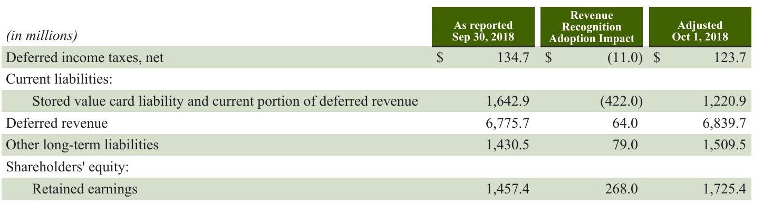

Recent Accounting Pronouncements Not Yet Adopted

Due to the adoption, we began classifying stored value card liabilities as current and long-term deferred revenue.

In February 2018, the FASB issued guidance on the reclassification of certain tax effects from AOCI.The guidance permits entities to reclassify the stranded tax effects resulting from the Tax Act from AOCI to retained earnings. The guidance will be effective at the beginning of our first quarter of fiscal 2020 and will be adopted prospectively. We do not expect a material impact upon adoption of this guidance. In February 2016, the FASB issued guidance on the recognition and measurement of leases. Under the new guidance, lessees are required to recognize a lease liability, which represents the discounted obligation to make future minimum lease payments, and a corresponding right-of-use asset on the balance sheet for most leases. The guidance retains the current accounting for lessors and does not make significant changes to the recognition, measurement, and presentation of expenses and cash flows by a lessee. Enhanced disclosures will also be required to give financial statement users the ability to assess the amount, timing and uncertainty of cash flows arising from leases. We will be applying the guidance, as permitted by the alternative method issued by the FASB, at the beginning of our first quarter of fiscal 2020, with certain practical expedients. Most significantly, we are electing the "package of practical expedients,' which allows us to rely on our prior conclusions regarding lease identification, classification and initial direct costs. In preparation for the adoption of the guidance,we are in the process of implementing controls and key system changes to enable the preparation of financial information. We expect this adoption will result in a right-of-use asset and lease liability in the range of approximately $8 billion to $9 billion on our consolidated balance sheets but will have an insignificant impact on our consolidated statements of earnings.

Starbucks Corporation 2019 Form 10-K59

Starbucks Corporation 2019 Form 10-K59

Starbucks Corporation 2019 Form 10-K59

Note 2:Acquisitions, Divestitures and Strategic Alliance Fiscal 2019 In the third quarter of fiscal 2019, we sold our company-operated retail business in Thailand to Coffee Concepts Thailand, a joint-venture between Maxim's Caterers Limited and F&N Retail Connection Co. Ltd, converting this operation to a fully licensed market. This transaction resulted in a pre-tax gain of $601.9 million, which was included in net gains resulting from divestiture of certain operations on our consolidated statements of earnings. In the second quarter of fiscal 2019, we sold our company-operated retail businesses in France and the Netherlands to Alsea. S.A.B. de C.V. converting these operations to fully licensed markets. These transactions did not have a material impact on our consolidated financial statements.

In the second quarter of fiscal 2019, we sold our company-operated retail businesses in France and the Netherlands to Alsea. S.A.B. de C.V. converting these operations to fully licensed markets. These transactions did not have a material impact on our consolidated financial statements. Fiscal 2018 We entered into an agreement on May 6, 2018 to establish the Global Coffee Alliance with Nestle. On August 26, 2018, Nestle licensed the rights to market, sell and distribute Starbucks consumer packaged goods and foodservice products in authorized channels. We received an up-front payment of approximately $7 billion consisting primarily of prepaid royalties which was recorded to current and long-term deferred revenue. See Note 1, Summary of Significant Accounting Policies, for the accounting treatment. On March 23, 2018, we sold our company-operated retail store assets and operations in Brazil to SouthRock, converting these operations to a fully licensed market. This transaction did not have a material impact on our consolidated financial statements. On December 31, 2017, we acquired the remaining 50% interest of our East China joint venture ("East China") from President Chain Store (Hong Kong) Holding Ltd. and Kai Yu (BVI) collectively, "Uni-President Group" or "UPG, for approximately $1.4 billion.Approximately $90.5 million of pre-existing liabilities owed by East China to Starbucks were effectively settled upon the acquisition. Acquiring the remaining interest of East China, which at the time operated over 1,400 stores in the Shanghai, Jiangsu and Zhejiang Provinces, built on the Company's ongoing investment in China. The estimated fair values of the assets acquired and liabilities assumed are based on valuation and analysis performed by management. Concurrently with the purchase of our East China joint venture, we sold our 50% interest in President Starbucks Coffee Taiwan Limited, our joint venture operations in Taiwan, to UPG for approximately $181.2 million. The transaction resulted in a pre-tax gain of $156.6 million which was included in net gain resulting from divestiture of certain operations on our consolidated statements of earnings

60Starbucks Corporation 2019 Form 10-K

60Starbucks Corporation 2019 Form 10-K

The following table summarizes the preliminary allocation of the total consideration to the fair values of the assets acquired and liabilities assumed as of December 31, 2017, which are reported within our International segment (in millions):

|  |  |  |
| --- | --- | --- |
| Consideration: |  | 1,440.8 |
| Cash paid for UPG 50% equity interest | $ |  |
| Fair value of our pre-existing 50% equity interest |  | 1,440.8 |
| Settlement of pre-existing liabilities |  | 90.5 |
| Total consideration | $ | 2,972.1 |
|  |  |  |
| Fair value of assets acquired and liabilities assumed: |  |  |
| Cash and cash equivalents | $ | 129.5 |
| Accounts receivable |  | 14.3 |
| Inventories |  | 16.1 |
| Prepaid expenses and other current assets |  | 20.6 |
| Property, plant and equipment |  | 254.1 |
| Other long-term assets |  | 44.6 |
| Other intangible assets |  | 818.0 |
| Goodwill |  | 2,164.1 |
| Total assets acquired | $ | 3,461.3 |
| Accounts payable |  | 34.7 |
| Accrued liabilities |  | 187.7 |
| Stored value card liability |  | 21.7 |
| Other long-term liabilities |  | 245.1 |
| Total liabilities assumed |  | 489.2 |
| Total consideration | $ | 2,972.1 |

As a result of this acquisition, we remeasured the carrying value of our preexisting 50% equity method investment to fair value, which resulted in a total gain of $1.4 billion that is not subject to income tax, and was presented as gain resulting from acquisition of joint venture on our consolidated statements of earnings. The fair value of $1.4 billion was calculated using an income approach, which was based on significant inputs that are not observable in the market and thus represents a fair value measurement categorized within Level 3 of the fair value hierarchy. Key assumptions used in estimating future cash flows included projected revenue growth and operating expenses, as well as the selection of an appropriate discount rate. Estimates of revenue growth and operating expenses were based on internal projections and considered the historical performance of stores, local market economics and the business environments impacting store performance. The discount rate applied was based on East China's weighted-average cost of capital and included company-specific and size risk premiums. The assets acquired and liabilities assumed are reported within our International segment. Other current and long-term assets acquired primarily include lease deposits and prepaid rent. Accrued liabilities and other long-term liabilities assumed primarily include deferred income tax, dividend payable, accrued payroll, income tax payable and accrued occupancy costs. The definite-lived intangibles primarily relate to reacquired rights to operate stores exclusively in East China.The reacquired rights of $798.0 million represent the fair value calculated over the remaining original contractual period and will be amortized on a straight-line basis through September 2022. Amortization expense for these definite-lived intangible assets was $163.8 million and $129.8 million for fiscal 2019 and 2018, respectively. The estimated future amortization expense is approximately $157.8 million each year for the next two years and approximately $154.4 million in fiscal 2022. Goodwill represents the intangible assets that do not qualify for separate recognition and primarily includes the acquired customer base,the acquired workforce including store partners in the region that have strong relationships with these customers, and the existing geographic retail and online presence. The entire balance was allocated to the International segment and is not deductible for income tax purposes. Due to foreign currency translation, the balance of goodwill related to the acquisition decreased $190.6 million since the date of acquisition to $2.0 billion as of September 29, 2019. We began consolidating East China's results of operations and cash flows into our consolidated financial statements after December 31,2017.For the year ended September 30,2018, East China's revenue included in our consolidated statements of earnings was $903.0 million. For the year ended September 30, 2018, East China's net earnings included in our consolidated statements of earnings was $73.1 million.

Starbucks Corporation 2019 Form 10-K61

Starbucks Corporation

2019 Form 10-K61

The following table provides the supplemental pro forma revenue and net earnings of the combined entity had the acquisition date of East China been October 3, 2016, the first day of our first quarter of fiscal 2017, rather than the end of our first quarter of fiscal 2018 (in millions):

Revenue

Net earnings attributable to Starbucks

(1)The pro forma net earnings attributable to Starbucks for fiscal 2017 includes acquisition-related gain of $1.4 billion and transaction and integration costs of $39.3 million for the year ended October 1, 2017. The amounts in the supplemental pro forma earnings for the periods presented above fully eliminate intercompany transactions, apply our accounting policies and reflect adjustments for additional occupancy costs as well as depreciation and amortization that would have been charged assuming the same fair value adjustments to leases,property, plant and equipment and acquired intangibles had been applied on October 3, 2016. These pro forma results are unaudited and are not necessarily indicative of results of operations that would have occurred had the acquisition actually closed in the prior period or indicative of the results of operations for any future period. During the year ended September 30, 2018, we incurred approximately $3.6 million of acquisition-related costs, such as regulatory, legal, and advisory fees, which were recorded in general and administrative expenses. In the first quarter of fiscal 2018, we sold the assets associated with our Tazo brand including Tazo% signature recipes, intellectual property and inventory to Unilever for a total of $383.8 million. The transaction resulted in a pre-tax gain of $347.9 million, which was included in the net gain from divestiture of certain operations on our consolidated statements of earnings. Results from Tazo operations prior to the sale were reported primarily in Channel Development.

In the fourth quarter of fiscal 2017, we sold our company-operated retail store assets and operations in Singapore to Maxim's Caterers Limited, converting these operations to a fully licensed market, for a total of $119.9 million. This transaction resulted in a pre-tax gain of $83.9 million, which was included in the net gain resulting from divestiture of certain operations on our consolidated statements of earnings.

# Note 3:Derivative Financial Instruments

# Interest Rates

From time to time, we enter into designated cash flow hedges to manage the variability in cash flows due to changes in benchmark interest rates. We enter into interest rate swap agreements and treasury locks, which are synthetic forward sales of U.S. treasury securities settled in cash based upon the difference between an agreed-upon treasury rate and the prevailing treasury rate at settlement. These agreements are cash settled at the time of the pricing of the related debt. Each derivative agreement's gain or loss is recorded in AOCI and is subsequently reclassified to interest expense over the life of the related debt.

To hedge the exposure to changes in the fair value of our fixed-rate debt, we enter into interest rate swap agreements, which are designated as fair value hedges. The changes in fair values of these derivative instruments and the offsetting changes in fair values of the underlying hedged debt due to changes in the relevant benchmark interest rates are recorded in interest expense. Refer to Note 9 Debt, for additional information on our long-term debt.

To reduce cash flow volatility from foreign currency fluctuations, we enter into forward and swap contracts to hedge portions of cash flows of anticipated intercompany royalty payments, inventory purchases, and intercompany borrowing and lending activities. The resulting gains and losses from these derivatives are recorded in AOCI and subsequently reclassified to revenue, cost of sales, or interest income and other,net,respectively,when the hedged exposures affect net earnings From time to time, we may enter into financial instruments, including but not limited to forward contracts or foreign currency- denominated debt, to hedge the currency exposure of our net investments in certain international operations. The resulting gains and losses from these derivatives are recorded in AOCI and are subsequently reclassified to net earnings when the hedged net investment is either sold or substantially liquidated. Foreign currency forward and swap contracts not designated as hedging instruments are used to mitigate the foreign exchange risk of certain other balance sheet items. Gains and losses from these derivatives are largely offset by the financial impact of

2019 Form 10-K

other, net. Commodities Depending on market conditions, we may enter into coffee forward contracts, futures contracts, and collars to hedge anticipated cash flows under our price-to-be-fixed green coffee contracts, which are described further in Note 5, Inventories, or our longer- dated forecasted coffee demand where underlying fixed price and price-to-be-fixed contracts are not yet available. The resulting gains and losses are recorded in AOCI and are subsequently reclassified to cost of sales when the hedged exposure affects net earnings. Depending on market conditions, we may also enter into dairy forward contracts and futures contracts to hedge a portion of anticipated cash flows under our dairy purchase contracts and our forecasted dairy demand. The resulting gains or losses are recorded in AOCI and are subsequently reclassified to cost of sales when the hedged exposure affects net earnings To mitigate the price uncertainty of a portion of our future purchases, including dairy products, diesel fuel and other commodities, we enter into swap contracts, futures and collars that are not designated as hedging instruments. The resulting gains and losses are recorded in interest income and other, net to help offset price fluctuations on our beverage, food, packaging and transportation costs, which are included in cost of sales on our consolidated statements of earnings. Gains and losses on derivative contracts and foreign currency-denominated debt designated as hedging instruments included in AOCI and expected to be reclassified into earnings within 12 months, net of tax (in millions):

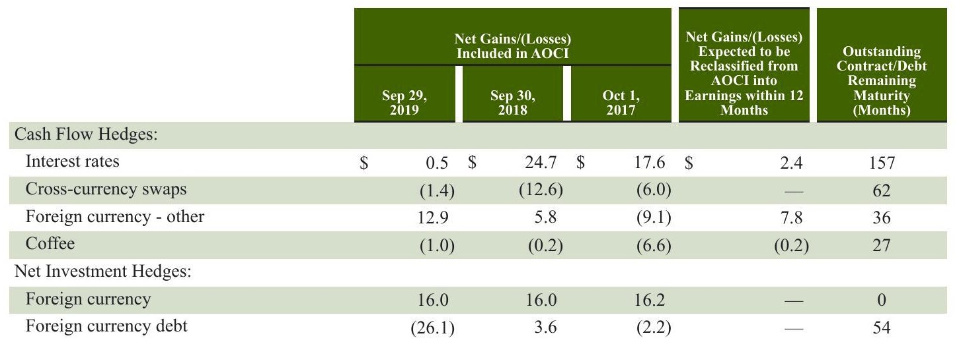

Starbucks Corporation 2019 Form 10-K63

Starbucks Corporation 2019 Form 10-K63

Starbucks Corporation 2019 Form 10-K63

Starbucks Corporation 2019 Form 10-K63

Pretax gains and losses on derivative contracts and foreign currency-denominated long-term debt designated as hedging instruments recognized in OCI and reclassifications from AOCI to earnings (in millions):

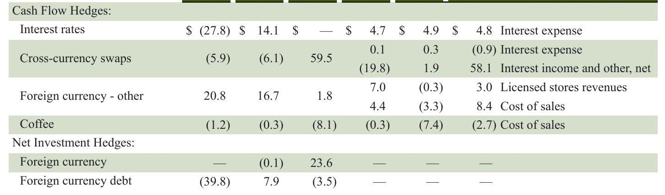

Pretax gains and losses on non-designated derivatives and designated fair value hedging instruments and the related hedged item recognized in earnings (in millions):

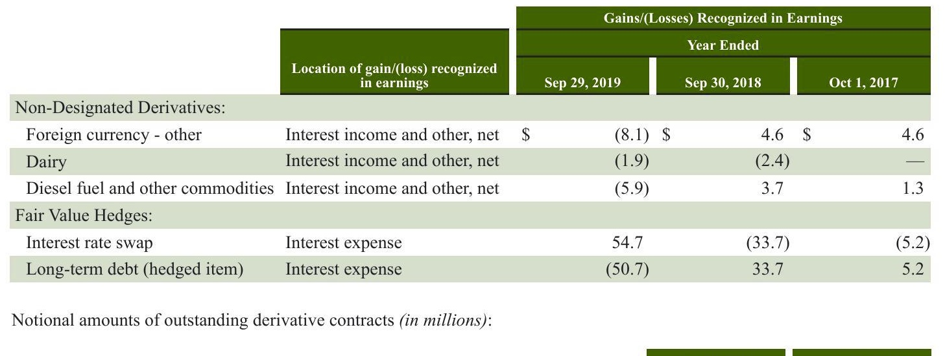

64 Starbucks Corporation 2019 Form 10-K

2019 Form 10-K

Fair value of outstanding derivative contracts (in millions) including the location of the asset and/or liability on the consolidated balance sheets:

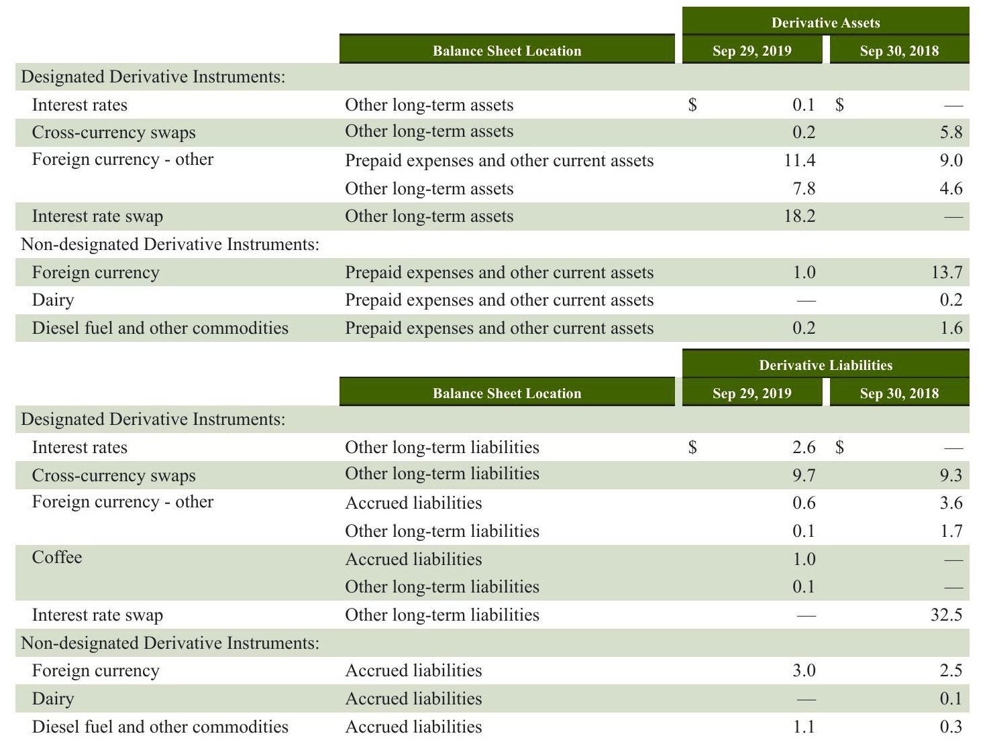

The following amounts were recorded on the consolidated balance sheets related to fixed-to-floating interest rate swaps designated in fair value hedging relationships:

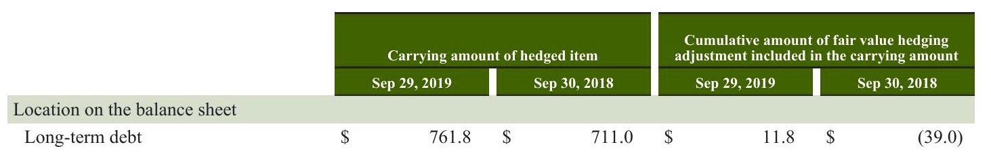

Additional disclosures related to cash flow gains and losses included in AOCI, as well as subsequent reclassifications to earnings,are included in Note 11,Equity

Starbucks Corporation 2019 Form 10-K65

Starbucks Corporation

2019 Form 10-K65

Note 4:Fair Value Measurements Assets and Liabilities Measured at Fair Value on a Recurring Basis (in millions).

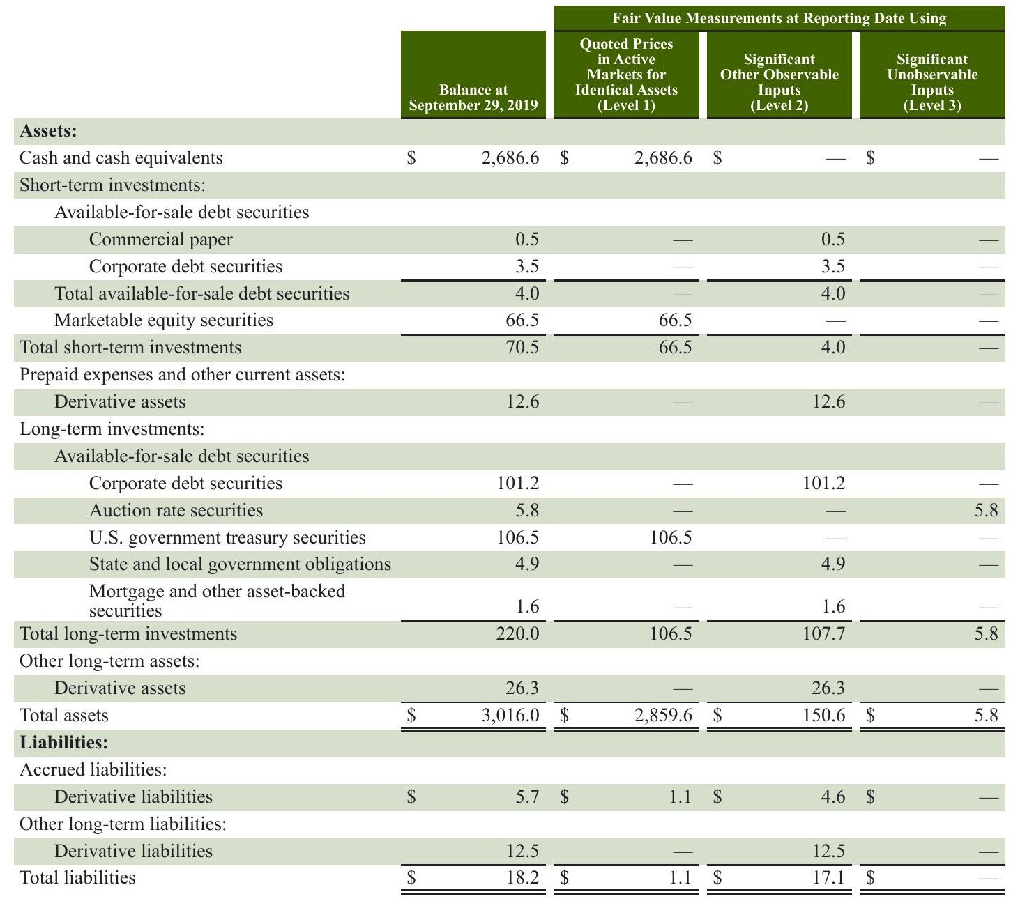

66Starbucks Corporation 2019 Form 10-K

2019 Form 10-K

Revenue Components We generate the majority of our revenues through company-operated stores and licensed stores. Company-operated and Licensed Store Summary as of September 29, 2019

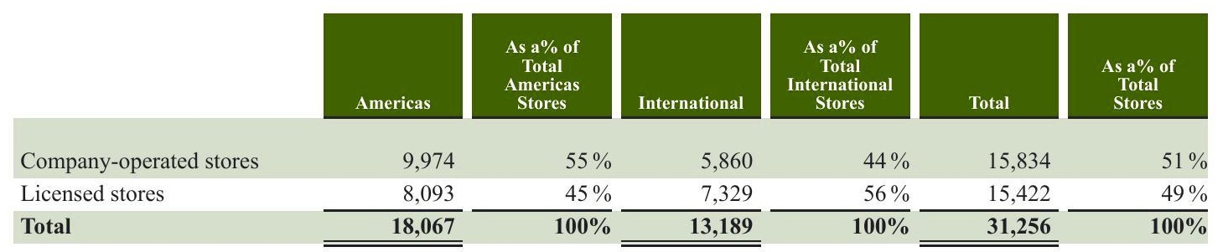

The mix of company-operated versus licensed stores in a given market will vary based on several factors, including our ability to access desirable local retail space,the complexity, profitability and expected ultimate size of the market for Starbucks and our ability to leverage the support infrastructure within a geographic region

# Company-operated Stores

Revenue from company-operated stores accounted for 81% of total net revenues during fiscal 2019. Our retail objective is to be the leading retailer and brand of coffee and tea in each of our target markets by selling the finest quality coffee, tea and related products, as well as complementary food offerings, and by providing each customer with a unique Starbucks Experience. The Starbucks Experience is built upon superior customer service and a seamless digital experience as well as clean and well- maintained stores that reflect the personalities of the communities in which they operate, thereby building a high degree of customer loyalty. Our strategy for expanding our global retail business is to increase our market share in a disciplined manner, by selectively opening additional stores in new and existing markets, as well as increasing sales in existing stores, to support our long-term strategic objective to maintain Starbucks standing as one of the most recognized and respected brands in the world. Store growth in specific existing markets will vary due to many factors, including expected financial returns, the maturity of the market, economic conditions, consumer behavior and local business practices. Company-operated store data for the year-ended September 29, 2019:

|  |  |  |  |  |  |  |
| --- | --- | --- | --- | --- | --- | --- |
| Americas: |  |  |  |  |  |  |
| U.S. | 8,575 | 412 | (196) |  | 216 | 8,791 |
| Canada | 1,109 | 82 | (16) |  | 66 | 1,175 |
| Siren Retail | 6 | 3 | (1) |  | 2 | 8 |
| Total Americas | 9,690 | 497 | (213) |  | 284 | 9,974 |
| International (0): |  |  |  |  |  |  |
| China | 3,521 | 629 | (27) |  | 602 | 4,123 |
| Japan | 1,286 | 105 | (12) |  | 93 | 1,379 |
| Thailand | 352 | 29 | (4) | (377) | (352) |  |
| U.K. | 335 | 6 | (53) |  | (47) | 288 |
| All Other | 155 | 1 | (9) | (82) | (90) | 65 |
| Siren Retail | 2 | 3 |  |  | 3 | 5 |
| Total International | 5,651 | 773 | (105 | (459) | 209 | 5,860 |
| Total company-operated | 15,341 | 1,270 | (318) | (459) | 493 | 15,834 |

International store data includes the transfer of 377 company-operated stores in Thailand to licensed stores as a result of the sale of operations late in the third quarter of fiscal 2019, and the transfer of 82 company-operated stores in France and the Netherlands to licensed stores as a result of the sales of operations in the second quarter of fiscal 2019.

Starbucks Corporation

2019 Form 10-K

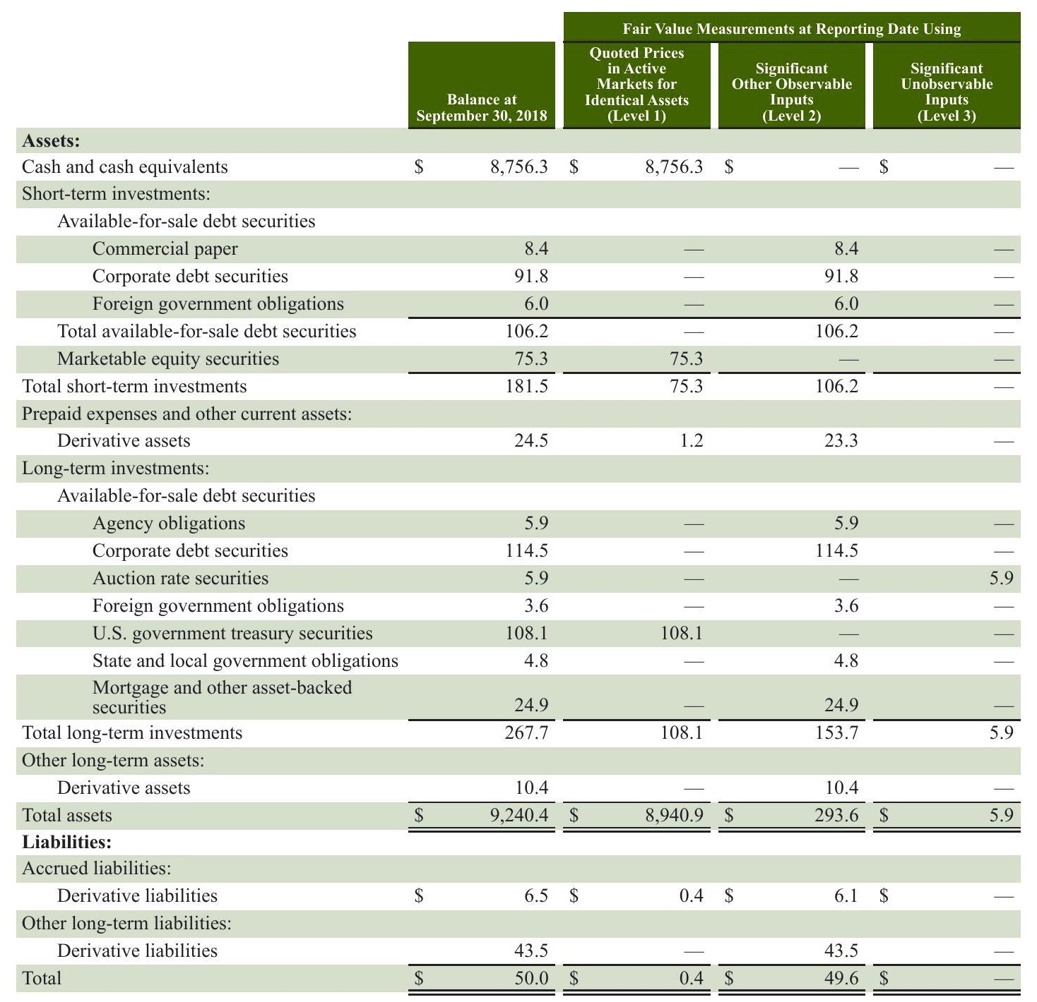

There were no material transfers between levels and there was no significant activity within Level 3 instruments during the periods presented. The fair values of any financial instruments presented above exclude the impact of netting assets anc

Long-term investments generally mature within 4 years. Proceeds from sales of securities were $291.1 million, $459.0 million. and $999.7 million for fiscal 2019, 2018 and 2017, respectively. Realized gains and losses were not material for fiscal 2019, 2018, and 2017. Gross unrealized holding gains and losses were not material as of September 29, 2019 and September 30, 2018.

Starbucks Corporation 2019Form 10-K67

Starbucks Corporation 2019Form 10-K67

2019Form 10-K67

2019Form 10-K67

# Marketable Equity Securities

Marketable equity securities include equity mutual funds and exchange-traded funds. Our marketable equity securities portfolio approximates a portion of our liability under our MDCP, a defined contribution plan. Our MDCP liability was $92.1 million and $102.2 million as of September 29, 2019 and September 30, 2018, respectively. The changes in net unrealized holding gains and losses in the marketable equity securities portfolio included in earnings for fiscal 2019, 2018 and 2017 were not material. Gross unrealized holding gains and losses on marketable equity securities were not material as of September 29, 2019 and September 30, 2018. Derivative Assets and Liabilities Derivative assets and liabilities include foreign currency forward contracts, commodity futures contracts, collars and swaps, which are described further in Note 3, Derivative Financial Instruments. Assets and Liabilities Measured at Fair Value on a Nonrecurring Basis Assets and liabilities recognized or disclosed at fair value on a nonrecurring basis include items such as property, plant and equipment, goodwill and other intangible assets, equity and other investments, and other assets. These assets are measured at fair value if determined to be impaired. Impairment of property, plant, and equipment is included at Note 1, Summary of Significant Accounting Policies. Other than the impairments discussed in Note 8, Other Intangible Assets and Goodwill, and the aforementioned fair value adjustments, there were no other material fair value adjustments during fiscal 2019 and 2018. Fair Value of Other Financial Instruments The estimated fair value of our long-term debt based on the quoted market price (Level 2) is included at Note 9, Debt. Note 5:Inventories (in millions)

|  |  |  |  |
| --- | --- | --- | --- |
| Coffee: |  |  |  |
| Unroasted | $ | 656.5$ | 588.6 |
| Roasted |  | 276.5 | 281.2 |
| Other merchandise held for sale |  | 288.0 | 273.1 |
| Packaging and other supplies |  | 308.4 | 257.6 |
| Total | $ | 1,529.4 $ | 1,400.5 |
| Other merchandise held for sale includes, among other items, serveware, food and tea. Inventory levels vary due to seasonality, commodity market supply and price fluctuations. | | | |
| As of September 29, 2019, we had committed to purchasing green coffee totaling $854 million under fixed-price contracts and an estimated $203 million under price-to-be-fixed contracts. A portion of our price-to-be-fixed contacts are effectively fixed | | | |

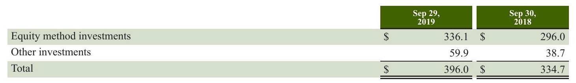

As of September 29,2019,we had 50% ownership interests in Starbucks Coffee Korea Co.,Ltd.and Tata Starbucks Limited (India). These international entities operate licensed Starbucks retail stores. Additional disclosure regarding changes in our

2019 Form 10-K

2019 Form 10-K

68 Starbucks Corporation

equity method investments due to acquisition or divestiture is included at Note 2, Acquisitions, Divestitures and Strategic Alliance. We also license the rights to produce and distribute Starbucks-branded products to our 50% owned joint venture, The North American Coffee Partnership with the Pepsi-Cola Company, which develops and distributes bottled Starbucks beverages, including Frappuccino coffee drinks, Starbucks Doubleshot espresso drinks, Starbucks Refreshers beverages, and StarbucksIced Espresso Classics Our share of income and losses from our equity method investments is included in income from equity investees on our consolidated statements of earnings. Also included in this line item is our proportionate share of gross profit resulting from coffee and other product sales to, and royalty and license fee revenues generated from, equity investees. Revenues generated from these related parties were $130.7 million, $112.8 million, and $187.3 million in fiscal 2019, 2018 and 2017, respectively Related costs of sales were $73.2 million, $71.5 million,and $109.3 million in fiscal 2019,2018 and 2017,respectively.As of September 29, 2019 and September 30, 2018, there were $35.5 million and $41.2 million of accounts receivable from equity investees, respectively, on our consolidated balance sheets, primarily related to product sales and royalty revenues.

We have equity interests in entities that develop and operate Starbucks licensed stores in several global markets, as well as in companies that support our strategic initiatives. We do not have significant influence over these entities and their fair values are not readily determinable. Therefore, we elected to measure these investments at cost with adjustments for observable changes in price or impairment. Note 7: Supplemental Balance Sheet Information (in millions) Prepaid Expenses and Other Current Assets

|  |  |  |  |  |
| --- | --- | --- | --- | --- |
| Income tax receivable | $ | 141.1$ |  | 955.4 |
| Other prepaid expenses and current assets |  | 347.1 |  | 507.4 |
| Total prepaid expenses and current assets | $ | 488.2$ |  | 1,462.8 |
| Property, Plant and Equipment, net |  |  |  |  |
|  | Sep 29, 2019 | | Sep 30, 2018 | |
| Land | $ | 46.8$ |  | 46.8 |
| Buildings |  | 691.5 |  | 557.3 |
| Leasehold improvements |  | 7,948.6 |  | 7,372.8 |
| Store equipment |  | 2,659.5 |  | 2,400.2 |
| Roasting equipment |  | 769.6 |  | 658.8 |
| Furniture, fixtures and other |  | 1,799.0 |  | 1,659.3 |
| Work in progress |  | 358.5 |  | 501.9 |
| Property, plant and equipment, gross |  | 14,273.5 |  | 13,197.1 |
| Accumulated depreciation |  | (7,841.8) |  | (7,268.0) |
| Property, plant and equipment, net | $ | 6,431.7. | $ | 5,929.1 |
| Accrued Liabilities |  |  |  |  |
|  | Sep 29, 2019 |  |  | Sep 30, 2018 |

Accrued occupancy costs 176.9 $ 164.2 Accrued dividends payable 485.7 445.4 Accrued capital and other operating expenditures 703.9 745.4 Self insurance reserves 210.5 213.7 Accrued business taxes 176.7 183.8 Total accrued liabilities $ 1,753.7 $ 1,752.5

Note 8: Other Intangible Assets and Goodwill Indefinite-Lived Intangible Assets

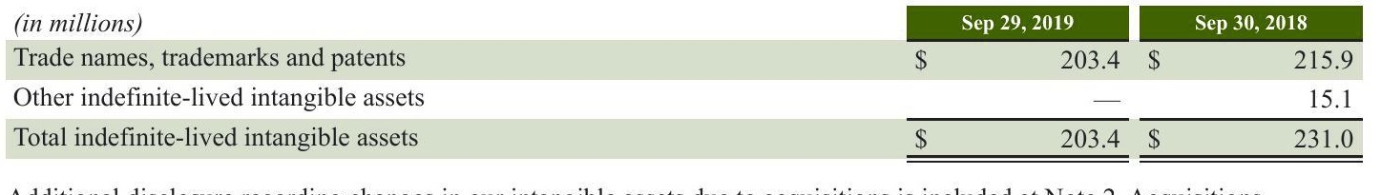

Changes in the carrying amount of goodwill by reportable operating segment (in millions):

|  |  |  |  |  |  |  |  |  |  |  |
| --- | --- | --- | --- | --- | --- | --- | --- | --- | --- | --- |
|  | Americas | | International | | Channel Development | | Corporate and Other | | Total | |
| Goodwill balance at October 2,2017 | $ | 211.6$ |  | 892.7 $ |  | 30.2$ |  | 404.7 | $ | 1,539.2 |
| Acquisition/(divestiture) |  |  | 2,164.0 |  |  | (1.5) |  |  |  | 2,162.5 |
| Impairment |  |  |  | (37.6) |  |  |  |  |  | (37.6) |
| Other |  | 285.8 |  | (15.9) |  | 6.0 |  | (398.4) |  | (122.5) |
| Goodwill balance at October 1,2018 | $ | 497.4$ |  | 3,003.2$ |  |  | 34.7$ | 6.3 | $ | 3,541.6 |
| Acquisition/(divestiture) |  |  |  | (5.5) |  |  |  |  |  | (5.5) |
| Impairment |  |  |  | (5.3) |  |  |  | (5.2) |  | (10.5 |
| Other |  | (0.7) |  | (34.0) |  |  |  | (0.1) |  | (34.8) |
| Goodwill balance at September 30, 2019 | $ | 496.7 | $ | 2,958.4 $ |  | 34.7 $ |  | 1.0 | $ | 3,490.8 |

For fiscal 2018, "Other" primarily consists of changes in the goodwill balance resulting from transfers between segments due to the dissolution of the Teavana reporting unit. For both fiscal 2019 and 2018, "Other" also includes foreign currency translation. During fiscal 2018, a strengthening Swiss franc diverted consumer traffic to neighboring countries and despite our operational investments and improvements, projections indicated that the carrying value of Switzerland goodwill balance was not fully recoverable. This resulted in an impairment charge for the remaining Switzerland goodwill balance of $37.6 million. During the third quarter of fiscal 2017, management finalized its long-term strategy for the Teavana reporting unit, which included closing all Teavana-branded retail stores. As a result, we recorded store asset impairment of $33.0 million and goodwill impairment of $69.3 million, reducing goodwill of the Teavana reporting unit to $398.3 million as of July 2, 2017. During the third quarter of fiscal 2018, we dissolved the Teavana reporting unit upon completion of the retail store closures. As a result, we reorganized the Teavana business and allocated the remaining $398.3 million of goodwill to other reporting units, primarily within the Americas segment, based on a relative fair value approach. Finite-Lived Intangible Assets

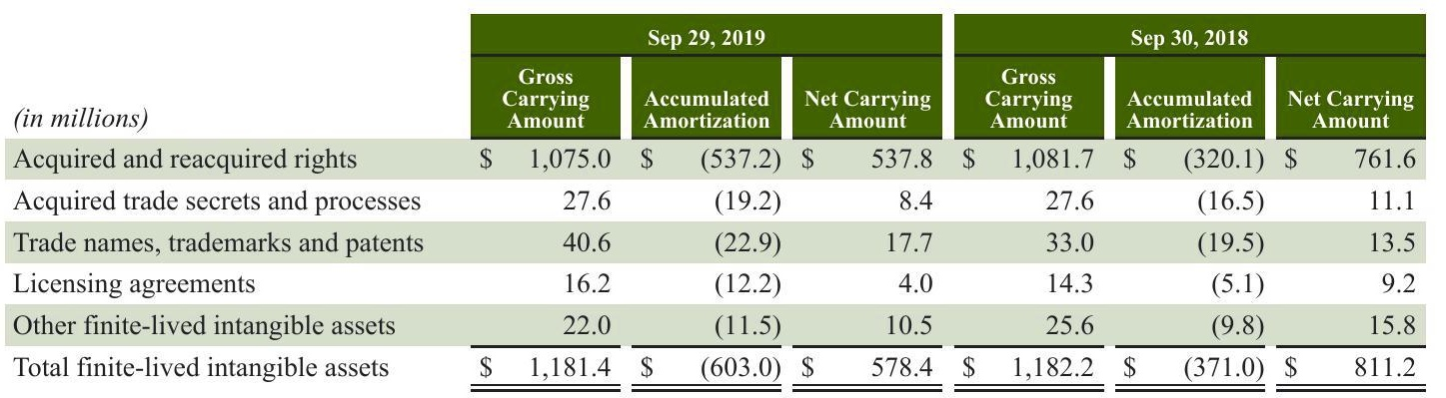

Amortization expense for finite-lived intangible assets was $232.8 million, $186.5 million, and $57.5 million during fiscal 2019, 2018 and 2017, respectively.

70Starbucks Corporation 2019 Form 10-K

70Starbucks Corporation

2019 Form 10-K

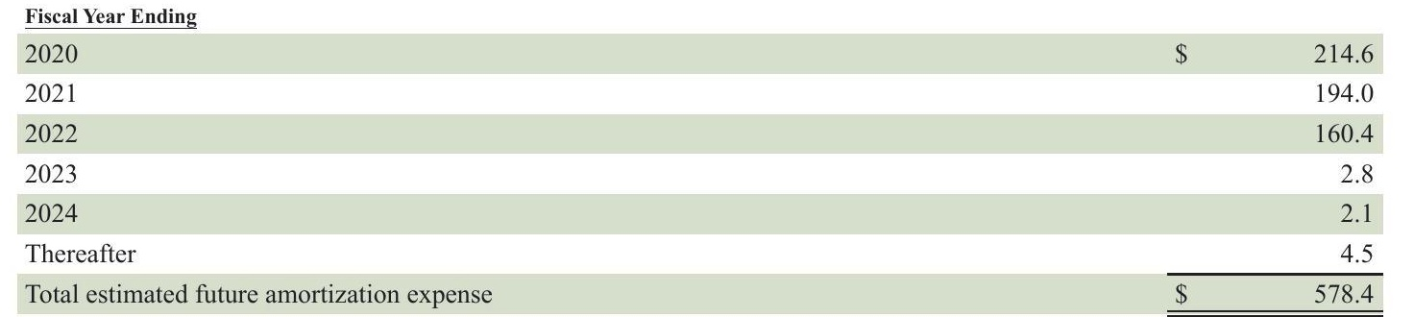



Note 9:Debt Revolving Credit Facility and Commercial Paper Program

Our $2.0 billion unsecured 5-year revolving credit facility (the 2018 credit facility) and a $1.0 billion unsecured 364- Day credit facility (the "364-day credit facility) are available for working capital, capital expenditures and other corporate purposes, including acquisitions and share repurchases. The 2018 credit facility, of which $150 million may be used for issuances of letters of credit, is currently set to mature on October 25, 2022. We have the option, subject to negotiation and agreement with the related banks, to increase the maximum commitment amount by an additional $500 million. Borrowings under the credit facility will bear interest at a variable rate based on LIBOR,and, for U.S.dollar-denominated loans under certain circumstances, a Base Rate (as defined in the credit facility), in each case plus an applicable margin. The applicable margin is based on the better of (i) the Company's long-term credit ratings assigned by Moody's and Standard & Poor's rating agencies and (ii) the Company's fixed charge coverage ratio, pursuant to a pricing grid set forth in the five-year credit agreement. The current applicable margin is 0.910% for Eurocurrency Rate Loans and 0.000% (nil) for Base Rate Loans. The 364-day credit facility, of which no amount may be used for issuances of letters of credit, has been extended to mature on October 21, 2020. We have the option, subject to negotiation and agreement with the related banks, to increase the maximum eommitment amount by an additional $500 million. Borrowings under the credit facility bear interest at a variable rate based on LIBOR, and, for U.S. dollar-denominated loans under certain circumstances, a Base Rate (as defined in the credit facility), in each case plus an applicable margin. The applicable margin was 0.920% for Eurocurrency Rate Loans and 0.000% (nil) for Base Rate Loans. Both credit facilities contain provisions requiring us to maintain compliance with certain covenants, including a minimum fixed charge coverage ratio, which measures our ability to cover financing expenses. As of September 29, 2019, we were in compliance with all applicable covenants. No amounts were outstanding under our credit facility as of September 29, 2019 Under our commercial paper program, we may issue unsecured commercial paper notes up to a maximum aggregate amount outstanding at any time of $3.0 billion, with individual maturities that may vary but not exceed 397 days from the date of issue. Amounts outstanding under the commercial paper program are required to be backstopped by available commitments under our credit facility discussed above. The proceeds from borrowings under our commercial paper program may be used for working capital needs, capital expenditures and other corporate purposes, including, but not limited to, business expansion, payment of cash dividends on our common stock and share repurchases. As of September 29, 2019, we had no borrowings outstanding under the program.

Starbucks Corporation 2019 Form 10-K71

Starbucks Corporation 2019 Form 10-K71

Starbucks Corporation 2019 Form 10-K71

Long-term Debt Components of long-term debt including the associated interest rates and related fair values by calendar maturity (in millions,

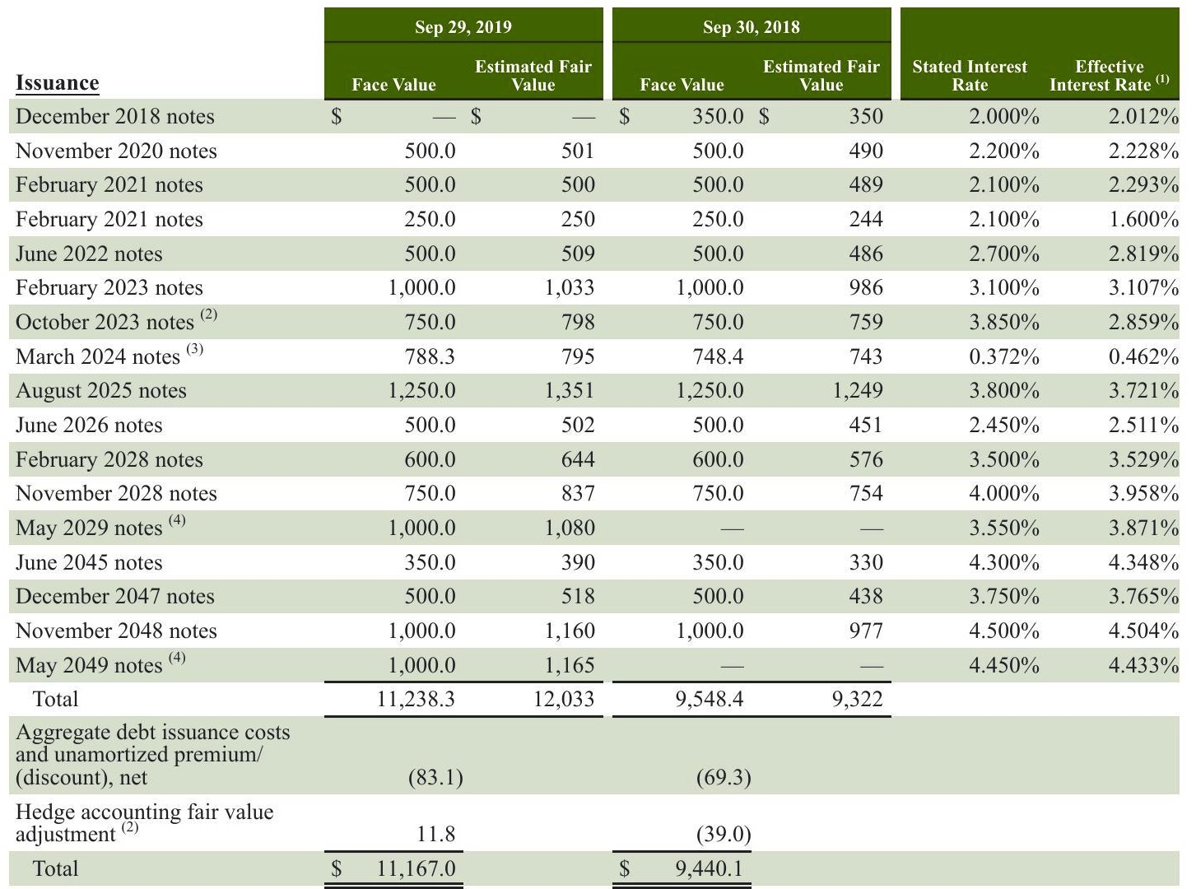

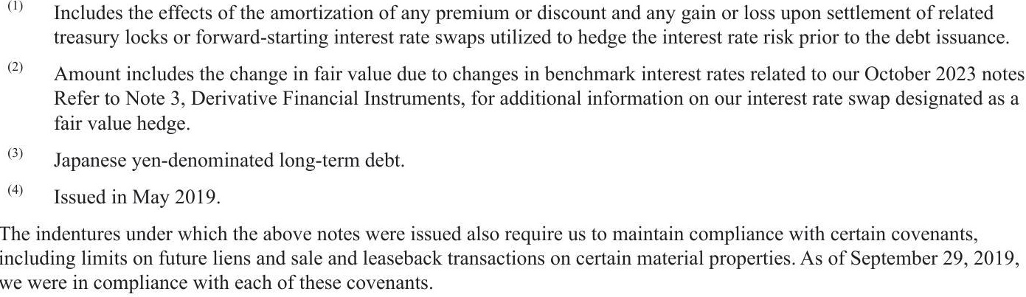

72 Starbucks Corporation 2019 Form 10-K

2019 Form 10-K

The following table summarizes our long-term debt maturities as of September 29, 2019 by fiscal year (in millions):

|  |  |  |
| --- | --- | --- |
| Fiscal Year | Total | |
| 2020 | $ |  |
| 2021 |  | 1,250.0 |
| 2022 |  | 500.0 |
| 2023 |  | 1,000.0 |
| 2024 |  | 1,538.3 |
| Thereafter |  | 6,950.0 |
| Total | $ | 11,238.3 |

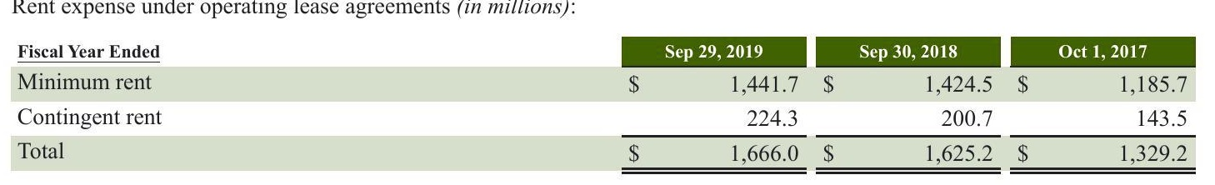

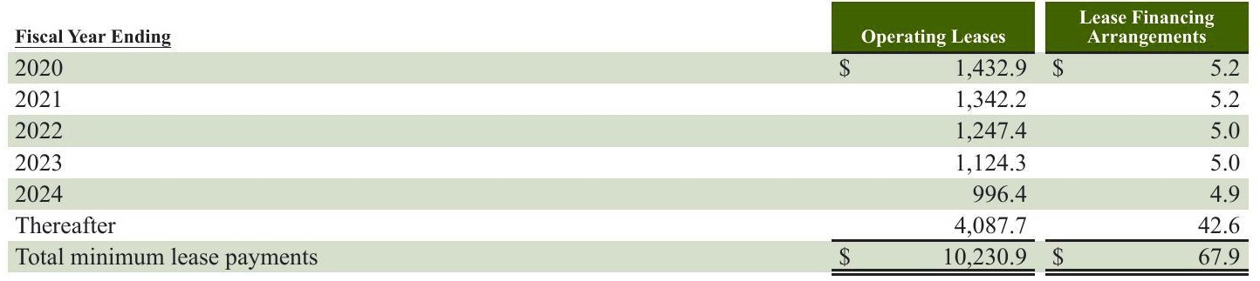

We have subleases related to certain of our operating leases. During fiscal 2019, 2018 and 2017, we recognized sublease income of $10.9 million, $12.3 million, and $15.5 million, respectively. Additionally, as of September 29, 2019 and September 30, 2018, the gross carrying values of assets related to build-to-suit lease arrangements accounted for as financing leases were $122.3 million and $103.2 million, respectively,with associated accumulated depreciation of $17.2 million and $12.7 million, respectively. Lease exit costs associated with our restructuring efforts primarily relate to the closure of Teavana retail stores and certain Starbucks company-operated stores, and are recognized concurrently with actual store closures. Total lease exit costs of $55.3 million, $119.3 million, and $15.7 million were recorded within restructuring and impairments on the consolidated statement of earnings in fiscal 2019, 2018, and 2017, respectively. Remaining lease exit costs are not expected to be material.

# Note 11: Equity

shares of preferred stock, none of which was outstanding at September 29, 2019. In September 2018, we entered into accelerated share repurchase agreements ("ASR agreements") with third-party financial institutions totaling $5.0 billion, effective October 1, 2018. We made a $5.0 billion up-front payment to the financial institutions and received an initial delivery of 72.0 million shares.In March 2019,we received an additional 4.9 million shares upon the completion of the program based on a volume-weighted average share price (less discount) of $65.03. In March 2019, we entered into ASR agreements with third-party financial institutions totaling $2.0 billion, effective March 22, 2019. We made a $2.0 billion up-front payment to the financial institutions and received an initial delivery of 22.2 million shares. In June 2019, we received an additional 3.9 million shares upon the completion of the program based on a volume- weighted average share price(less discount) of $76.50.

Starbucks Corporation 2019 Form 10-K73

Starbucks Corporation 2019 Form 10-K73

Outside of the ASR agreements noted above,we repurchased 36.6 million shares of common stock for $3.1 billion on the open market during the year ended September 29, 2019. In connection with the ASR agreements and other open market transactions, we repurchased 139.6 million shares of common stock at a total cost of $10.1 billion,131.5 million shares at a total cost of $7.2 billion, and 37.5 million shares of common stock at a total cost of $2.1 billion for the years ended September 29, 2019. September 30, 2018, and October 1, 2017, respectively. In the first quarter 2019, we announced that our Board of Directors approved an increase of 120 million shares to our ongoing share repurchase program. As of September 29, 2019, 29.2 million shares remained available for repurchase under current authorizations.

During the fourth quarter of fiscal 2019, our Board of Directors declared a quarterly cash dividend to shareholders of $0.41 per share to be paid on November 29, 2019 to shareholders of record as of the close of business on November 13, 2019 Comprehensive Income

Comprehensive income includes all changes in equity during the period, except those resulting from transactions with our shareholders. Comprehensive income is comprised of net earnings and other comprehensive income. Accumulated other comprehensive income reported on our consolidated balance sheets consists of foreign currency translation adjustments and other items and the unrealized gains and losses, net of applicable taxes, on available-for-sale debt securities and on derivative instruments designated and qualifying as cash flow and net investment hedges. Changes in AOCI by component for the years ended September 29, 2019, September 30, 2018, and October 1, 2017, net of tax, are as follows:

|  |  |  |  |  |  |  |  |  |  |
| --- | --- | --- | --- | --- | --- | --- | --- | --- | --- |
| (in millions) | Securities | | Hedges | | Hedges | | and Other | | Total |
| September 29,2019 | $ |  |  |  |  |  |  |  |  |
| Net gains/(losses) in AOCI, beginning of period Net gains/(losses) recognized in OCI before |  | (4.9)$ |  | 17.7 $ |  | 19.6 $ | (362.7)$ |  | (330.3) |
| reclassifications |  | 8.2 |  | (10.7) | (29.7) |  | (143.7) |  | (175.9) |
| Net (gains)/losses reclassified from AOCI to earnings |  | 0.6 |  | 4.0 |  |  | (1.7) |  | 2.9 |
| Other comprehensive income/(loss) attributable to Starbucks |  | 8.8 |  | (6.7) | (29.7) |  | (145.4) |  | (173.0) |
| Net gains/(losses) in AOCI, end of period | $ | 3.9 | $ 11.0 | | $ | (10.1) $ |  | (508.1) $ | (503.3) |
| Available- for-Sale |  | Cash Flow | | Net Investment |  | Translation Adjustment | |  |
| (in millions) |  | Securities | Hedges |  | Hedges |  | and Other |  | Total |
| September 30,2018 | $ |  |  |  |  |  |  |  |  |
| Net gains/(losses) in AOCI, beginning of period Net gains/(losses) recognized in OCI before |  | (2.5)$ |  | 4.1$ |  | 14.0 $ | (163.0)$ |  | (155.6) |
| reclassifications Net (gains)/losses reclassified from AOCI to |  | (5.1) |  | 17.9 | 5.6 |  | (216.6) |  | (198.2) |
| earnings Other comprehensive income/(loss) attributable to |  | 2.7 |  | 3.9 |  |  | 16.9 |  | 23.5 |
| Starbucks Net gains/(losses) in AOCI, end of period |  | (2.4) (4.9) |  | 21.8 17.7 $ | 5.6 19.6 |  | (199.7) (362.7) | $ | (174.7) (330.3) |
| $ Available- | | $ | |  | $ | |  |  |
| (in millions) | for-Sale Securities |  | Cash Flow Hedges |  | Net Investment Hedges |  | Translation Adjustment and Other |  | Total |
| October 1,2017 |  |  |  |  |  |  |  |  |  |
| Net gains/(losses) in AOCI, beginning of period | $ | 1.1 | $ | 10.9 $ |  | 1.3$ | (121.7)$ |  | (108.4) |
| Net gains/(losses) recognized in OCI before reclassifications |  | (6.6) |  | 40.6 | 12.7 |  | (40.7) |  | 6.0 |
| Net (gains)/losses reclassified from AOCI to earnings |  | 3.0 |  | (55.6) |  |  | (0.6) |  | (53.2) |
| Other comprehensive income/(loss) attributable to Starbucks |  | (3.6) |  | (15.0) | 12.7 |  | (41.3) |  | (47.2) |
| Net gains/(losses) in AOCI, end of period 74 Starbucks Corporation |  | (2.5) |  | (4.1 $ | 14.0 | $ | (163.0) | $ | (155.6) |
| $ 2019 Form 10-K |  | $ |  |  |  |  |  |  |

Impact of reclassifications from AOCI on the consolidated statements of earnings (in millions):

|  |  |  |  |  |
| --- | --- | --- | --- | --- |
| AOCI | Amounts Reclassified from AOCI | | | Affected Line Item in |
| Sep 29, 2019 | Fiscal Year Ended |  |
| Components Gains/(losses) on available-for-sale | $ | Sep 30, 2018 | Oct 1, 2017 | the Statements of Earnings 4.1)Interest income and other, net |
| securities | 0.9 | $ (3.6$ |  |  |
| Gains/(losses) on cash flow hedges | (3.9) | (3.9) |  | 70.7 Please refer to Note 3, Derivative Instruments for additional information. |
| Translation adjustment () |  |  |  | Net gain resulting from divestiture of certain |
| Brazil |  | (24.1) |  | operations |
| East China joint venture |  | 7.2 |  | Gain resulting from acquisition of joint venture |
| Taiwan joint venture |  | 1.4 |  | Net gain resulting from divestiture of certain operations |
| Thailand | 1.7 |  |  | Net gain resulting from divestiture of certain operations |
| Other |  | (1.7) | 0.6 | Interest income and other, net |
|  | (1.3 | (24.7) |  | 67.2 Total before tax |
|  | (1.6 | 1.2 | (14.0 | Tax (expense)/benefit 53.2 |
|  | $ (2.9) | $ (23.5) | $ | Net of tax |

(1 Release of cumulative translation adjustments to earnings upon sale or liquidation of foreign businesses. Note 12:Employee Stock and Benefit Plans

We maintain several equity incentive plans under which we may grant non-qualified stock options, incentive stock options, restricted stock, restricted stock units ("RSUs") or stock appreciation rights to employees, non-employee directors and consultants. We issue new shares of common stock upon exercise of stock options and the vesting of RSUs. We also have an employee stock purchase plan ("ESPP). As of September 29, 2019, there were 52.6 million shares of common stock available for issuance pursuant to future equity- based compensation awards and 12.4 million shares available for issuance under our ESPP. Stock-based compensation expense recognized in the consolidated financial statements (in millions):

|  |  |  |  |  |  |  |
| --- | --- | --- | --- | --- | --- | --- |
| Fiscal Year Ended | Sep 29, 2019 | | Sep 30,2018 | | Oct 1,2017 | |
| Options | $ | 20.0 | $ | 28.0$ |  | 44.3 |
| RSUs |  | 288.0 |  | 222.3 |  | 131.7 |
| Total stock-based compensation expense recognized in the consolidated statements of earnings | $ | 308.0 | $ | 250.3 | $ | 176.0 |
| Total related tax benefit | $ | 59.3 | $ | 62.4 | $ | 57.6 |
| Total capitalized stock-based compensation included in net property, plant and equipment and inventories on the consolidated balance sheets | $ | 3.4$ |  |  | 3.5 $ | 1.9 |

# Stock Option Plans

We provide stock options as a form of employee compensation, which are primarily time-vested. The majority of time-vested options become exercisable in four equal installments beginning a year from the grant date and generally expire 10 years from the grant date. Options granted to non-employee directors generally vest immediately or one year from grant. All outstanding stock options are non-qualified stock options.

Starbucks Corporation 2019 Form 10-K75

Starbucks Corporation

2019 Form 10-K75

The fair value of stock option awards was estimated at the grant date with the following weighted average assumptions for fiscal 2019, 2018 and 2017:

|  |  |  |  |  |  |  |
| --- | --- | --- | --- | --- | --- | --- |
|  | Employee Stock Options Granted During the Period | | | | | |
|  | | 2018 | | | 2017 |
| Fiscal Year Ended Expected term (in years) | 2019 4.1 | | 3.6 | | | 3.9 |
| Expected stock price volatility | 21.6% | | 20.5% | | | 21.6% |
| Risk-free interest rate | 2.9% | | 2.1% | | | 1.5% |
| Expected dividend yield | 2.1% | | 2.2% | | | 1.8% |
| Weighted average grant price | $ | | $ | | | 56.12 |
| Estimated fair value per option granted | $ | 67.33 11.06 | $ | 56.56 7.32 | $ $ | 8.56 |

The expected term of the options represents the estimated period of time until exercise and is based on historical experience of similar awards, giving consideration to the contractual terms, vesting schedules and expectations of future employee behavior. Expected stock price volatility is based on a combination of historical volatility of our stock and the one-year implied volatility of Starbucks traded options, for the related vesting periods.The risk-free interest rate is based on the implied yield available on U.S. Treasury zero-coupon issues with an equivalent remaining term. The dividend yield assumption is based on our anticipated cash dividend payouts. The amounts shown above for the estimated fair value per option granted are before the estimated effect of forfeitures, which reduce the amount of expense recorded in the consolidated statements of earnings. Stock option transactions for the year ended September 29, 2019 (in millions, except per share and contractual life amounts):

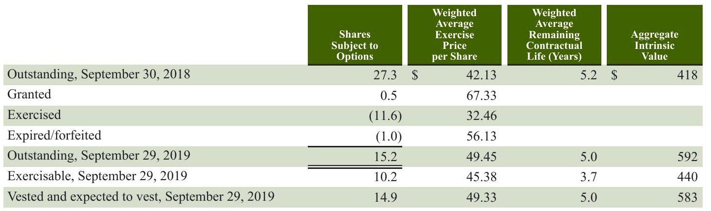

The aggregate intrinsic value in the table above, which is the amount by which the market value of the underlying stock exceeded the exercise price of outstanding options, is before applicable income taxes and represents the amount optionees Would have realized if all in-the-money options had been exercised on the last business day of the period indicated. As of September 29, 2019, total unrecognized stock-based compensation expense, net of estimated forfeitures, related to nonvested options was approximately $5 million, before income taxes, and is expected to be recognized over a weighted average period of approximately 1.6 years.The total intrinsic value of options exercised was $466 million, $236 million, and $181 million during fiscal 2019,2018 and 2017,respectively.The total fair value of options vested was $31 million,$53 million, and $40 million during fiscal 2019, 2018 and 2017, respectively.

We have both time-vested and performance-based RSUs. Time-vested RSUs are awarded to eligible employees and entitle the grantee to receive shares of common stock at the end of a vesting period, subject solely to the employee's continuing employment. The time-yested RSUs either vest in two or four equal annual installments beginning a year from the grant date. Our performance-based RSUs are awarded to eligible employees and entitle the grantee to receive shares of common stock if we achieve specified performance goals during the performance period and the grantee remains employed through the vesting period.

76 Starbucks Corporation

2019 Form 10-K

Starbucks company-operated stores are typically located in high-traffic, high-visibility locations. Our ability to vary the size and format of our stores allows us to locate them in or near a variety of settings, including downtown and suburban retail centers, office buildings, university campuses and in select rural and off-highway locations. We are continuing the expansion of our stores, particularly Drive Thru formats that provide a higher degree of access and convenience, and alternative store formats, which are focused on an elevated Starbucks Experience for our customers. Retail sales mix by product type for company-operated stores:

|  |  |  |  |
| --- | --- | --- | --- |
| Fiscal Year Ended | Sep 29, 2019 | Sep 30, 2018 | Oct1 2017 |
| Beverages | 74% | 74% | 73% |
| Food | 20% | 20% | 20% |
| Packaged and single-serve coffees and teas | 1% | 2% | 3% |
| Other () | 5% | 4% | 4% |
| Total | 100% | 100% | 100% |

"Other" primarily consists of sales of serveware and ready-to-drink beverages, among other items.

The Starbucks Card, our branded stored value card program, is designed to provide customers with a convenient payment method, support gifting and increase the frequency of store visits by cardholders, in part through the related Starbucks* Rewards loyalty program where available, as discussed below. Stored value cards are issued to customers when they initially load them with an account balance. They can be obtained in our company-operated and most licensed stores in North America, China, Japan, and many of our markets in our International segment. Stored value cards can also be obtained on-line,via the Starbucks Mobile App, and through other U.S. and international retailers. Customers may access their card balances by utilizing their stored value card or the StarbucksMobile App in participating stores. Using the Mobile Order and Pay functionality of the Starbucks Mobile App, customers can also place orders in advance for pick-up at certain participating locations in several markets. In nearly all markets, including the U.S. and Canada, customers who register their Starbucks Cards are automatically enrolled in the Starbucks Rewards program. Registered members can receive various benefits depending on factors such as the number of reward points ("Stars") earned. Refer to Note 1, Summary of Significant Accounting Policies, included in Item 8 of Part II of this 10-K, for further discussion of our stored value cards and loyalty program.

# Licensed Stores

Revenues from our licensed stores accounted for 11% of total net revenues in fiscal 2019. Licensed stores generally have a lower gross margin and a higher operating margin than company-operated stores. Under the licensed model, Starbucks receives a margin on branded products and supplies sold to the licensed store operator along with a royalty on retail sales. Licensees are responsible for operating costs and capital investments which more than offset the lower revenues we receive under the licensed store model. In our licensed store operations, we leverage the expertise of our local partners and share our operating and store development experience. Licensees provide improved, and at times the only, access to desirable retail space. Most licensees are prominent retailers with in-depth market knowledge and access. As part of these arrangements, we sell coffee, tea, food and related products to licensees for resale to customers and receive royalties and license fees from the licensees. We also sell certain equipment, such as coffee brewers and espresso machines, to our licensees for use in their operations. Employees working in licensed retail locations are required to follow our detailed store operating procedures and attend training classes similar to those given to employees in company-operated stores. In a limited number of international markets, we also use traditional franchising and include these stores in the results of operations from our other licensed stores.

Starbucks Corporation2019 Form 10-K

Starbucks Corporation2019 Form 10-K

RSU transactions for the year ended September 29, 2019 (in millions, except per share and contractual life amounts):

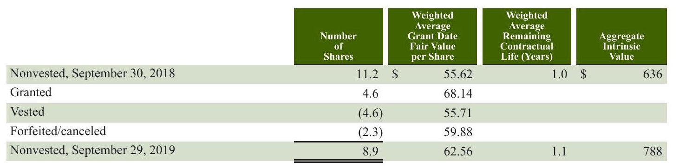

For fiscal 2018 and 2017, the weighted average fair value per RSU granted was $56.48 and $54.30, respectively. As of September 29, 2019, total unrecognized stock-based compensation expense related to nonvested RSUs, net of estimated forfeitures, was approximately $165 million, before income taxes, and is expected to be recognized over a weighted average period of approximately 2.0 years. The total fair value of RSUs vested was $255 million, $166 million and $182 million during fiscal 2019, 2018 and 2017, respectively.

Our ESPP allows eligible employees to contribute up to 10% of their base earnings toward the quarterly purchase of our common stock, subject to an annual maximum dollar amount. The purchase price is 95% of the fair market value of the stock on the last business day of the quarterly offering period. The number of shares issued under our ESPP was 0.4 million in fiscal 2019. Deferred Compensation Plan

We have a Deferred Compensation Plan for Non-Employee Directors under which non-employee directors may, for any fiscal year, irrevocably elect to defer receipt of shares of common stock the director would have received upon vesting of restricted stock units. The number of deferred shares outstanding related to deferrals made under this plan is not material. Defined Contribution Plans

We maintain voluntary defined contribution plans, both qualified and non-qualified, covering eligible employees as defined in the plan documents. Participating employees may elect to defer and contribute a portion of their eligible compensation to the plans up to limits stated in the plan documents, not to exceed the dollar amounts set by applicable laws. Our matching contributions to all U.S. and non-U.S. plans were $122.1 million, $111.7 million and $101.4 million in fiscal 2019, 2018 and 2017, respectively. Note 13:Income Taxes

On December 22, 2017, the President of the United States signed and enacted comprehensive tax legislation into law H.R. 1, commonly referred to as the Tax Act. Except for certain provisions, the Tax Act is effective for tax years beginning on or after January 1, 2018. The tax rate for fiscal 2019 and future years was reduced to 21% from our blended 24.5% in fiscal 2018. In the first quarter of fiscal 2019 the measurement period related to the Tax Act concluded, which resulted in immaterial adjustments to our provisional estimates. While the Tax Act provides for a modified territorial tax system, global intangible low-taxed income (GILTI') provisions are applied providing an incremental tax on foreign income. We have made a policy election to classify taxes due under the GILTI provision as a current period expense. Components of earnings before income taxes (in millions).

|  |  |  |  |  |  |  |
| --- | --- | --- | --- | --- | --- | --- |
| Fiscal Year Ended | Sep 29, 2019 | | Sep 30, 2018 | | Oct 1, 2017 | |
| United States | $ | 3,518.7$ |  | 4,826.0$ |  | 3,393.0 |
| Foreign |  | 947.5 |  | 954.0 |  | 924.5 |
| Total earnings before income taxes | $ | 4,466.2 | $ | 5,780.0 | $ | 4,317.5 |

Starbucks Corporation 2019 Form 10-K77

Starbucks Corporation 2019 Form 10-K77

Starbucks Corporation 2019 Form 10-K77

|  |  |  |  |  |  |  |
| --- | --- | --- | --- | --- | --- | --- |
| Provision/(benefit) for income taxes (in millions): Fiscal Year Ended | Sep 29, 2019 | | Sep 30, 2018 | | Oct 1,2017 | |
| Current taxes: | | | | | | |
| U.S.federal | $ | 1,414.3$ |  | 156.2$ |  | 931.0 |
| U.S.state and local |  | 447.8 |  | 52.0 |  | 170.8 |
| Foreign |  | 458.3 |  | 327.0 |  | 216.6 |
| Total current taxes |  | 2,320.4 |  | 535.2 |  | 1,318.4 |
| Deferred taxes: | | | | | | |
| U.S.federal |  | (1,074.5) |  | 633.7 |  | 121.2 |
| U.S. state and local |  | (322.4) |  | 101.5 |  | 14.2 |
| Foreign |  | (51.9) |  | (8.4) |  | (21.2) |
| Total deferred taxes |  | (1,448.8) |  | 726.8 |  | 114.2 |
| Total income tax expense | $ | 871.6 | $ | 1,262.0 | $ | 1,432.6 |

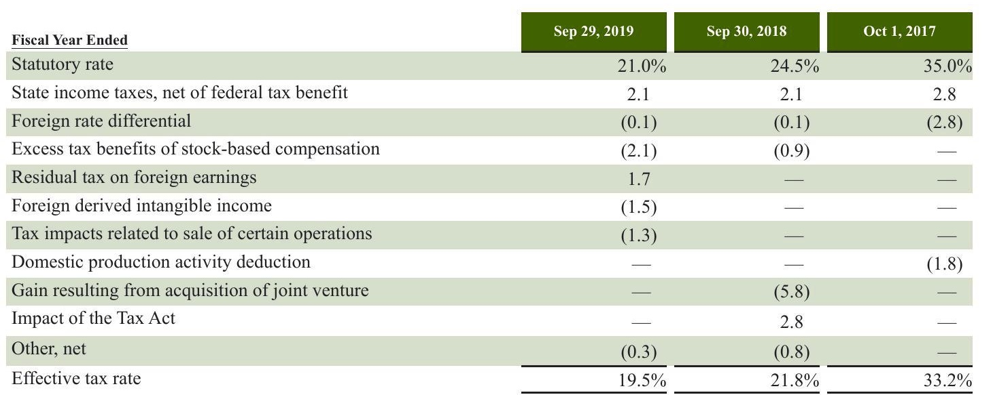

In the first quarter of fiscal 2019, we revised our indefinite reinvestment assertions for prior years' earnings from certain foreign subsidiaries. This change did not have a material impact to our financial results. As of September 29, 2019, in foreign subsidiaries in which we are partially indefinitely reinvested, the gross taxable temporary difference between the accounting basis and tax basis was approximately $1.3 billion, for which there could be up to approximately $300 million of unrecognized tax liability.

78Starbucks Corporation 2019 Form 10-K

2019 Form 10-K

Tax effect of temporary differences and carryforwards that comprise significant portions of deferred tax assets and liabilities (in millions):

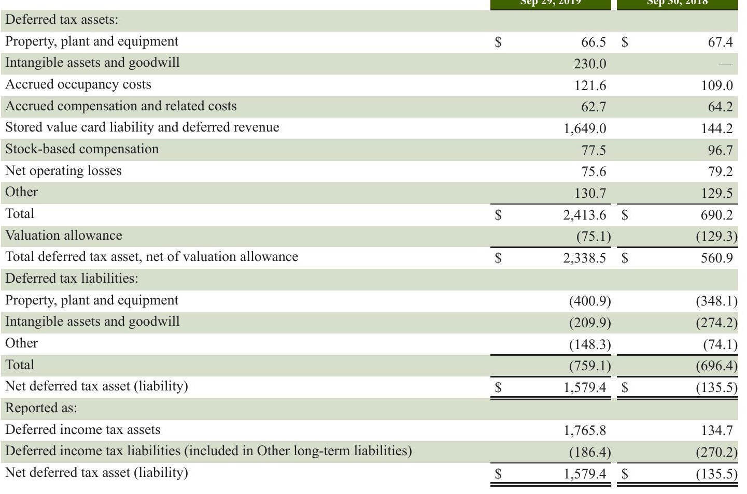

The valuation allowance as of September 29, 2019 and September 30, 2018 was primarily related to net operating losses and other deferred tax assets of consolidated foreign subsidiaries.

As of September 29, 2019, we had federal net operating loss carryforwards of $41.8 million which have an indefinite carryforward period, state net operating loss carryforwards of $78.1 million which will begin to expire in fiscal 2024, state tax credit carryforwards of $3.5 million which will begin to expire in fiscal 2024, and foreign net operating loss carryforwards of $246.2 million, of which $109.5 million have an indefinite carryforward period and the remainder expire at various dates starting from fiscal 2020.

# Uncertain Tax Positions

As of September 29, 2019, we had $132.1 million of gross unrecognized tax benefits of which $113.2 million, if recognized, would affect our effective tax rate. We recognized a benefit of $2.8 million, a benefit of $0.5 million and an expense of $5.2 million of interest and penalties in income tax expense, prior to the benefit of the federal tax deduction, for fiscal 2019, 2018 and 2017, respectively. As of September 29, 2019 and September 30, 2018, we had accrued interest and penalties of $10.0 million and $12.8 million, respectively, within our consolidated balance sheets

Starbucks Corporation 2019 Form 10-K79

Starbucks Corporation 2019 Form 10-K79

Starbucks Corporation 2019 Form 10-K79

Starbucks Corporation 2019 Form 10-K79

The following table summarizes the activity related to our unrecognized tax benefits (in millions):

Sep 29, 2019 Sep 30, 2018 Oct 1, 2017 146.5

|  |  |  |  |  |  |
| --- | --- | --- | --- | --- | --- |
| Beginning balance | $ | 224.6 $ |  | 196.9 $ | 146.5 |
| Increase related to prior year tax positions |  | 3.8 |  | 17.5 | 10.4 |
| Decrease related to prior year tax positions |  | (75.3) |  | (41.8) |  |
| Increase related to current year tax positions |  | 18.5 |  | 62.4 | 41.3 |
| Decreases related to settlements with taxing authorities |  | (16.4) |  | (4.5) |  |
| Decrease related to lapsing of statute of limitations |  | (23.1) |  | (5.9) | (1.3) |
| Ending balance | $ | 132.1 | $ | 224.6 $ | 196.9 |

We are currently under examination, or may be subject to examination, by various U.s. federal, state, local and foreign tax jurisdictions for fiscal 2008 through 2018.We are no longer subject to U.S.federal examination for years prior to fiscal 2016 We are no longer subject to U.S. state examination for years prior to fiscal 2011. We are no longer subject to examination in any material international markets prior to 2008.

# Note 14: Earnings per Share

Calculation of net earnings per common share ("EPS") -- basic and diluted (in millions, except EPS):

|  |  |  |  |  |  |  |
| --- | --- | --- | --- | --- | --- | --- |
| Fiscal Year Ended | Sep 29, 2019 | | Sep 30, 2018 | | Oct 1,2017 | |
| Net earnings attributable to Starbucks | | $ | 3,599.2$ |  | 4,518.3$ | 2,884.7 |
| Weighted average common shares outstanding (for basic calculation) | |  | 1,221.2 | 1,382.7 |  | 1,449.5 |
| Dilutive effect of outstanding common stock options and RSUs | |  | 12.0 | 11.9 |  | 12.0 |
| Weighted average common and common equivalent shares outstanding (for diluted calculation) | | 1,233.2 | | 1,394.6 | | 1,461.5 |
| EPS-basic |  | $ | 2.95$ |  | 3.27 $ | 1.99 |
| EPS diluted | $ |  | 2.92 $ | 3.24 | $ | 1.97 |

Potential dilutive shares consist of the incremental common shares issuable upon the exercise of outstanding stock options (both vested and non-vested) and unvested RSUs, calculated using the treasury stock method. The calculation of dilutive shares outstanding excludes out-of-the-money stock options (i.e., such options' exercise prices were greater than the average market price of our common shares for the period) because their inclusion would have been antidilutive. As of September 29, 2019, we had no out-of-the-money stock options, compared to 14.1 million and 11.4 million as of September 30, 2018 and October 1, 2017, respectively.

# Legal Proceedings

On April 13, 2010, an organization named Council for Education and Research on Toxics ("Plaintiff') filed a lawsuit in the Superior Court of the State of California, County of Los Angeles, against the Company and certain other defendants who manufacture, package, distribute or sell brewed coffee. The lawsuit is Council for Education and Research on Toxics v. Starbucks Corporation, et al. On May 9, 2011, the Plaintiff filed an additional lawsuit in the Superior Court of the State of California, County of Los Angeles, against the Company and additional defendants who manufacture, package, distribute or sell packaged coffee. The lawsuit is Council for Education and Research on Toxics v. Brad Barry LLC, et al.. Both cases have since been consolidated and now include nearly eighty defendants, which constitute the great majority of the coffee industry in California. Plaintiff alleges that the Company and the other defendants failed to provide warnings for their coffee products of exposure to the chemical acrylamide as required under California Health and Safety Code section 25249.5, the California Safe Drinking Water and Toxic Enforcement Act of 1986, better known as Proposition 65. Plaintiff seeks equitable relief, including providing warnings to consumers of coffee products, as well as civil penalties in the amount of the statutory maximum of two thousand five hundred dollars per day per violation of Proposition 65. The Plaintiff asserts that every consumed cup of coffee, absent a compliant warning, is equivalent to a violation under Proposition 65. The Company, as part of a joint defense group organized to defend against the lawsuit, disputes the claims of the Plaintiff. Acrylamide is not added to coffee but is present in all coffee in small amounts (parts per billion) as a byproduct of the coffee

bean roasting process. The Company has asserted multiple affirmative defenses. Trial of the first phase of the case commenced on September 8, 2014, and was limited to three affirmative defenses shared by all defendants. On September 1, 2015, the trial court issued a final ruling adverse to defendants on all Phase 1 defenses.Trial of the second phase of the case commenced in the fall of 2017. On May 7, 2018, the trial court issued a ruling adverse to defendants on the Phase 2 defense, the Company's last remaining defense to liability.On June 22,2018, the California Office of Environmental Health Hazard Assessment (OEHHA) proposed a new regulation clarifying that cancer warnings are not required for coffee under Proposition 65. The case was set to proceed to a third phase trial on damages, remedies and attorneys' fees on October 15, 2018. However, on October 12,2018,the California Court of Appeal granted the defendants request for a stay of the Phase 3 trial. On June 3, 2019, the Office of Administrative Law (OAL) approved the coffee exemption regulation. The regulation will be effective on October 1, 2019. On June 24, 2019, the Court of Appeal lifted the stay of the litigation. A status conference before the trial judge to discuss discovery issues and dispositive motions is scheduled for January 21, 2020. At this stage of the proceedings, Starbucks believes that the likelihood that the Company will ultimately incur a loss in connection with this litigation is less than reasonably possible. Accordingly, no loss contingency was recorded for this matter. Starbucks is party to various other legal proceedings arising in the ordinary course of business, including certain employment

Starbucks is party to various other legal proceedings arising in the ordinary course of business, including certain employment litigation cases that have been certified as class or collective actions, but, except as noted above, is not currently a party to any legal proceeding that management believes could have a material adverse effect on our consolidated financial position, results of operations or cash flows.

# Note 16: Segment Reporting

Segment information is prepared on the same basis that our ceo, who is our Chief Operating Decision Maker, manages the segments, evaluates financial results, and makes key operating decisions. We have three reportable operating segments: 1) Americas, which is inclusive of the U.S., Canada, and Latin America; 2) International, which is inclusive of China, Japan, Asia Pacific, Europe, Middle East, and Africa; and 3) Channel Development. Americas and International operations sell coffee and other beverages, complementary food,packaged coffees, single-serve coffee products and a focused selection of merchandise through company-operated stores and licensed stores. Our Americas segment is our most mature business and has achieved significant scale. Channel Development revenues include packaged coffee sales, tea and ready-to-drink beverages to customers outside of our company-operated and licensed stores. Historically revenues have included domestic and international sales of our packaged coffee, tea and ready-to-drink products to grocery, warehouse club and specialty retail stores and through institutional foodservice companies which serviced businesses. Since the fourth quarter of fiscal 2018, most of our Channel Development revenues are from product sales to and royalty revenues from Nestle. The collaborative business relationships for ready-to- drink products and the associated revenues remain unchanged due to the Global Coffee Alliance

Consolidated revenue mix by product type (in millions):

|  |  |  |  |  |  |
| --- | --- | --- | --- | --- | --- |
| Fiscal Year Ended | Sep 29, 2019 |  | Sep 30, 2018 | Oct 1, 2017 |  |
| Beverage | $15,921.2 | 60%$ | 14,463.1 | 59%$12,915.0 | 58% |
| Food | 4,792.8 | 18% | 4,397.7 | 18% 3,832.1 | 17% |
| Packaged and single-serve coffees and teas | 2,126.8 | 8% | 2,797.5 | 11% 2,883.6 | 13% |
| Other (1) | 3,667.8 | 14% | 3,061.2 12% | 2,756.1 | 12% |
| Total | 26,508.6 | 100% $ | 24,719.5 | 100% $ 22,386.8 | 100% |

beverages, among other items.

Starbucks Corporation 2019 Form 10-K81

Starbucks Corporation 2019 Form 10-K81

Starbucks Corporation 2019 Form 10-K81

|  |  |  |  |  |  |  |
| --- | --- | --- | --- | --- | --- | --- |
| Fiscal Year Ended | Sep 29, 2019 | | Sep 30, 2018 | | Oct 1,2017 | |
| Net revenues: |  |  |  |  |  |  |
| United States | $ | 18,622.7$ |  | 17,409.4$ |  | 16,527.1 |
| Other countries |  | 7,885.9 |  | 7,310.1 |  | 5,859.7 |
| Total | $ | 26,508.6 | $ | 24,719.5 | $ | 22,386.8 |
| Long-lived assets: |  |  |  |  |  |  |
| United States | $ |  |  |  |  | 5,848.3 |
| Other countries |  | 7,330.2$ |  | 5,635.9 |  |  |
|  |  | 6,235.5 |  | 6,026.3 |  | 3,234.0 |
| Total | $ | 13,565.7 | $ | 11,662.2 | $ | 9,082.3 |

No customer accounts for 10% or more of our revenues. Revenues are shown based on the geographic location of our customers. Revenues from countries other than the U.S. consist primarily of revenues from China, Japan, Canada and the U.K.. which together account for approximately 83% of net revenues from other countries for fiscal 2019.

Management evaluates the performance of its operating segments based on net revenues and operating income. The accounting policies of the operating segments are the same as those described in Note 1, Summary of Significant Accounting Policies. Operating income represents earnings before other income and expenses and income taxes. The identifiable assets by segment disclosed in this note are those assets specifically identifiable within each segment and include cash and cash equivalents, net property, plant and equipment, equity and cost investments, goodwill, and other intangible assets. Assets not attributed to reportable operating segments are corporate assets and are primarily comprised of cash and cash equivalents available for general corporate purposes, investments, assets of the corporate headquarters and roasting facilities, and inventory The table below presents financial information for our reportable operating segments and Corporate and Other segment for the years ended September 29, 2019, September 30, 2018 and October 1, 2017.

Channel Americas International Other Total

|  |  |  |  |  |  |  |  |  |  |  |
| --- | --- | --- | --- | --- | --- | --- | --- | --- | --- | --- |
| Fiscal 2019 | $ |  |  | 6,190.7$ |  | 1,992.6 $ |  |  |  |  |
| Total net revenues |  | 18,259.0$ |  |  |  |  |  | 66.3 $ |  | 26,508.6 |
| Depreciation and amortization expenses |  | 696.1 |  | 511.5 |  | 13.0 |  | 156.7 |  | 1,377.3 |
| Income from equity investees |  |  |  | 102.4 |  | 195.6 |  |  |  | 298.0 |
| Operating income/(loss) |  | 3,782.8 |  | 964.7 |  | 697.5 |  | (1,367.1) |  | 4,077.9 |
| Total assets | $ | 4,446.7 |  | 6,724.6$ |  | 132.2 |  | 7,916.1 | $ | 19,219.6 |
| Fiscal 2018 |  |  |  |  |  |  |  |  |  |  |
| Total net revenues |  | 16,748.6$ |  | 5,551.2$ |  | 2,297.3$ |  | 122.4$ |  | 24,719.5 |
| Depreciation and amortization expenses |  | 641.0 |  | 447.6 |  | 1.3 |  | 157.1 |  | 1,247.0 |
| Income from equity investees |  |  |  | 117.4 |  | 183.8 |  |  |  | 301.2 |
| Operating income/(loss) |  | 3,485.2 |  | 872.8 |  | 927.1 |  | (1,401.8) |  | 3,883.3 |
| Total assets | $ | 4,473.7 | $ | 6,361.9 | $ | 148.2 | $ | 13,172.6 | $ | 24,156.4 |
| Fiscal 2017 |  |  |  |  |  |  |  |  |  |  |
| Total net revenues | $ | 15,629.4 $ |  | 4,204.3$ |  | 2,256.6 $ |  | 296.5 |  | 22,386.8 |
| Depreciation and amortization expenses |  | 616.1 |  | 233.2 |  | 3.0 |  | 159.1 |  | 1,011.4 |
| Income from equity investees |  |  |  | 197.0 |  | 194.4 |  |  |  | 391.4 |
| Operating income/(loss) |  | 3,577.2 |  | 835.6 |  | 967.0 |  | (1,245.1) |  | 4,134.7 |
| Total assets | $ | 3,374.9 | $ | 3,117.1 | $ | 129.1 | $ | 7,744.5 | $ | 14,365.6 |

82Starbucks Corporation 2019 Form 10-K

2019 Form 10-K

Note 17:Selected Quarterly Financial Information (unaudited; in millions, except EPS)

|  |  |  |  |  |  |  |  |  |  |  |
| --- | --- | --- | --- | --- | --- | --- | --- | --- | --- | --- |
|  | First Quarter | | Second Quarter | | Third Quarter | | Fourth Quarter | | Full Year | |
| Fiscal 2019: |  |  |  |  |  |  |  |  |  |  |
| Net revenues | $ | 6,632.7 |  | 6,305.9 | $ | 6,823.0 |  | 6,747.0 | $ | 26,508.6 |
| Operating income |  | 1,015.7 |  | 857.7 |  | 1,121.3 |  | 1,083.3 |  | 4,077.9 |
| Net earnings attributable to Starbucks |  | 760.6 |  | 663.2 |  | 1,372.8 |  | 802.9 |  | 3,599.2 |
| EPS-diluted |  | 0.61 |  | 0.53 |  | 1.12 |  | 0.67 |  | 2.92 |
| Fiscal 2018: |  |  |  |  |  |  |  |  |  |  |
| Net revenues | $ | 6,073.7 $ |  | 6,031.8$ |  | 6,310.3$ |  | 6,303.6 | $ | 24,719.5 |
| Operating income |  | 1,116.1 |  | 772.5 |  | 1,038.2 |  | 956.6 |  | 3,883.3 |
| Net earnings attributable to Starbucks |  | 2,250.2 |  | 660.1 |  | 852.5 |  | 755.8 |  | 4,518.3 |
| EPS-diluted |  | 1.57 |  | 0.47 |  | 0.61 |  | 0.56 |  | 3.24 |

Starbucks Corporation 2019 Form 10-K83

Starbucks Corporation 2019 Form 10-K83

REPORT OFINDEPENDENTREGISTERED PUBLICACCOUNTINGFIRM To the shareholders and the Board of Directors of Starbucks Corporation

Opinion on the Financial Statements We have audited the accompanying consolidated balance sheets of Starbucks Corporation and subsidiaries (the "Company") as of September 29, 2019 and September 30, 2018, the related consolidated statements of earnings, comprehensive income, equity, and cash flows, for each of the three years in the period ended September 29, 2019, and the related notes (collectively referred to as the "financial statements"). In our opinion,the financial statements present fairly, in all material respects,the financial position of the Company as of September 29, 2019 and September 30, 2018, and the results of its operations and its cash flows for each of the three years in the period ended September 29, 2019, in conformity with accounting principles generally accepted in the United States of America.

We have also audited, in accordance with the standards of the Public Company Accounting Oversight Board (United States) (PCAOB),the Company's internal control over financial reporting as of September 29,2019,based on criteria established in Internal Control -Integrated Framework (2013) issued by the Committee of Sponsoring Organizations of the Treadway Commission and our report dated November 15, 2019, expressed an unqualified opinion on the Company's internal control over financial reporting.

# Basis for Opinion

These financial statements are the responsibility of the Company's management. Our responsibility is to express an opinion on the Company's financial statements based on our audits.We are a public accounting firm registered with the PCAOB and are required to be independent with respect to the Company in accordance with the U.S. federal securities laws and the applicable rules and regulations of the Securities and Exchange Commission and the PCAOB.

We conducted our audits in accordance with the standards of the PCAOB. Those standards require that we plan and perform the audit to obtain reasonable assurance about whether the financial statements are free of material misstatement, whether due to error or fraud. Our audits included performing procedures to assess the risks of material misstatement of the financial statements, whether due to error or fraud, and performing procedures that respond to those risks. Such procedures included examining, on a test basis, evidence regarding the amounts and disclosures in the financial statements. Our audits also included evaluating the accounting principles used and significant estimates made by management, as well as evaluating the overall presentation of the financial statements. We believe that our audits provide a reasonable basis for our opinion.

# Critical Audit Matter

The critical audit matter communicated below is a matter arising from the current-period audit of the financial statements that was communicated or required to be communicated to the audit committee and that (1) relates to accounts or disclosures that are material to the financial statements and (2) involved our especially challenging, subjective, or complex judgments. The communication of critical audit matters does not alter in any way our opinion on the financial statements, taken as a whole, and we are not, by communicating the critical audit matter below, providing a separate opinion on the critical audit matter or on the accounts or disclosures to which it relates.

Critical Audit Matter Description

We identified goodwill for the China company-operated reporting unit (China) as a critical audit matter. The Company's evaluation of goodwill for impairment involves the comparison of the fair value of the reporting unit to its carrying value. The Company uses a discounted cash flow model to estimate the fair value of the reporting unit, which requires management to make subjective estimates and assumptions, particularly related to the forecast of future revenues. The total goodwill balance of the International Segment was $2,958.4 million as of September 29, 2019, of which the majority was allocated to China. The sensitivity of operating results in China to changes in market risk factors,such as economic conditions, regulatory environment, and competition, required the application of a high degree of auditor judgment and an increased extent of effort when performing audit procedures to evaluate the reasonableness of management's estimates and assumptions related to the forecast of future revenues. How the Critical Audit Matter Was Addressed in the Audit Our principal audit procedures related to the Company's forecast of future revenues used by management to estimate the fair value of China included the following, among others: : We tested the effectiveness of controls over management's goodwill impairment evaluation, including the controls related to management's forecast of future revenues

2019 Form 10-K

84 Starbucks Corporation

: We evaluated management's ability to accurately forecast future revenues by comparing actual results to management's historical forecast : We assessed the reasonableness of the forecast of future revenues by comparing the forecast to: Historical revenues Internal communications to management and the Board of Directors Forecast information included in analyst and industry reports for the Company Historical and forecast information included in macro-economic reports for the China market Subsequent forecasts, to evaluate for changes made by management since the annual measurement date through issuance of the financial statements. /s/Deloitte & Touche LLP Seattle, Washington November 15, 2019 We have served as the Company's auditor since 1987.

Starbucks Corporation 2019 Form 10-K85

Item 9. Changes in and Disagreements with Accountants on Accounting and Financial Disclosure Not applicable.

Item 9A. Controls and Procedures Disclosure Controls and Procedures

We maintain disclosure controls and procedures that are designed to ensure that material information required to be disclosed in our periodic reports filed or submitted under the Securities Exchange Act of 1934, as amended (the "Exchange Act"), is recorded, processed, summarized and reported within the time periods specified in the SEC's rules and forms. Our disclosure controls and procedures are also designed to ensure that information required to be disclosed in the reports we file or submit under the Exchange Act is accumulated and communicated to our management, including our principal executive officer and principal financial officer, as appropriate to allow timely decisions regarding required disclosure. During the fourth quarter of fiscal 2019, we carried out an evaluation, under the supervision and with the participation of our management, including our chief executive officer and our chief financial officer, of the effectiveness of the design and operation of our disclosure controls and procedures, as defined in Rules 13a-15(e) and 15d-15(e) under the Exchange Act. Based upon that evaluation,our chief executive officer and chief financial officer concluded that our disclosure controls and procedures were effective, as of the end of the period covered by this report (September 29,2019). There were no changes in our internal control over financial reporting (as defined in Rules 13a-15(f) and 15d-15(f) of the Exchange Act) during our most recently completed fiscal quarter that materially affected or are reasonably likely to materially affect internal control over financial reporting. The certifications required by Section 302 of the Sarbanes-Oxley Act of 2002 are filed as exhibits 31.1 and 31.2, respectively, to this 10-K. Report of Management on Internal Control over Financial Reporting

Report of Management on Internal Control over Financial Reporting

Our management is responsible for establishing and maintaining adequate internal control over financial reporting. Internal control over financial reporting is a process to provide reasonable assurance regarding the reliability of our financial reporting for external purposes in accordance with accounting principles generally accepted in the United States of America. Internal control over financial reporting includes maintaining records that in reasonable detail accurately and fairly reflect our transactions; providing reasonable assurance that transactions are recorded as necessary for preparation of our financial statements; providing reasonable assurance that receipts and expenditures are made in accordance with management authorization; and providing reasonable assurance that unauthorized acquisition, use or disposition of company assets that could have a material effect on our financial statements would be prevented or detected on a timely basis. Because of its inherent limitations, internal control over financial reporting is not intended to provide absolute assurance that a misstatement of our financial statements would be prevented or detected. Management conducted an evaluation of the effectiveness of our internal control over financial reporting based on the framework and criteria established in Internal Control Integrated Framework, issued by the Committee of Sponsoring Organizations of the Treadway Commission. This evaluation included review of the documentation of controls, evaluation of the design effectiveness of controls, testing of the operating effectiveness of controls and a conclusion on this evaluation. Based on this evaluation, management concluded that our internal control over financial reporting was effective as of September 29, 2019. Our internal control over financial reporting as of September 29, 2019 has been audited by Deloitte & Touche LLP, an independent registered public accounting firm, as stated in their report which is included herein.

86Starbucks Corporation2019 Form 10-K

86Starbucks Corporation2019 Form 10-K

Licensed store data for the year-ended September 29, 2019:

|  |  |  |  |  |  |  |
| --- | --- | --- | --- | --- | --- | --- |
| Anencas. U.S. | 6,031 | 318 | (99) |  | 219 | 6,250 |
| Mexico | 708 | 49 | (9) |  | 40 | 748 |
| Latin America | 622 | 45 | (4) |  | 41 | 663 |
| Canada | 409 | 34 | (11) |  | 23 | 432 |
| Total Americas | 7,770 | 446 | (123) |  | 323 | 8,093 |
| International (0: |  |  |  |  |  |  |
| Korea | 1,231 | 128 | (25) |  | 103 | 1,334 |
| U.K. | 653 | 60 | (6) |  | 54 | 707 |
| Turkey | 453 | 47 | (6) |  | 41 | 494 |
| Taiwan | 458 | 35 | (13) |  | 22 | 480 |
| Indonesia | 365 | 56 |  |  | 56 | 421 |
| Philippines | 360 | 39 | (2) |  | 37 | 397 |
| Thailand |  | 15 |  | 377 | 392 | 392 |
| All Other | 2,681 | 396 | (55) | 82 | 423 | 3,104 |
| Total International | 6,201 | 776 | (107) | 459 | 1,128 | 7,329 |
| Corporate and Other: |  |  |  |  |  |  |
| Teavana | 12 |  | (12 |  | (12) |  |
| Total Corporate and Other | 12 |  | (12) |  | (12) |  |
| Total licensed | 13,983 | 1,222 | (242) | 459 | 1,439 | 15,422 |

International store data includes the transfer of 377 company-operated stores in Thailand to licensed stores as a result of the sale of operations late in the third quarter of fiscal 2019, and the transfer of 82 company-operated stores in France and the Netherlands to licensed stores as a result of the sales of operations in the second quarter of fiscal 2019.

# Other Revenues

Other revenues primarily are recorded in our Channel Development segment and include sales of packaged coffee, tea and ready-to-drink beverages to customers outside of our company-operated and licensed stores. Historically, revenues have included domestic and international sales of our packaged coffee, tea and ready-to-drink products to grocery, warehouse club and specialty retail stores and through institutional foodservice companies.With the establishment of the Global Coffee Alliance in the fourth quarter of fiscal 2018,other revenues include product sales to and licensing revenue from Nestle under this arrangement and the amortization of the up-front prepaid royalty. See Note 1, Summary of Significant Accounting Policies - Deferred Revenues, for further information. Our collaborative relationships with PepsiCo, Inc., Anheuser-Busch InBev, Tingyi Holding Corp., Arla Foods and others for our global ready-to-drink beverages businesses in this segment are excluded from the Global Coffee Alliance.

# Product Supply

Starbucks is committed to selling the finest whole bean coffees and coffee beverages. To ensure compliance with our rigorous coffee standards, we control substantially all coffee purchasing, roasting and packaging and the global distribution of coffee used in our operations. We purchase green coffee beans from multiple coffee-producing regions around the world and custom roast them to our exacting standards for our many blends and single origin coffees. The price of coffee is subject to significant volatility. Although most coffee trades in the commodity market, high-altitude arabica coffee of the quality sought by Starbucks tends to trade on a negotiated basis at a premium above the "C" coffee commodity price. Both the premium and the commodity price depend upon the supply and demand at the time of purchase Supply and price can be affected by multiple factors in the producing countries, including weather, natural disasters, crop disease, general increase in farm inputs and costs of production, inventory levels and political and economic conditions. Price is also impacted by trading activities in the arabica coffee futures market, including hedge funds and commodity index funds. In

REPORT OFINDEPENDENTREGISTERED PUBLICACCOUNTINGFIRM To the shareholders and the Board of Directors of Starbucks Corporation Opinion on Internal Control over Financial Reporting We have audited the internal control over financial reporting of Starbucks Corporation and subsidiaries (theCompany) as of September 29, 2019, based on criteria established in Internal Control - Integrated Framework (2013) issued by the Committee of Sponsoring Organizations of the Treadway Commission (COSO). In our opinion, the Company maintained, in all material respects,effective internal control over financial reporting as of September 29,2019, based on criteria established in Internal Control - Integrated Framework (2013) issued by COSO. We have also audited, in accordance with the standards of the Public Company Accounting Oversight Board (United States) (PCAOB), the consolidated financial statements as of and for the year ended September 29,2019, of the Company and our report dated November 15, 2019, expressed an unqualified opinion on those financial statements.

# Basis for Opinion

The Company's management is responsible for maintaining effective internal control over financial reporting and for its assessment of the effectiveness of internal control over financial reporting, included in the accompanying Report of Management on Internal Control over Financial Reporting. Our responsibility is to express an opinion on the Company's internal control over financial reporting based on our audit.We are a public accounting firm registered with the PCAOB and are required to be independent with respect to the Company in accordance with the U.S. federal securities laws and the applicable rules and regulations of the Securities and Exchange Commission and the PCAOB. We conducted our audit in accordance with the standards of the PCAOB. Those standards require that we plan and perform the audit to obtain reasonable assurance about whether effective internal control over financial reporting was maintained in all material respects. Our audit included obtaining an understanding of internal control over financial reporting, assessing the risk that a material weakness exists, testing and evaluating the design and operating effectiveness of internal control based on the assessed risk, and performing such other procedures as we considered necessary in the circumstances.We believe that our audi provides a reasonable basis for our opinion.

# Definition and Limitations of Internal Control over Financial Reporting

A company's internal control over financial reporting is a process designed to provide reasonable assurance regarding the reliability of financial reporting and the preparation of financial statements for external purposes in accordance with generally accepted accounting principles. A company's internal control over financial reporting includes those policies and procedures that (1) pertain to the maintenance of records that, in reasonable detail, accurately and fairly reflect the transactions and dispositions of the assets of the company; (2) provide reasonable assurance that transactions are recorded as necessary to permit preparation of financial statements in accordance with generally accepted accounting principles, and that receipts and expenditures of the company are being made only in accordance with authorizations of management and directors of the company; and (3) provide reasonable assurance regarding prevention or timely detection of unauthorized acquisition, use, or disposition of the company's assets that could have a material effect on the financial statements Because of its inherent limitations, internal control over financial reporting may not prevent or detect misstatements. Also, projections of any evaluation of effectiveness to future periods are subject to the risk that controls may become inadequate because of changes in conditions, or that the degree of compliance with the policies or procedures may deteriorate. /s/Deloitte & Touche LLP Seattle,Washington November 15, 2019

Starbucks Corporation 2019 Form 10-K87

Item 9B. Other Information None.

88Starbucks Corporation 2019 Form 10-K

PARTIII

Item 10.Directors,Executive Officers and Corporate Governance Information regarding our executive officers is set forth in Item 1 of Part 1 of this Report under the caption "Information about our Executive Officers." We adopted a code of ethics that applies to our chief executive officer, chief financial officer, controller and other finance leaders,which is a code of ethics"as defined by applicable rules of the SEC.This code is publicly available on our website at www.starbucks.com/about-us/company-information/corporate-governance. If we make any amendments to this code other than technical, administrative or other non-substantive amendments, or grant any waivers, including implicit waivers, from a provision of this code to our chief executive officer, chief operating officer, chief financial officer, chief accounting officer or controller,we will disclose the nature of the amendment or waiver, its effective date and to whom it applies on our website at www.starbucks.com/about-us/company-information/corporate-governance or in a report on Form 8-K filed with the SEC. The remaining information required by this item is incorporated herein by reference to the sections entitled "Proposal 1 Election of Directors" and "Beneficial Ownership of Common Stock - Delinquent Section 16(a) Reports," "Corporate Governance -- Board Committees and Related Matters" and "Corporate Governance -- Audit and Compliance Committe" in our definitive Proxy Statement for the Annual Meeting of Shareholders to be held on March 18, 2020 (the Proxy Statement").

Item 11. Executive Compensation The information required by this item is incorporated by reference to the section entitled "Executive Compensation," in the Proxy Statement.

Item 12. Security Ownership of Certain Beneficial Owners and Management and Related Shareholder Matters The information required by this item is incorporated by reference to the sections entitled "Equity Compensation Plan Information" and "Beneficial Ownership of Common Stock" in the Proxy Statement.

Item 13. Certain Relationships, Related Transactions and Director Independence The information required by this item is incorporated by reference to the section entitled "Certain Relationships and Related Transactions"and "Corporate Governance --Affirmative Determinations Regarding Director Independence and Other Matters" in the Proxy Statement.

Item 14. Principal Accounting Fees and Services

The information required by this item is incorporated by reference to the sections entitled "Proposal 3 - Ratification of Selection of Deloitte & Touche LLP as our Independent Registered Public Accounting Firm -Independent Registered Public Accounting Firm Fees" and "Proposal 3 - Ratification of Selection of Deloitte & Touche LLP as our Independent Registered Public Accounting Firm - Policy on Audit Committee Pre-Approval of Audit and Permissible Non-Audit Services of the Independent Registered Public Accounting Firm"in the Proxy Statement.

Starbucks Corporation 2019 Form 10-K89

Starbucks Corporation 2019 Form 10-K89

PARTIV

Item 15.Exhibits,Financial Statement Schedules (@) The following documents are filed as a part of this 10-K: 1. Financial Statements The following financial statements are included in Part II, Item 8 of this 10-K: Consolidated Statements of Earnings for the fiscal years ended September 29, 2019, September 30, 2018, and October 1,2017; Consolidated Statements of Comprehensive Income for the fiscal years ended September 29, 2019, September 30, 2018, and October 1, 2017; Consolidated Balance Sheets as of September 29,2019 and September 30,2018; Consolidated Statements of Cash Flows for the fiscal years ended September 29, 2019, September 30, 2018, and October 1, 2017; Consolidated Statements of Equity for the fiscal years ended September 29, 2019, September 30, 2018, and October 1, 2017; Notes to Consolidated Financial Statements; and Reports of Independent Registered Public Accounting Firm Financial Statement Schedules 2. Financial statement schedules are omitted because they are not required or are not applicable, or the required information is provided in the consolidated financial statements or notes described in Item 15(a)(1) above.

90Starbucks Corporation 2019 Form 10-K

90Starbucks Corporation 2019 Form 10-K

3.Exhibits

|  |  |  |  |  |  |
| --- | --- | --- | --- | --- | --- |
| Exhibit Number |  | Incorporated by Reference | | | |
| Exhibit Description | Form | File No. | Date of Filing | Exhibit Filed Number Herewith |
| 2.1 | Transaction Agreement, dated as of May 6,2018 by and between Starbucks Corporation and Nestle S.A | 8-K | 0-20322 | 5/7/2018 | 2.1 |
| 3.1 | Restated Articles of Incorporation of Starbucks Corporation | 10-Q | 0-20322 | 4/28/2015 | 3.1 |
| 3.2 | Amended and Restated Bylaws of Starbucks Corporation (As amended and restated through June 1,2018) | 8-K | 0-20322 | 6/5/2018 | 3.1 |
| 4.1 | Indenture, dated as of September 15, 2016, by and between Starbucks Corporation and U.S. Bank National Association, as trustee. | S-3ASR | 333-213645 | 9/15/2016 | 4.1 |
| 4.2 | First Supplemental Indenture, dated March 17,2017,by and between Starbucks Corporation and U.S. Bank National Association, as trustee, transfer agent and registrar, and Elavon Financial Services,DAC,UK Branch, as paying agent (0.372% Senior Notes due 2024) | 8-K | 0-20322 | 3/20/2017 | 4.2 |
| 4.3 | Form of 0.372% Senior Note due March 15, 2024 | 8-K | 0-20322 | 3/20/2017 | 4.3 |
| 4.4 | Second Supplemental Indenture,dated as of November 22,2017,by and between Starbucks Corporation and U.S. Bank National Association, as trustee (2.200% Senior Notes due 2020 and 3.750% Senior Notes due 2047) | 8-K | 0-20322 | 11/22/2017 | 4.2 |
| 4.5 | Form of 2.200% Senior Notes due November 22, 2020 (included in Exhibit 4.2) | 8-K | 0-20322 | 11/22/2017 | 4.3 |
| 4.6 | Form of 3.750% Senior Notes due December 1,2047 (included in Exhibit 4.2) | 8-K | 0-20322 | 11/22/2017 | 4.4 |
| 4.7 | Third Supplemental Indenture, dated as of February 28,2018,by and between Starbucks Corporation and U.S. Bank National Association, as trustee (3.100% Senior Notes due 2023 and 3.500% Senior Notes due | 8-K | 0-20322 | 2/28/2018 | 4.2 |
| 4.8 | 2028) Form of 3.100% Senior Notes due March 1,2023 | 8-K | 0-20322 | 2/28/2018 | 4.3 |
| 4.9. | Form of 3.500% Senior Notes due March 1, 2028 | 8-K | 0-20322 | 2/28/2018 | 4.4 |
| 4.10 | Fourth Supplemental Indenture, dated as of August 10,2018,by and between Starbucks Corporation and U.S.Bank National Association, as trustee (3.800% Senior Notes due 2025, 4.000% Senior Notes due 2028 and | 8-K | 0-20322 | 8/10/2018 | 4.2 |
| 4.11 | 4.500% Senior Notes due 2048) Form of 3.800% Senior Notes due August 15, 2025 | 8-K | 0-20322 | 8/10/2018 | 4.3 |

2019 Form 10-K91

Starbucks Corporation

2019 Form 10-K91

|  |  |  |  |  |  |  |
| --- | --- | --- | --- | --- | --- | --- |
| Exhibit Number | Exhibit Description | Form | Incorporated by Reference | | | Filed Herewith |
| File No. | Date of Filing | Exhibit Number |
| 4.12 | Form of 4.000% Senior Notes due November 15, 2028 | 8-K | 0-20322 | 8/10/2018 | 4.4 |  |
| 4.13 | Form of 4.500% Senior Notes due November 15,2048 | 8-K | 0-20322 | 8/10/2018 | 4.5 |  |
| 4.14 | Fifth Supplemental Indenture, dated as of May 13,2019, by and between Starbucks Corporation and U.S. Bank National Association, as trustee (3.550% Senior Notes due 2029 and 4.450% Senior Notes due 2049) | 8-K | 0-20322 | 5/13/2019 |  | 4.2 |
| 4.15 | Form on 3.550% Senior Notes due August 15, 2029 (included in Exhibit 4.2 | 8-K | 0-20322 | 5/13/2019 |  | 4.3 |
| 4.16 | Form on 4.450% Senior Notes due August 15, 2049 (included in Exhibit 4.2 | 8-K | 0-20322 | 5/13/2019 |  | 4.4 |
| 4.17 | Indenture, dated as of August 23, 2007, by and between Starbucks Corporation and Deutsche Bank Trust Company Americas, as trustee | S-3ASR | 333-190955 | 9/3/2013 |  | 4.1 |
| 4.18 | Second Supplemental Indenture, dated as of September 6, 2013, by and between Starbucks Corporation and Deutsche Bank Trust Company Americas, as trustee (3.850% Senior | 8-K | 0-20322 | 9/6/2013 |  | 4.2 |
| 4.19 | Notes due October 1, 2023) Form of 3.850% Senior Notes due October 1,2023 | 8-K | 0-20322 | 9/6/2013 |  | 4.3 |
| 4.20 | Third Supplemental Indenture, dated as of December 5,2013, by and between Starbucks Corporation and Deutsche Bank Trust Company Americas, as trustee (0.875% Senior Notes due 2016 and 2.000% Senior | 8-K | 0-20322 | 12/5/2013 |  | 4.2 |
| 4.21 | Notes due 2018) Form of 2.000% Senior Notes due December 5,2018 | 8-K | 0-20322 | 12/5/2013 |  | 4.4 |
| 4.22 | Fourth Supplemental Indenture, dated as of June 10, 2015, by and between Starbucks Corporation and Deutsche Bank Trust Company Americas, as trustee (2.700% Senior Notes due June 15, 2022 and 4.300% Senior Notes due June 15, 2045) | 8-K | 0-20322 | 6/10/2015 |  | 4.2 |
| 4.23 | Form of 2.700% Senior Notes due June 15, 2022 | 8-K | 0-20322 | 6/10/2015 | 4.3 |  |
| 4.24 | Form of 4.300% Senior Notes due June 15, 2045 | 8-K | 0-20322 | 6/10/2015 |  | 4.4 |
| 4.25 | Fifth Supplemental Indenture, dated as of February 4, 2016, by and between Starbucks Corporation and Deutsche Bank Trust Company Americas, as trustee (2.100% Senior Notes due February 4,2021) | 8-K | 0-20322 | 2/4/2016 |  | 4.2 |

92 Starbucks Corporation 2019 Form 10-K

|  |  |  |  |  |  |  |
| --- | --- | --- | --- | --- | --- | --- |
| Exhibit Number | Exhibit Description | Incorporated by Reference | | | | Filed Herewith |
| Form | File No. | Date of Filing | Exhibit Number |
| 4.26 | Form of 2.100% Senior Notes due February 4,2021 | 8-K | 0-20322 | 2/4/2016 | 4.3 |  |
| 4.27 | Sixth Supplemental Indenture, dated as of May 16,2016,by and between Starbucks Corporation and Deutsche Bank Trust Company Americas, as trustee (2.450% Senior Notes due June 15, 2026) | 8-K | 0-20322 | 5/16/2016 | 4.4 |  |
| 4.28 | Form of 2.450% Senior Notes due June 15, 2026 | 8-K | 0-20322 | 5/16/2016 | 4.5 |  |
| 4.29 10.1* | Description of Securities Starbucks Corporation Employee |  |  |  |  | X |
|  | Stock Purchase Plan-1995 as amended and restated on April 9,2015 to reflect adjustments for the 2-for-1 forward stock split effective on such date | 10-Q | 0-20322 | 8/1/2017 | 10.1 |  |
| 10.2* | Starbucks Corporation Executive Management Bonus Plan, as amended and restated on June 25,2019 | 10-Q | 0-20322 | 7/30/2019 | 10.1 |  |
| 10.3* | Starbucks Corporation Management Deferred Compensation Plan,as amended and restated effective January 1,2011 | 10-Q | 0-20322 | 2/4/2011 | 10.2 |  |
| 10.4* | Starbucks Corporation UK Share Save Plan | 10-K | 0-20322 | 12/23/2003 | 10.9 |  |
| 10.5* | Starbucks Corporation Deferred Compensation Plan for Non-Employee Directors,effective October 3,2011, as amended and restated effective September 11,2018 | 10-K | 0-20322 | 11/16/2018 | 10.5 |  |
| 10.6* | Starbucks Corporation UK Share Incentive Plan, as amended and restated effective November 14, 2006 | 10-K | 0-20322 | 12/14/2006 | 10.12 |  |
| 10.7* | Starbucks Corporation 2005 Long- Term Equity Incentive Plan, as amended and restated effective March 20,2013,as restated on April 9,2015 to reflect adjustments for the 2-for-1 forward stock split effective on such date,and as amended and restated by the Board on September | 10-K | 0-20322 | 11/16/2018 | 10.7 |  |
| 10.8* | 11,2018 2005 Key Employee Sub-Plan to the Starbucks Corporation 2005 Long- Term Equity Incentive Plan, as amended and restated effective November 15,2005 | 10-Q | 0-20322 | 2/10/2006 | 10.2 |  |

Starbucks Corporation 2019 Form 10-K93

Starbucks Corporation 2019 Form 10-K93

2019 Form 10-K93

2019 Form 10-K93

|  |  |  |  |  |  |  |
| --- | --- | --- | --- | --- | --- | --- |
| Exhibit |  | Incorporated by Reference | | | |  |
| Number 10:9* | Exhibit Description 200s Non- Employee Director | Form 10-K | File No. 0-20322 | Date of Filing. 11/1612018 | Eyhibit. Number 109 | Filed Herewith |
|  | Sub- Plan t0 the Starbucks Corporation 200: Long. Term Equity Incentive Pian, аş amended and restated effective September 11, 2018 |  |  |  |  |  |
| 10,10* | Form 0í Stock Option Grant Agreement for Purchase Öí I Stock under the Key Employee Sub-] Plan to the 200: Long-- Term Equity Incentive Plan | 10-0 | 0-20322 | S1212012 | 101 |  |
| 1011* | Form 0í Global Stock Option Grant Agreement for Purchase. 0í Stock under the Key Empld loyee Sub-Plan. t0 the 2005 Long Term Equity Incentive Plan | 10-Ｋ | 0-20322 | 11/18/2016 | 1014 |  |
| 10.12* | Form 0í Stock Option Grant Agreement. for Purchase 0í Stock Under the 2005 Non- -Employee Director Sub- -Plan the Starbucks. 七û Corporation 200$ Long- Term Equity Incentive Plan | 10-0 | 0-20322 | 4/26/2016 | 102 |  |
| 1013* | Form Restricted Stock Unit Grant 0í Agreement under. the 2005 Non- Employee Director Sub-Plan the Starbucks. Corporation 2005 Long- Term Equity Incentive Plan Credit Agreement. dated October 25, | 10-0 | 0-20322 | 4/26/2016 | 103 |  |
| 1014 | 2017, among Starbucks Corporation, Bank Of America, N.A. ín its Capacity Adminis istrativ Agent, ās ć Swing Line Lender and LIC Issuer, Wells Fargo Bank, N.A. Citibank, N.A and U.S. Bank Nationa! Association, аs LIC Issuers. and the Other Lenders from time t0 time 丑 party thereto. | 8-Ｋ | 0-20322 | 10/3012017 | 10,1 |  |
| 1015 | Amended and Restated 364-Day Credit Agreement. dated October 24, 2018, among Starbucks Corporation. Bank of America, N.A. ín its capacity as Administrative Agent and Swing Line Lender and U.s. Bank National Association, as ＬIC Issuers, and the other Lenders from time 0 time ａ | 8-Ｋ | 0-20322 | 10/26/2018 | 101 |  |
| party 10,16 | thereto. Description Extension, dated as of 0í October 23, 2019, t0 the Amended and Restated 364- Day Credit Agret ement, dated of October 24, 20i8, аş among Starbucks. Corporation, Bank Öf America, N.A, in its Capacity. aş Administrative. Agent and Swing Line Lender and U.S. Bank National! Association,. as Issuers, and the | 8-Ｋ | 0-20322 | 10/25/2019 |  |  |
| 10.17 | other Lenders from time t0 time ａ party thereto. Form 0í Commercia! Paper Dealer Agreement between Starbucks | 8-Ｋ | 0-20322 | 7129/2016 | 101 |  |
| 10.18* Plan | Corporation. Issuer, and Dealer аş the Form of Time Vested Restricted Stock Unit Grant A greement U.S. under the Key Employee Sub. -Plan t0 the 200s Long- Term Equity Incentive | 10-Ｋ | 0-20322 | 11/18/2011 | 1030 |  |

94 Starbucks Corporation 2019 Form 10-K

|  |  |  |  |  |  |  |
| --- | --- | --- | --- | --- | --- | --- |
| Exhibit Number |  | Incorporated by Reference | | | | |
| Form | File No. | Date of Filing | Exhibit Number | Filed Herewith |
| 10.19* | Exhibit Description Form of Time Vested Global Restricted Stock Unit Grant Agreement under the Key Employee Sub-Plan to the 2005 Long-Term | 10-K | 0-20322 | 11/18/2016 | 10.21 |  |
| 10.20* | Equity Incentive Plan Form of Performance Based Global Restricted Stock Unit Grant Agreement under the Key Employee | 10-K | 0-20322 | 11/18/2016 | 10.22 |  |
| 10.21* | Sub-Plan to the 2005 Long-Term Equity Incentive Plan Form of Global Key Employee Restricted Stock Unit Grant | 10-K | 0-20322 | 11/17/2017 | 10.24 |  |
| 10.22* | Agreement Form of Global Key Employee Restricted Stock Unit Grant Agreement (Effective November |  |  |  |  | X |
| 10.23* | 2019) Form of Global Key Employee Stock Option Grant Agreement for Purchase of Stock under the 2005 Long-Term | 10-K | 0-20322 | 11/17/2017 | 10.25 |  |
| 10.24* | Equity Incentive Plan Form of Global Key Employee Performance-Based Stock Option Grant Agreement for Purchase of | 10-K | 0-20322 | 11/16/2018 | 10.23 |  |
| 10.25* | Stock under the 2005 Long-Term Equity Incentive Plan Form of Global Key Employee Restricted Stock Unit Grant | 10-K | 0-20322 | 11/17/2017 | 10.26 |  |
| 10.26* | Agreement (Performance-Based) Form of Global Key Employee Restricted Stock Unit Grant Agreement (Performance-Based) |  |  |  |  | X |
| 10.27* | (Effective November 2019) Exclusive Aircraft Sublease (S/N 6003) dated as of September 27,2013 by and between Cloverdale Services, | 10-Q | 0-20322 | 4/29/2014 | 10.3 |  |
| 10.28* | LLC and Starbucks Corporation Transition Agreement dated June 27, 2018 between Scott Maw and | 8-K/A | 0-20322 | 6/29/2018 | 10.1 |  |
| 10.29* | Starbucks Corporation Letter Agreement dated November 30, 2009 between Starbucks Corporation | 10-Q | 0-20322 | 2/2/2010 | 10.3 |  |
| 10.30* | and John Culver Letter Agreement dated May 16, 2012 between Starbucks Corporation and | 10-K | 0-20322 | 11/14/2014 | 10.33 |  |
| 10.31* | Lucy Lee Helm Offer Letter dated March 23,2017 between Starbucks Corporation and Kevin Johnson | 10-Q | 0-20322 | 5/2/2017 | 10.1 |  |
| 10.32* | Offer Letter dated August 23, 2017 between Starbucks Corporation and Rosalind Brewer | 8-K | 0-20322 | 9/6/2017 | 10.1 |  |
| 10.33* | Offer Letter dated October 5,2018 between Starbucks Corporation and Patrick J.Grismer | 8-K | 0-20322 | 10/9/2018 | 10.1 |  |

Starbucks Corporation 2019 Form 10-K95

Starbucks Corporation

2019 Form 10-K95

|  |  |  |  |  |  |  |
| --- | --- | --- | --- | --- | --- | --- |
| Exhibit | Exhibit Description | Incorporated by Reference | | | |  |
| Form | File No. | Date of Filing | Exhibit Number | Filed Herewith |
| Number 21 | Subsidiaries of Starbucks Corporation |  |  |  |  | x |
| 23 | Consent of Independent Registered Public Accounting Firm |  |  |  |  | x |
| 24 | Power of Attorney (included on the Signatures page of this Annual Report on Form 10-K |  |  |  |  | X |
| 31.1 | Certification of Principal Executive Officer Pursuant to Rule 13a-14(a) of the Securities Exchange Act of 1934, As Adopted Pursuant to Section 302 of the Sarbanes-Oxley Act of 2002 |  |  |  |  | x |
| 31.2 | Certification of Principal Financial Officer Pursuant to Rule 13a-14(a)of the Securities Exchange Act of 1934, As Adopted Pursuant to Section 302 of the Sarbanes-Oxley Act of 2002 |  |  |  |  | X |
| 32** | Certifications of Principal Executive Officer and Principal Financial Officer Pursuant to 18 U.S.C. Section 1350, As Adopted Pursuant to Section 906 of the Sarbanes-Oxley Act of 2002 The following financial statements |  |  |  |  |  |
| 101 | from the Company's 10-K for the fiscal year ended September 29,2019 formatted in iXBRL:(i Consolidated Statements of Earnings, (ii) Consolidated Statements of Comprehensive Income,iii Consolidated Balance Sheets,(iv) Consolidated Statements of Cash Flows, (v) Consolidated Statements of Equity,and (vi Notes to Consolidated Financial Statements |  |  |  |  | X |

Denotes a management contract or compensatory plan or arrangement.

Furnished herewith.

96Starbucks Corporation 2019 Form 10-K

2019 Form 10-K

# Competition

Our primary competitors for coffee beverage sales are specialty coffee shops. We believe that our customers choose among specialty coffee retailers primarily on the basis of product quality, service and convenience, as well as price. We continue to experience direct competition from large competitors in the quick-service restaurant sector and the ready-to-drink coffee beverage market, in addition to both well-established and start-up companies in many international markets. We also compete with restaurants and other specialty retailers for prime retail locations and qualified personnel to operate both new and existing stores Our coffee and tea products sold through our Channel Development segment compete directly against specialty coffees and teas sold through grocery stores, warehouse clubs, specialty retailers, convenience stores and foodservice accounts and compete indirectly against all other coffees and teas on the market.

Trademarks, Copyrights, Patents and Domain Names

Starbucks owns and has applied to register numerous trademarks and service marks in the U.S. and in other countries throughout the world. Some of our trademarks, including Starbucks, the Starbucks logo, Starbucks Reserve, Seattle's Best Coffee, Teavana, Frappuccino and Starbucks VIA are of material importance. The duration of trademark registrations varies from country to country. However, trademarks are generally valid and may be renewed indefinitely as long as they are in use and/or their registrations are properly maintained. We own numerous copyrights for items such as product packaging, promotional materials, in-store graphics and training materials. We also hold patents on certain products, systems and designs. In addition, Starbucks has registered and maintains numerous Internet domain names, including "Starbucks.com," "Starbucks.net," "Starbucksreserve.com," "Seattlesbest.com' and "Teavana.com."

# Seasonality and Quarterly Results

Our business is subject to moderate seasonal fluctuations, of which our fiscal second quarter typically experiences lower revenues and operating income. Additionally, as Starbucks Cards are issued to and loaded by customers during the holiday season, we tend to have higher cash flows from operations during the first quarter of the fiscal year. However, since revenues from Starbucks Cards are recognized upon redemption and not when cash is loaded onto the Card, the impact of seasonal fluctuations on the consolidated statements of earnings is much less pronounced. As a result of moderate seasonal fluctuations, results for any quarter are not necessarily indicative of the results that may be achieved for the full fiscal year.

2019 Form 10-K